Contents

Websites: 5

JVM 5

32 bits vs 64 bits JVM 12

Garbage Collection 12

Multithreading 14

Producer Consumer Problem 15

Core Java 20

API 20

Primitives 21

Exceptions: 21

Serialization 23

Generics 24

Lambda 25

Functional Interface 26

Default Methods 27

Stream 27

Date/Time API changes 30

String 32

Palindrome 34

Database 35

JDBC: 39

Spring JDBC 40

Java Collections-Data Structures 42

Array 42

HashMap 45

LinkedHashMap 47

TreeMap 49

ArrayList vs LinkedList 50

Singly Linked List 52

Doubly Linked List 56

Tree 58

Binary Search Tree 60

Heap – (min Heap, max Heap) 64

Graph Data Structure 64

Trie 64

Sorting Algorithm 65

Bubble Sort 65

Selection Sort 65

Merge Sort 66

Insertion Sort 66

Quick Sort: 68

Binary Search 69

Heap Sort 70

Recursion 71

Spring 72

REST 75

JSON/Protobuff 75

Scala 77

Map Reduce 77

Hadoop 77

Apache Kafka 81

Apache Spark 95

Distributed Systems Patterns 95

Apache Cassandra 97

Design Patterns 103

Creational: 103

Structural: 103

Behavioral: 103

Core Design Patterns: 105

Core J2EE: 183

Presentation Tier: 183

Business Tier: 183

Integration Tier: 184

Algorithms 195

Maths Problems: 202

Linked Lists: 204

Arrays Problems: 205

Stacks and Queues Problems: 207

Trees Problems: 208

Strings Problems: 212

Dynamic Programming 213

Miscellaneous problems: 214

Design Questions 217

Largest Rectangular Area in a Histogram | Set 1 230

*“It's hard to beat a person who never gives up.”..Babe Ruth*

Interview Preparation – Questionnaire ***- Ashay Raut***

Let me tell you something you already know. The world ain’t all sunshine and rainbows. It’s a very mean and nasty place and I don’t care how tough you are it will beat you to your knees and keep you there permanently if you let it. You, me, or nobody is gonna hit as hard as life. But it ain’t about how hard ya hit. It’s about how hard you can get it and keep moving forward. How much you can take and keep moving forward. That’s how winning is done! Now if you know what you’re worth then go out and get what you’re worth. But ya gotta be willing to take the hits, and not pointing fingers saying you ain’t where you wanna be because of him, or her, or anybody! Cowards do that and that ain’t you! You’re better than that!

Sylvestor Stalone, Rocky

# Websites:

[WWW.CAREERCUP.COM](http://WWW.CAREERCUP.COM)

<http://www.geeksforgeeks.org/java/>

[WWW.LEETCODE.COM](http://WWW.LEETCODE.COM)

<http://www.programmerinterview.com>

[www.codercareer.com](http://www.codercareer.com)

# JVM

JVM: Abstract Machine which executes bytecodes.

JRE: It implements JVM for specific OS and provides other class libraries to execute java specific programs.

JDK: Provides development kit and system/Java libraries

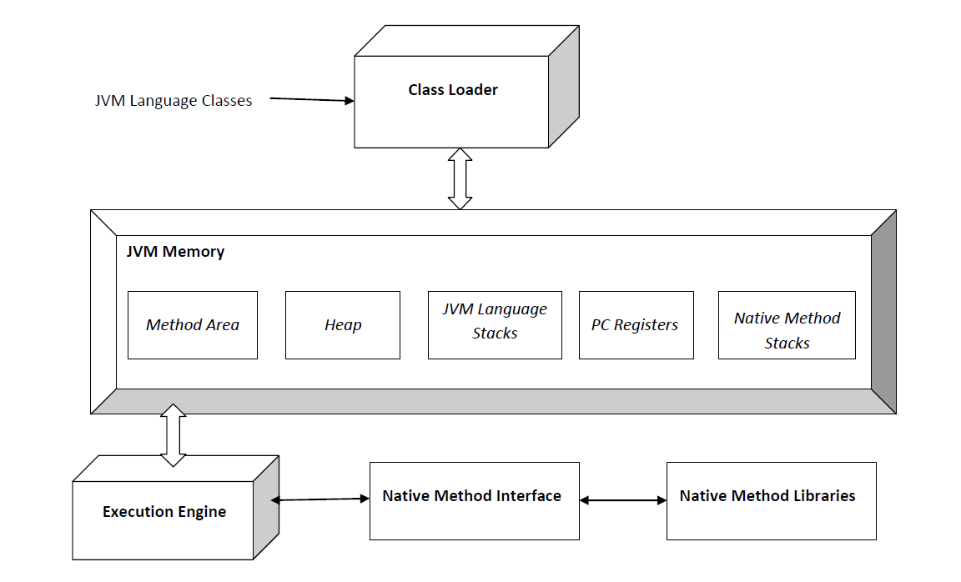

**Class Loader Sub System:**

Loading, Linking, Initialization

**Loading**:

The Class loader reads the ***.class*** file, **generate the corresponding binary data and save it in method area**. For each *.class* file, JVM stores following information in method area.

* Fully qualified name of the loaded class and its immediate parent class.
* Whether *.class* file is related to Class or Interface or Enum
* Modifier, Variables and Method information etc

**Linking :** Performs **verification, preparation, and (optionally) resolution**.

1. ***Verification*** : It ensures the correctness of *.class* file i.e. it check whether this file is properly formatted and generated by valid compiler or not. If verification fails, we get run-time exception *java.lang.VerifyError*.
2. ***Preparation*** : JVM allocates memory for class variables and initializing the memory to default values.
3. ***Resolution*** : It is the process of replacing symbolic references from the type with direct references. It is done by searching into method area to locate the referenced entity.

**Initialization :** In this phase, all static variables are assigned with their values defined in the code and static block(if any). This is executed from top to bottom in a class and from parent to child in class hierarchy.  
In general there are three class loaders:

1. ***Bootstrap class loader*:** Every JVM implementation must have a bootstrap class loader, capable of loading trusted classes. It loads core java API classes present in *JAVA_HOME/jre/lib* directory. This path is popularly known as bootstrap path. It is implemented in native languages like C, C++.
2. ***Extension class loader*:** It is child of bootstrap class loader. It loads the classes present in the extensions directories *JAVA_HOME/jre/lib/ext*(Extension path) or any other directory specified by the java.ext.dirs system property. It is implemented in java by the *sun.misc.Launcher$ExtClassLoader* class.
3. ***System/Application class loader*:** It is child of extension class loader. It is responsible to load classes from application class path. It internally uses Environment Variable which mapped to java.class.path. It is also implemented in Java by the *sun.misc.Launcher$ExtClassLoader* class.

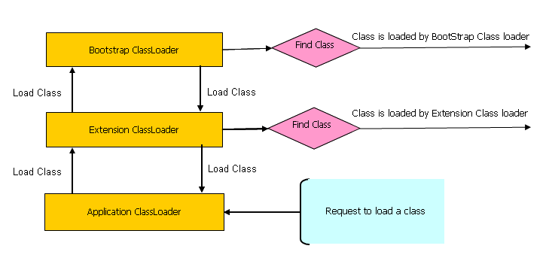

**JVM Memory:**

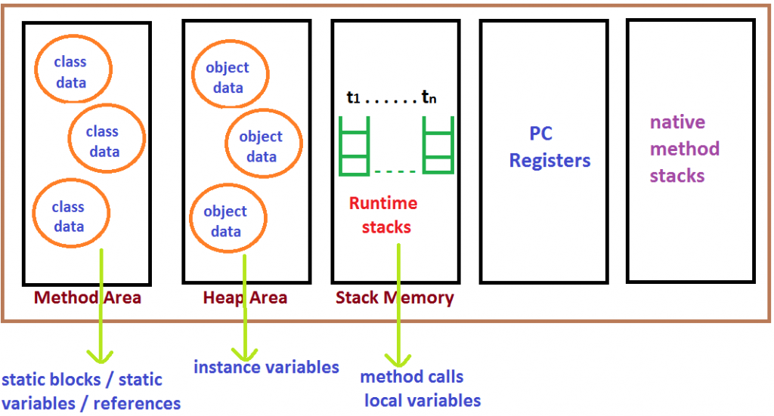

**Method area:** In method area, all class level information like class name, immediate parent class name, methods and variables information etc. are stored, including static variables. There is only **one method area per JVM**, and it is a shared resource.

**Heap area:** Information of all objects is stored in heap area. There is also one Heap Area per JVM. It is also a shared resource.

**Stack area:** For every thread, JVM create one run-time stack which is stored here. Every block of this stack is called activation record/stack frame which store methods calls. All local variables of that method are stored in their corresponding frame. After a thread terminate, it’s run-time stack will be destroyed by JVM. It is not a shared resource.

**PC Registers:** Store address of current execution instruction of a thread. Obviously, each thread has

separate PC Registers.

**Native method stacks:** For every thread, separate native stack is created. It stores native method information.

**Execution Engine:**

Execution engine execute the .class (bytecode). It reads the byte-code line by line, use data and information present in various memory area and execute instructions. It can be classified in three parts :-

* **Interpreter**: It interprets the bytecode line by line and then executes. The disadvantage here is that when one method is called multiple times, every time interpretation is required.
* **Just-In-Time Compiler(JIT**): It is used to increase efficiency of interpreter. It compiles the entire bytecode and changes it to native code so whenever interpreter see repeated method calls, JIT provide direct native code for that part so re-interpretation is not required, thus efficiency is improved.
* **Garbage Collector**: It destroy un-referenced objects. For more on Garbage Collector,refer [Garbage Collector](http://www.geeksforgeeks.org/garbage-collection-java/).

Thread Stack

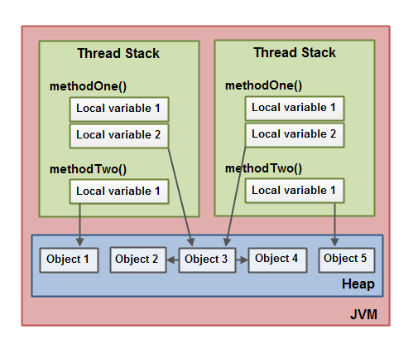

A modern computer often has 2 or more CPUs in it. Some of these CPUs may have multiple cores too

Each CPU contains a set of registers which are essentially in-CPU memory. The CPU can perform operations much faster on these registers than it can perform on variables in main memory. That is because the CPU can access these registers much faster than it can access main memory.

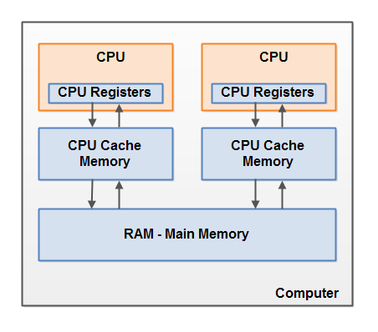

As already mentioned, the Java memory model and the hardware memory architecture are different. The hardware memory architecture does not distinguish between thread stacks and heap. On the hardware, both the thread stack and the heap are located in main memory. Parts of the thread stacks and heap may sometimes be present in CPU caches and in internal CPU registers. This is illustrated in this diagram:

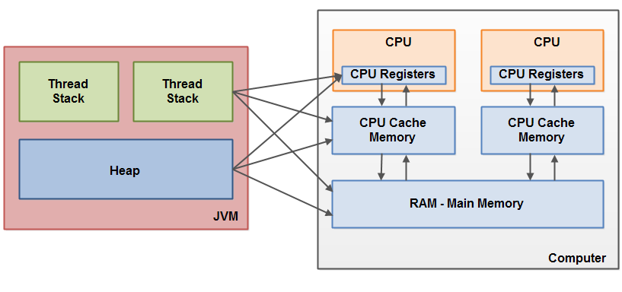

When objects and variables can be stored in various different memory areas in the computer, certain problems may occur. The two main problems are:

1. Visibility of thread updates (writes) to shared variables.
2. Race conditions when reading, checking and writing shared variables.

Stack dump

Kill -3 on linux

Jstat -l <pid>

Stack Heap:

Jmap -dump:format=b

jps

**java.lang.OutOfMemoryError: Metaspace**  
this error is Java 8 equivalent of Permgen error because the Permanent generation has been removed in java 8 and a new Metaspace is introduced.  
  
Read more: <http://javarevisited.blogspot.com/2017/05/solution-of-javalangoutofmemoryerror-gc-overhead-limit-exceeded.html#ixzz4loT5ckJ2>

## 32 bits vs 64 bits JVM

64-bit vs. 32-bit really boils down to the size of object references, not the size of numbers.

In 32-bit mode, references are four bytes, allowing the JVM to uniquely address 2^32 bytes of memory. This is the reason 32-bit JVMs are limited to a maximum heap size of 4GB (in reality, the limit is smaller due to other JVM and OS overhead, and differs depending on the OS).

In 64-bit mode, references are (surprise) eight bytes, allowing the JVM to uniquely address 2^64 bytes of memory, which should be enough for anybody. JVM heap sizes (specified with -Xmx) in 64-bit mode can be huge.

But 64-bit mode comes with a cost: references are double the size, increasing memory consumption. This is why Oracle introduced ["Compressed oops"](https://wikis.oracle.com/display/HotSpotInternals/CompressedOops). With compressed oops enabled (which I believe is now the default), object references are shrunk to four bytes, with the caveat that the heap is limited to four billion objects (and 32GB Xmx). Compressed oops are not free: there is a small computational cost to achieve this big reduction in memory consumption.

Problem 1: 30-50% of more heap is required on 64-bit. Why so? Mainly because of the memory layout in 64-bit architecture. First of all – object headers are 12 bytes on 64-bit JVM. Secondly, object references can be either 4 bytes or 8 bytes, depending on JVM flags and the size of the heap. This definitely adds some overhead compared to the 8 bytes on headers on 32-bit and 4 bytes on references. You can also dig into one of our earlier posts for more information about calculating the memory consumption of an object.

Problem 2: Longer garbage collection pauses. Building up more heap means there is more work to be done by GC while cleaning it up from unused objects. What it means in real life is that you have to be extra cautious when building heaps larger than 12-16GB. Without fine tuning and measuring you can easily introduce full GC pauses spanning several minutes. In applications where latency is not crucial and you can optimize for throughput only this might be OK, but on most cases this might become a showstopper.

## Garbage Collection

Garbage Collection tracks each and every object available in the JVM heap space and removes unused ones.

* **Mark –**it is where the garbage collector identifies which pieces of memory are in use and which are not
* **Sweep –**this step removes objects identified during the “mark” phase

VM has four types of *GC* implementations:

* Serial Garbage Collector
* Parallel Garbage Collector
* CMS Garbage Collector
* G1 Garbage Collector

These implementations can be declared with the below parameters:

|  |  |
| --- | --- |
| 1  2  3  4 | -XX:+UseSerialGC  -XX:+UseParallelGC  -XX:+USeParNewGC  -XX:+UseG1GC |

**Serial GC**: This is the simplest GC implementation, as it basically works with a single thread. As a result, **this GC implementation freezes all application threads when it runs**. Hence, it not a good idea to use it in multi-threaded applications like server environments.

java -XX:+UseSerialGC -jar Application.java

**parallel GC:** multiple garbage collectors threads to manage heap space and also freeze application threads while GC. garbage collector threads can be controlled, -XX:ParallelGCThreads=<N>.

java -XX:+UseParallelGC -jar Application.java

CMS Garbage Collection: Multiple Garbage Collection threads for GC. Shorter GC pauses.

Applications using this type of GC respond slower on average but do not stop responding to perform garbage collection.

java -XX:+USeParNewGC -jar Application.java

# Multithreading

Process & Thread:

**Wait**: Object wait methods has three variances, one which waits indefinitely for any other thread to call notify or notifyAll method on the object to wake up the current thread. Other two variances puts the current thread in wait for specific amount of time before they wake up.

**notify**: notify method wakes up only one thread waiting on the object and that thread starts execution. So if there are multiple threads waiting for an object, this method will wake up only one of them. The choice of the thread to wake depends on the OS implementation of thread management.

**notifyAll**: notifyAll method wakes up all the threads waiting on the object, although which one will process first depends on the OS implementation.

InterruptedException:

The Object class in java contains three final methods that allows threads to communicate about the lock status of a resource.

The current thread which invokes these methods on any object should have the object **monitor** else it throws **java.lang.IllegalMonitorStateException** exception.

ExecutorService service=Executors.newSingleThreadExecutor(1); //thread pool of just 1

ExecutorService service=Executors.newFixedThreadpool(1); //fixed # of threads

ExecutorService service=Executors. newCachedThreadPool (); //cached thread pool

Future f = executorService.submit(Callable<>); //instead of Runnable, it’s callable and instead of run, it’s call()

**AtomicInteger:**

Combination of volatile variable and **CompareAndSwap** (optimistic locking).

It compares last value as the expected memory in the memory and if it matches then updates it.

It is **nonblocking concurrent algorithm** where it does require explicit synchronized lock. It works best with low to medium thread contention.

public final int getAndIncrement() {

for (;;) {

int current = get();

int next = current + 1;

if (compareAndSet(current, next))

return current;

}

}

CountDownLatch.await() will wait until count reaches zero. It can’t be reused once it’s reaches to zero.

CyclicBarrier: CyclicBarrier by calling reset()

**ExecutorService** extends Executor (Parent Interface) **Executor** defines execute() method which accepts an object of the Runnable interface, while submit() method can accept objects of both [Runnable](http://www.java67.com/2016/01/7-differences-between-extends-thread-vs-implements-Runnable-java.html) and [Callable](http://javarevisited.blogspot.com/2016/08/useful-difference-between-callable-and-Runnable-in-Java.html) interfaces. Executor’s execute() method doesn't return any result, its return type is void.   
ExecutorService -> submit() method returns the result of computation via a [Future](http://javarevisited.blogspot.com/2015/06/how-to-use-callable-and-future-in-java.html) object  
Future.get() can result at later time, blocking call.

ExecutorService also provides methods to control the thread pool e.g. terminate the thread pool by calling the shutDown() method.

**Executors** class provides [factory methods](http://javarevisited.blogspot.sg/2017/02/5-difference-between-constructor-and-factory-method-in-java.html) to create different kinds of thread pools e.g. newSingleThreadExecutor() creates a thread pool of just one thread, newFixedThreadPool(int numOfThreads) creates a thread pool of fixed number of threads and newCachedThreadPool() creates new threads when needed but reuse the existing threads if they are available

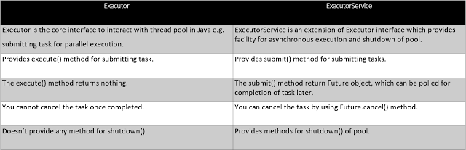

## Producer Consumer Problem

Wait, notify, notifyall methods are on object to manage communication between objects. They are not on thread as it can’t be on individual thread instance. It requires lock before using them for mutually exclusive lock then operation carry out.

**import** java.util.Vector;  
**import** java.util.logging.Level;  
**import** java.util.logging.Logger;  
  
/**  
 * **Java program to solve Producer Consumer problem using wait and notify**  
 * method in Java. Producer Consumer is also a popular concurrency design pattern.  
 *  
 * @author Javin Paul  
 */  
**public** **class** ProducerConsumerSolution {  
  
    **public** **static** **void** main(**String** args[]) {  
        **Vector** sharedQueue = **new** **Vector**();  
        **int** size = 4;  
        **Thread** prodThread = **new** **Thread**(**new** Producer(sharedQueue, size), "Producer");  
        **Thread** consThread = **new** **Thread**(**new** Consumer(sharedQueue, size), "Consumer");  
        prodThread.start();  
        consThread.start();  
    }  
}  
  
**class** Producer **implements** **Runnable** {  
  
    **private** **final** **Vector** sharedQueue;  
    **private** **final** **int** SIZE;  
  
    **public** Producer(**Vector** sharedQueue, **int** size) {  
        **this**.sharedQueue = sharedQueue;  
        **this**.SIZE = size;  
    }  
  
    @**Override**  
    **public** **void** run() {  
        for (**int** i = 0; i < 7; i++) {  
            **System**.out.println("Produced: " + i);  
            **try** {  
                produce(i);  
            } **catch** (**InterruptedException** ex) {  
                **Logger**.getLogger(Producer.**class**.getName()).log(**Level**.SEVERE, **null**, ex);  
            }  
  
        }  
    }  
  
    **private** **void** produce(**int** i) **throws** **InterruptedException** {  
  
        *//wait if queue is full*  
        while (sharedQueue.size() == SIZE) {  
            **synchronized** (sharedQueue) {  
                **System**.out.println("Queue is full " + **Thread**.currentThread().getName()

                                    + " is waiting , size: " + sharedQueue.size());  
  
                sharedQueue.wait();  
            }  
        }  
  
        *//producing element and notify consumers*  
        **synchronized** (sharedQueue) {  
            sharedQueue.add(i);  
            sharedQueue.notifyAll();  
        }  
    }  
}  
  
**class** Consumer **implements** **Runnable** {  
  
    **private** **final** **Vector** sharedQueue;  
    **private** **final** **int** SIZE;  
  
    **public** Consumer(**Vector** sharedQueue, **int** size) {  
        **this**.sharedQueue = sharedQueue;  
        **this**.SIZE = size;  
    }  
  
    @**Override**  
    **public** **void** run() {  
        while (**true**) {  
            **try** {  
                **System**.out.println("Consumed: " + consume());  
                **Thread**.sleep(50);  
            } **catch** (**InterruptedException** ex) {  
                **Logger**.getLogger(Consumer.**class**.getName()).log(**Level**.SEVERE, **null**, ex);  
            }  
  
        }  
    }  
  
    **private** **int** consume() **throws** **InterruptedException** {  
        *//wait if queue is empty*  
        while (sharedQueue.isEmpty()) {  
            **synchronized** (sharedQueue) {  
                **System**.out.println("Queue is empty " + **Thread**.currentThread().getName()

                                    + " is waiting , size: " + sharedQueue.size());  
  
                sharedQueue.wait();  
            }  
        }  
  
        *//Otherwise consume element and notify waiting producer*  
        **synchronized** (sharedQueue) {  
            sharedQueue.notifyAll();  
            **return** (**Integer**) sharedQueue.remove(0);  
        }  
    }  
}  
  
**Output:**  
Produced: 0  
**Queue** is empty Consumer is waiting , size: 0  
Produced: 1  
Consumed: 0  
Produced: 2  
Produced: 3  
Produced: 4  
Produced: 5  
**Queue** is full Producer is waiting , size: 4  
Consumed: 1  
Produced: 6  
**Queue** is full Producer is waiting , size: 4  
Consumed: 2  
Consumed: 3  
Consumed: 4  
Consumed: 5  
Consumed: 6  
**Queue** is empty Consumer is waiting , size: 0

# Core Java

## API

**java.lang.String**

**//Constructor:**

String()

String(byte[] b)

String(char[] c)

String(char[] c, int offset, int count)

String(String s)

String(StringBuilder sb)

String(StringBuffer sf)

**//Methods:**

Char charAt(int index)

int indexOf(char c) //first occurrence of the character

int indexOf(String str) //first occurrence of the string

int indexOf(char c, int startindex)//first occurrence after start index

int lastIndexof(int charcter)

int compareTo(String anotherString)

int comparToIgnoreCase(String anotherString)

String concate(string s)

boolean contains(CharSequence S)

boolean endsWith(String suffix)

boolean startsWith(String suffix)

boolean isEmpty()

boolean equalsIgnorecase(String anotherString)

boolean contentEquals(CharSequence s)

boolean contentEquals(StringBuffer sf)

String replace(char oldchar, char newchar)

String replaceFirst(String regex, String replacement)

String replaceAll(String regex, String replacement)

//replaceAll("[^\\p{ASCII}]", "");

// text.replaceAll("\\<.*?\\>", "");

String substring(int beginIndex)

String substring(int beginIndex, int endIndex)

int length()

byte[] getBytes(String s) => b.length (byte array length)

Char[] toCharArray()

String trim()

String valueOf(int i)/valueof(char c)/ valueof(long l)/ valueof(double c)/ valueof(float c)

String copyValueOf(char[] data)

String copyValueOf(char[] data, int beginindex, int charcount)

String[] split(“ ”); //String arrays by token of char (char, comma)

//text.split("[\n|\r]").length

**Java.lang.Integer**

Integer(int value)

Integer(String str)

int compare(int x, int y)

int compareTo(Integer anotherint)

double doubleValue() //returns double value of int after widening

Integer getInteger(String s)

int parseInt(String s)

Character

## Primitives

**byte**, **short**, **int** and **long** data types are used for storing whole numbers. **float** and **double** are used for fractional numbers. **char** is used for storing characters(letters). **boolean** data type is used for variables that holds either true or false.

byte: Default size of 1 byte. Can hold smallest whole number -128 to 128

short: Default size is 2 byte2. -32,768 to 327677

int: Default size: 4 bytes. Number can be of: -2,147,483,648 to 2,147,483,647

**float**: Sufficient for holding 6 to 7 decimal digits  
size: 4 bytes

**double**: Default size: 8 bytes. Sufficient for holding 15 decimal digits

**long**: Default size: 8 bytes. it has wider range than int data type, ranging from -9,223,372,036,854,775,808 to 9,223,372,036,854,775,807.

**boolean**: holds either true of false.

**char**: holds characters. size: 2 bytes

## Exceptions:

An Exception can be anything which interrupts the normal flow of the program. When an exception occurs program, processing gets terminated and doesn’t continue further. In such cases we get a system generated error message. The good thing about exceptions is that they can be handled. We will cover the handling part later in this same tutorial.

Exception can occur at runtime (known as runtime exceptions) as well as at compile-time (known Compile-time exceptions)

**Errors** indicate serious problems and abnormal conditions that most applications should not try to handle. Error defines problems that are not expected to be caught under normal circumstances by our program. For example, memory error, hardware error, JVM error etc.

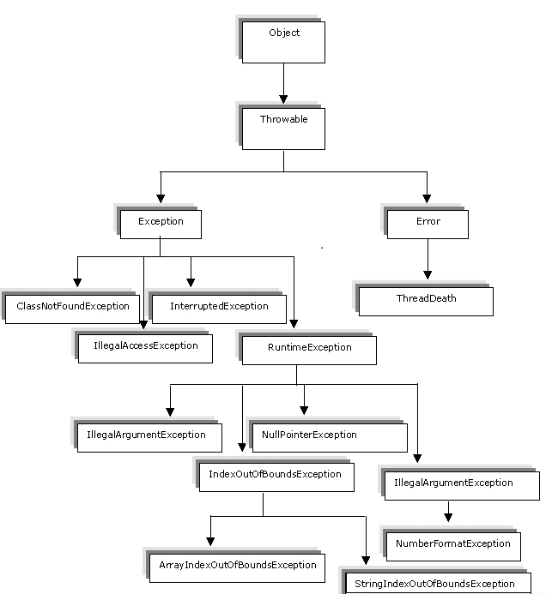

## Serialization

Serialization is a mechanism to convert an object into stream of bytes so that it can be written into a file, transported through a network or stored into database. De-serialization is just a vice versa.

public static void main(String args[])

{

Student obj = new Student(101, 25, "Chaitanya", "Agra", 6);

try{

FileOutputStream fos = new FileOutputStream("Student.ser");

ObjectOutputStream oos = new ObjectOutputStream(fos);

oos.writeObject(obj);

oos.close();

fos.close();

System.out.println("Serialzation Done!!");

}catch(IOException ioe){

System.out.println(ioe);

}

}

De-Serialization:

try{

FileInputStream fis = new FileInputStream("Student.ser");

ObjectInputStream ois = new ObjectInputStream(fis);

o = (Student)ois.readObject();

ois.close();

fis.close();

}

catch(IOException ioe)

{

ioe.printStackTrace();

return;

}catch(ClassNotFoundException cnfe)

{

System.out.println("Student Class is not found.");

cnfe.printStackTrace();

return;

}

## Generics

T is a general Type which can be used for any Objet Type.

GenericClass<T> means GenericClass<Integer> and GenericClass<String>

List<E> myList;

E is called a type variable, namely a variable that will be replaced by a type.

1. A generic type that uses a type variable E allows you to pass E when declaring or instantiating the generic type.
2. If E is a class, you may also pass a subclass of E.
3. If E is an interface, you may also pass a class that implements E.
4. By convention, you use a single uppercase letter for type variable names.

## Lambda

They work like anonymous function – where no name.

(parameters) -> expression or

(parameters) -> { statements; } or

() -> expression

Example:

//This function takes two parameters and return their sum.

(x, y) -> x + y

1. A lambda expression can have zero, one or more parameters.
2. The type of the parameters can be explicitly declared or it can be inferred from the context.
3. Multiple parameters are enclosed in mandatory parentheses and separated by commas. Empty parentheses are used to represent an empty set of parameters.
4. When there is a single parameter, if its type is inferred, it is not mandatory to use parentheses. e.g. a -> return a*a.
5. The body of the lambda expressions can contain zero, one or more statements.
6. If body of lambda expression has single statement curly brackets are not mandatory and the return type of the anonymous function is the same as that of the body expression. When there is more than one statement in body than these must be enclosed in curly brackets.

A lambda expression is a block of code that can be passed around to execute.

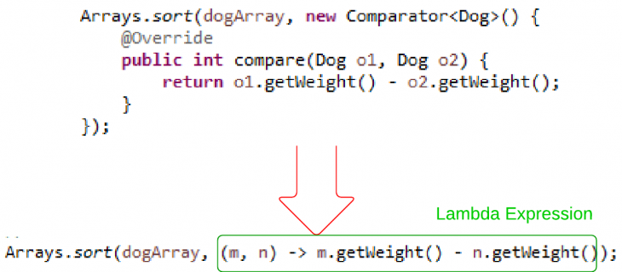

Above Lambda is inferred to Integer.compare();

//with type declaration

MathOperation addition = (int a, int b) -> a + b;

private int operate(int a, int b, MathOperation mathOperation){

return mathOperation.operation(a, b);

}

System.out.println("10 + 5 = " + tester.operate(10, 5, addition));

Method references help to point to methods by their names. A method reference is described using **::** (double colon) symbol. A method reference can be used to point the following types of methods −

* Static methods
* Instance methods
* Constructors using new operator (TreeSet::new)

## Functional Interface

Single (Simple) Abstract Method interfaces – where exactly **one abstract** method allowed.

Annotation - @FunctionalInterface is used to inform compiler.

It can have other default method – with implementation but still requires one abstract method.

It can have other overloaded methods from Object but still requires one abstract method.

@FunctionalInterface

public interface MyFirstFunctionalInterface

{

    public void firstWork();

    @Override

    public String toString();                //Overridden from Object class

    @Override

    public boolean equals(Object obj);        //Overridden from Object class

}

## Default Methods

Java 8 allows having non-abstract method in the interface (to allow functionality of the Lambda expression). It allows binary to be compatible with prior version of the library.

public interface Moveable {

    default void move(){

        System.out.println("I am moving");

    }

}

public class Animal implements Moveable{

    public static void main(String[] args){

        Animal tiger = new Animal();

        tiger.move();

    }

}

Output: I am moving

## Stream

Stream represents a sequence of objects from a source, which supports aggregate operations.

Sequence of elements supporting sequential and parallel aggregate operations.

Streams API provides mechanism for processing a set of data in various way to filter, transformation by iterations (on each item).

Example to remove items which begins with some text:

List<String> items;

String prefix;

List<String> filteredList = items.stream().filter(e -> (!e.startsWith(prefix))).collect(Collectors.toList());

//keep those items which does not begin with exclusion text – filter out those matching ones.

//sorted function

**public** **static** **void** main(String[] args) {

*// create an array of dogs*

Dog d1 = **new** Dog("Max", 2, 50);

Dog d2 = **new** Dog("Rocky", 1, 30);

Dog d3 = **new** Dog("Bear", 3, 40);

Dog[] dogArray = { d1, d2, d3 };

*// use stream to sort*

Stream<Dog> dogStream = Stream.of(dogArray);

Stream<Dog> sortedDogStream = dogStream.sorted((Dog m, Dog n) -> Integer.compare(m.getHeight(), n.getHeight()));

sortedDogStream.**forEach**(d -> System.out.print(d));

}

//filter function

*//filter function*

Stream<String> stream = list.stream().filter(p -> p.length() >

String[] arr = stream.toArray(String[]::**new**);

List<String> strings = Arrays.asList("abc", "", "bc", "efg", "abcd","", "jkl");

List<String> filtered = strings.stream().filter(string -> !string.isEmpty()).collect(Collectors.toList());

//For each:

Random random = new Random();

random.ints().limit(10).forEach(System.out::println);

//map

List<Integer> numbers = Arrays.asList(3, 2, 2, 3, 7, 3, 5);

//get list of unique squares

List<Integer> squaresList = numbers.stream().map( i -> i*i).distinct().collect(Collectors.toList());

Limit – limit size of the stream

Random random = new Random();

random.ints().limit(10).forEach(System.out::println);

sorted – sort the stream. Below shows how to print 10 random numbers in a sorted order.

random.ints().limit(10).sorted().forEach(System.out::println);

ParallelStream:

List<String> strings = Arrays.asList("abc", "", "bc", "efg", "abcd","", "jkl");

//get count of empty string

int count = strings.parallelStream().filter(string -> string.isEmpty()).count();

Collectors – combine the result of processing on the elements of a stream.

List<String>strings = Arrays.asList("abc", "", "bc", "efg", "abcd","", "jkl");

List<String> filtered = strings.stream().filter(string -> !string.isEmpty()).collect(Collectors.toList());

System.out.println("Filtered List: " + filtered);

String mergedString = strings.stream().filter(string -> !string.isEmpty()).collect(Collectors.joining(", "));

System.out.println("Merged String: " + mergedString);

Statistics:

List<Integer> numbers = Arrays.asList(3, 2, 2, 3, 7, 3, 5);

IntSummaryStatistics stats = integers.stream().mapToInt((x) -> x).summaryStatistics();

System.out.println("Highest number in List : " + stats.getMax());

System.out.println("Lowest number in List : " + stats.getMin());

System.out.println("Sum of all numbers : " + stats.getSum());

System.out.println("Average of all numbers : " + stats.getAverage());

## Date/Time API changes

The new Date and Time APIs/classes (JSR-310), also called as ThreeTen, which have simply change the way you have been handling dates in java applications.

Dates

Date class has even become obsolete. The new classes intended to replace Date class are LocalDate, LocalTime and LocalDateTime.

1. The LocalDate class represents a date. There is no representation of a time or time-zone.
2. The LocalTime class represents a time. There is no representation of a date or time-zone.
3. The LocalDateTime class represents a date-time. There is no representation of a time-zone.

If you want to use the date functionality with zone information, then Lambda provide you extra 3 classes similar to above one i.e. OffsetDate, OffsetTime and OffsetDateTime. Timezone offset can be represented in “+05:30” or “Europe/Paris” formats. This is done via using another class i.e. ZoneId.

|  |
| --- |
| LocalDate localDate = LocalDate.now();  LocalTime localTime = LocalTime.of(12, 20);  LocalDateTime localDateTime = LocalDateTime.now();  OffsetDateTime offsetDateTime = OffsetDateTime.now();  ZonedDateTime zonedDateTime = ZonedDateTime.now(ZoneId.of("Europe/Paris")); |

Timestamp and Duration

For representing the specific timestamp ant any moment, the class needs to be used is Instant. The Instant class represents an instant in time to an accuracy of nanoseconds. Operations on an Instant include comparison to another Instant and adding or subtracting a duration.

|  |
| --- |
| Instant instant = Instant.now();  Instant instant1 = instant.plus(Duration.ofMillis(5000));  Instant instant2 = instant.minus(Duration.ofMillis(5000));  Instant instant3 = instant.minusSeconds(10); |

Duration class is a whole new concept brought first time in java language. It represents the time difference between two time stamps.

|  |
| --- |
| Duration duration = Duration.ofMillis(5000);  duration = Duration.ofSeconds(60);  duration = Duration.ofMinutes(10); |

Duration deals with small unit of time such as milliseconds, seconds, minutes and hour. They are more suitable for interacting with application code. To interact with human, you need to get **bigger durations** which are presented with Period class.

|  |
| --- |
| Period period = Period.ofDays(6);  period = Period.ofMonths(6);  period = Period.between(LocalDate.now(), LocalDate.now().plusDays(60)); |

## String

**common Constructors:**

String(byte[] b)

String(String s)

String(char[] b)

String(StringBuffer sf)

String(StringBuilder sb)

**Common Methods:**

Char charAt(int index)

int compareTo(String anotherStirng)

int compareToIgnoreCase(String anotherString)

boolean contains(CharSequence s)

String[] split(expression)

java.util.StringTokenizer

StringTokenizer st = new StringTokenizer(str);

while (st.hasMoreElements()) { System.out.println(st.nextElement()); }

String Str = new String("Welcome-to-Tutorialspoint.com");

System.out.println("Return Value :" );

for (String retval: Str.split("-")) {

System.out.println(retval);

}

String message = String.join("-", "Java", "is", "cool");

// message returned is: "Java-is-cool"

If we again write **str = new String(“very”)**, then it will create a new object with value “very”, rather than pointing to the available objects in heap area with same value.But if we write **str = “very”**,then it will point to String constant object with value “very”,present in String pooled area.

**1. equals() method:**It compares**values** of string for equality. Return type is boolean. In almost all the situation you can use useObjects.equals().

**2. == operator:**It compares **references not values**. Return type is boolean. == is used in rare situations where you know you’re dealing with interned strings.

**3. compareTo() method:**It compares values lexicographically and returns an integer value that describes if first string is less than, equal to or greater than second string.For example,if str1 and str2 are two string variables then if

**str1==str2:** return0  
**str1>str2:** returnpositive

**str1 < str2:** return a negative value

**Note:** The positive and negative values returned by **compareTo** method is the difference of first unmatched character in the two strings

String str5 = **new** String("abc");

String str6 = **new** String("abc");

System.***out***.println("str5 == str6 => are NOT equals");

String str5_i = **new** String("abc").intern();

String str6_i = **new** String("abc").intern();

System.***out***.println("str5_i == str5_i => are equals");

String str7 = "abc";

String str8 = "abc";

**if**(str7 == str8)

System.***out***.println("str7 == str8 => are equals");

**char**[] sArray = s1.toCharArray();

s.charAt(i-1)

StringBuffer s=**new** StringBuffer("GeeksforGeeks");

s.delete(0,5);

System.***out***.println(s); //returns forGeeks

s.deleteCharAt(7);

System.***out***.println(s); //returns forGeek

Java.lang.Character

**Maximum Occurance of characters:**

**for** (**int** i=1; i<=n; i++)

{

**for** (**int** j=1; j<=n; j++)

{

// If characters match and indexes are not same

**if** (strArray[i-1] == strArray[j-1] && i!=j)

dp[i][j] = 1 + dp[i-1][j-1];

// If characters do not match

**else**

dp[i][j] = Math.*max*(dp[i][j-1], dp[i-1][j]);

}

System.***out***.println("i ="+ i );

*printArray*(dp);

## Palindrome

String is equal in characters – either way you read it

boolean isPalindrome(String str) {

int n = str.length();

for( int i = 0; i < n/2; i++ )

if (str.charAt(i) != str.charAt(n-i-1)) return false;

return true;

}

private boolean isPalindrome(String s) {

int length = s.length();

if (length < 2) // If the string only has 1 char or is empty

return true;

else {

// Check opposite ends of the string for equality

if (s.charAt(0) != s.charAt(length - 1))

return false;

// Function call for string with the two ends snipped off

else

return isPalindrome(s.substring(1, length - 1));

}

}

java.lang.String

**common Constructors:**

String(byte[] b)

String(String s)

String(char[] b)

String(StringBuffer sf)

String(StringBuilder sb)

**Common Methods:**

Char charAt(int index)

int compareTo(String anotherStirng)

int compareToIgnoreCase(String anotherString)

boolean contains(CharSequence s)

java.lang.Integer

[**parseInt**](http://docs.oracle.com/javase/8/docs/api/java/lang/Integer.html#parseInt-java.lang.String-)([**String**](http://docs.oracle.com/javase/8/docs/api/java/lang/String.html) s)

**java.util.StringTokenizer**

**java.util.Arrays**

[**asList**](http://docs.oracle.com/javase/8/docs/api/java/util/Arrays.html#asList-T...-)(T... a)

StringTokenizer st = new StringTokenizer(str);

while (st.hasMoreElements()) {

System.out.println(st.nextElement());

Longest # for subsequence – dynamic programming with multi dimestion

## Database

A left outer join retains all of the rows of the left table, regardless of whether there is a row that matches on the right table. (employee left join location -> gives all from employee)

A right outer join is pretty much the same thing as a left outer join, except that the rows that are retained are from the right table

The difference between an inner join and an outer join is that an inner join will return ***only*** the rows that actually match based on the join predicate



Primary Key vs Unique (or candidate) key:

Primary key Is unique to identify a row in a table. It can be only 1 key.

Unique can be multiple but there can’t be clustered index on them and only non-clustered can exist

**ACID**:

* **Atomicity:** A transaction should be treated as a single unit of operation which means either the entire sequence of operations is successful or unsuccessful.
* **Consistency:** This represents the consistency of the referential integrity of the database, unique primary keys in tables etc.
* **Isolation:** There may be many transactions processing with the same data set at the same time, each transaction should be isolated from others to prevent data corruption.
* **Durability:** Once a transaction has completed, the results of this transaction have to be made permanent and cannot be erased from the database due to system failure.

Truncate – delete all rows of table, without specifying WHERE clause. removes data by deallocating space used by a table which removes a lot of overhead in terms of logging and locking and that's why to truncate is faster than delete. Can’t Rollback data.   
  
DELETE: takes where clause, operation can be rolled back, also fires triggers. DISADVANTAGE is logging and locking, and so speed.

1. truncate is fast, delete is slow.

2. truncate doesn't do logging delete logs on per row basis.

3. rollback is possible with delete not with truncate until specifically supported by the vendor.

4. truncate doesn't fire trigger, delete does.

5. Don't delete, truncate it when it comes to purge tables.

6. truncate reset identity column in table if any, delete doesn't.

7. truncate is DDL while delete is DML (use this when you are writing exam)

8. truncate doesn't support where clause, delete does.

**Database Transactions:** Connection includes five values to represent isolation using JDBC.

|  |  |  |  |  |
| --- | --- | --- | --- | --- |
| **Isolation Level** | **Transactions** | **Dirty Reads** | **Non-Repeatable Reads** | **Phantom Reads** |
| TRANSACTION_NONE | Not supported | *Not applicable* | *Not applicable* | *Not applicable* |
| TRANSACTION_READ_COMMITTED | Supported | Prevented | Allowed | Allowed |
| **TRANSACTION_READ_UNCOMMITTED** | **Supported** | **Allowed** | **Allowed** | **Allowed** |
| TRANSACTION_REPEATABLE_READ | Supported | Prevented | Prevented | Allowed |
| **TRANSACTION_SERIALIZABLE** | **Supported** | **Prevented** | **Prevented** | **Prevented** |

A *non-repeatable read* occurs when transaction A retrieves a row, transaction B subsequently updates the row, and transaction A later retrieves the same row again. Transaction A retrieves the same row twice but sees different data.

A *phantom read* occurs when transaction A retrieves a set of rows satisfying a given condition, transaction B subsequently inserts or updates a row such that the row now meets the condition in transaction A, and transaction A later repeats the conditional retrieval. Transaction A now sees an additional row. This row is referred to as a phantom.

## JDBC:

* Register the driver class
* Creating a connection
* Creating Statement
* Executing queries
* Closing a connection

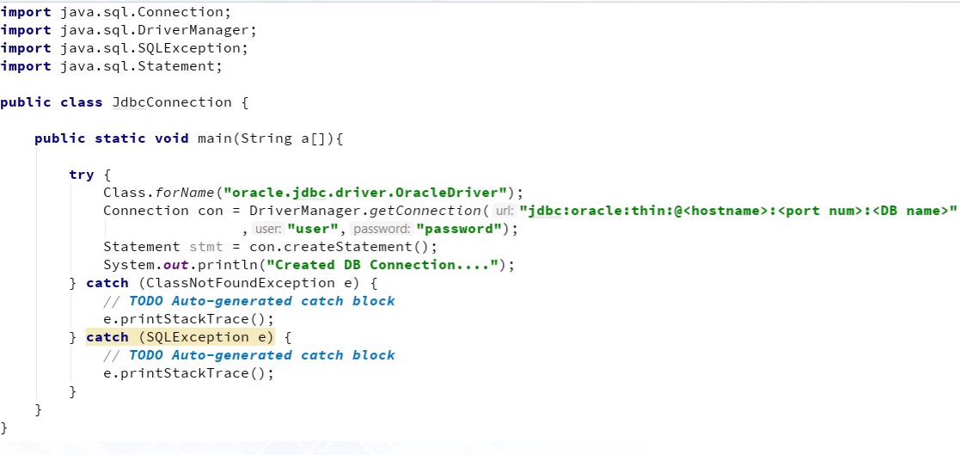

**SQL Exception**: is a checked exception.

Question: given an Employee table with EmpId, Salary. Find 2nd row with maximum salary.

Find managers, subordinate that report to manager. Find count of reporting employee for a given manager.

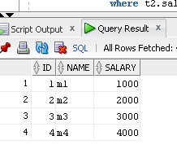

//highest salary data; => return 4000 line

select * from test t1 where t1.salary = (select max(t2.salary) from test t2)

//second highest salary => 3000

select max(t1.salary) as salary

from test t1

where t1.salary < (select max(t2.salary) from test t2)

//nth highest salary - here it would return 2000 – as it’s 3nd highest with N=3, =>2

select t1.salary

from test t1

where (2) = (select count (distinct t2.salary)

from test t2

where t2.salary > t1.salary)

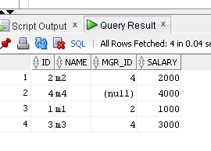

//Employee who are managers

select distinct t1.id as manager_id

from test t1, test t2

where t1.id = t2.mgr_id

## Spring JDBC

Create a DataSource, and then create springjdbctemplate by passing datasource in the constructor.

Then run sql to insert/update/query on the jdbctemplate.

<?xml version="1.0" encoding="UTF-8"?>

<beans xmlns="http://www.springframework.org/schema/beans"

xmlns:xsi="http://www.w3.org/2001/XMLSchema-instance"

xsi:schemaLocation="http://www.springframework.org/schema/beans

http://www.springframework.org/schema/beans/spring-beans-3.0.xsd ">

<!-- Initialization for data source -->

<bean id="dataSource"

class="org.springframework.jdbc.datasource.DriverManagerDataSource">

<property name="driverClassName" value="com.mysql.jdbc.Driver"/>

<property name="url" value="jdbc:mysql://localhost:3306/TEST"/>

<property name="username" value="root"/>

<property name="password" value="password"/>

</bean>

<!-- Definition for studentJDBCTemplate bean -->

<bean id="studentJDBCTemplate"

class="com.tutorialspoint.StudentJDBCTemplate">

<property name="dataSource" ref="dataSource" />

</bean>

</beans>

# Java Collections-Data Structures

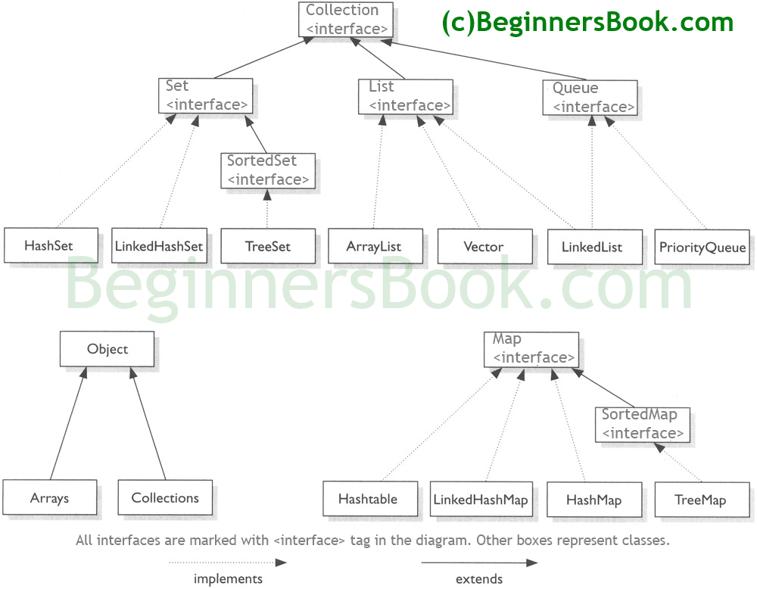

## Array

1. **What’s an array?**

* An arrangement of items at equally spaced addresses in computer memory. Elements are inserted and retrieved by accessing an index. Insert and lookup time by index is O(1) aka “Big O of 1”

1. **What can you tell me about the memory allocation of an array?**

* It is a continuous block of memory that is statically allocated with a specific size.

1. **If I have an array of primitive integers of capacity five, how many bytes of memory did I just allocate on the heap?**

* 20 bytes (4bytes per primitive integer x 5 elements)
  + Make sure the candidate clarifies how they arrived at their answer.
  + The candidate may mistake the size of a primitive integer with 1 byte or 2 bytes or 8 bytes. I give them half credit if they still multiply that number by 5.
  + The candidate may add some bytes to the 20 bytes because they are accounting for object allocation or the array size. Just let them know that they don’t have to worry about that for the question.

1. **If I want to retrieve index number two from this array, what are the operations in memory that are done?**

* Take the head pointer and add SIZE_OF_INT x 2, and read the next SIZE_OF_INT bytes.
  + Ideally, SIZE_OF_INT should be 4 bytes, but if they did not answer the previous question properly, they should still get half credit for this question for this question if they plugged in whatever value they thought is the SIZE_OF_INT
  + The candidate will most likely mistake “index number two” for the second element, which is not correct. They should get half credit if they make this mistake.

1. **If I have an array that holds five strings, how many bytes of memory did I just allocate on the heap?**

* 20 bytes on 32bit architecture or 40 bytes on 64bit architecture (SIZE_OF_REFERENCE x 5 elements)
  + The candidate may ask how long each string is. You should tell them, no strings have been allocated.
  + If the candidate assumes 32bit architecture, ask them if it will be the same for 64bit architecture.

Common API in Java

Arrays.sort(intArray, Collections.reverseOrder());

**List:** Ordered collection. May contain duplicates. Inserted and accessed by their position using index.

ArrayLIst, LinkedList, Vector

**Set:** does not contain duplicates. HashSet, TreeSet and LInkedHashSet

HashSet, which stores its elements in a **hash table**, is the best-performing implementation; however it makes no guarantees concerning the order of iteration.

TreeSet, which stores its elements in a red-black tree, orders its elements based on their values; it is substantially slower than HashSet.

LinkedHashSet, which is implemented as a hash table with a linked list running through it, orders its elements based on the order in which they were inserted into the set (insertion-order).

**Map:**  key value pairs. Cannot contain duplicates.HashMap, TreeMap, and LinkedHashMap.  
HashMap: it makes no guarantees concerning the order of iteration  
TreeMap: It stores its elements in a red-black tree, orders its elements based on their values; it is substantially slower than HashMap.  
LinkedHashMap: It orders its elements based on the order in which they were inserted into the set (insertion-order).

**What are the changes in Collections framework in Java 8?**

There are several changes in Collections Framework in Java 8 mostly influenced by the inclusion of [Lambda expression in Java 8](http://netjs.blogspot.com/2015/06/lambda-expression-in-java-8-overview.html) -

* **Stream API** - Stream can be obtained for Collection via the stream() and parallelStream() methods;  
  **As exp** if you have a list of cities in a List and you want to remove the duplicate cities from that list it can be done as

cityList = cityList.stream().distinct().collect(Collectors.toList());

* **ForEach loop** which can be used with Collection. **Spliterators** which are helpful in parallel processing where several threads can iterate/process part of the collection.
* New methods are added to Collections like replaceAll, getOrDefault, putIfAbsent in Map.
* HashMap, [LinkedHashMap](http://netjs.blogspot.com/2015/11/linkedhashmap-in-java.html) and ConcurrentHashMap.implementation is changed to reduce hash collisions. Instead of linked list a balanced tree is used to store the entries after a certain threshold is reached.
* **HashMap changes in Java 8**
* Though HashMap implementation provides constant time performance O(1) for get() and put() method but that is in the ideal case when the Hash function distributes the objects evenly among the buckets.
* **But the performance may worsen in the case hashCode() used is not proper and there are lots of hash collisions. As we know now that in case of hash collision entry objects are stored as a node in a linked-list and equals() method is used to compare keys. That comparison to find the correct key with in a linked-list is a linear operation so in a worst case scenario the complexity becomes O(n).**
* To address this issue in Java 8 hash elements use balanced trees instead of linked lists after a certain threshold is reached. Which means HashMap starts with storing Entry objects in linked list but after the number of items in a hash becomes larger than a certain threshold, the hash will change from using a linked list to a balanced tree, this will improve the worst case performance from O(n) to O(log n).

## HashMap

* Put is called with two parameters, a key and a value.
* A hash is taken from the key by calling its hashCode method.
* Convert the value returned by the hashCode (a primitive integer) and mod it by the size of the underlying array.
* Take the index returned by the previous operation and jump to that index in the array.
* If a value does not exist, add a Map.Entry object containing the key and value and add it to this location.
* If a value does exist, scan each Map.Entry to see if the new key equals any key that is currently in the chain.
* If it matches any key, replace the value in that Map.Entry, else add the new Map.Entry to the end of the chain.
  + The candidate might summarize the last three steps and call it “chaining” which is fine.
  + If the candidate refers to the underlying array as “a bucket”, ask him to define a bucket by asking him what kind of data structure is a bucket. If he doesn’t say array, he is incorrect – no partial credit.
* **HashMap** works on the principal of hashing.
* **Map.Entry interface** - This interface gives a map entry (key-value pair). HashMap in Java stores both key and value object, in bucket, as an object of Entry class which implements this nested interface Map.Entry.
* **hashCode()** -HashMap provides put(key, value) for **storing** and get(key) method for **retrieving** Values from HashMap. When put() method is used to store (Key, Value) pair, HashMap implementation **calls hashcode** on Key object to calculate a hash that is used to find a bucket where Entry object will be stored. When get() method is used to retrieve value, again key object is used to calculate a hash which is used then to find a bucket where that particular key is stored.
* **equals()** - equals() method is used to **compare objects for equality**. In case of HashMap key object is used for comparison, also using equals() method Map knows how to handle **hashing collision** (hashing collision means more than one key having the same hash value, thus assigned to the same bucket. In that case objects are stored in a linked list, refer [figure](http://netjs.blogspot.com/2015/05/how-hashmap-internally-works-in-java.html#hashmap) for more clarity.   
  Where hashCode method helps in finding the bucket where that key is stored, equals method helps in finding the right key as there may be more than one key-value pair stored in a single bucket.

**\*\*** Bucket term used here is actually an index of array, that array is called table in HashMap implementation. Thus table[0] is referred as bucket0, table[1] as bucket1 and so on.

**And the general contract of hashCode is -**

* Whenever it is invoked on the same object more than once during an execution of a Java application, the hashCode method must consistently return the same integer, provided no information used in equals comparisons on the object is modified. This integer need not remain consistent from one execution of an application to another execution of the same application.
* **If two objects are equal according to the equals(Object) method, then calling the hashCode method on each of the two objects must produce the same integer result.**
* It is not required that **if two objects are unequal according to the equals(java.lang.Object) method, then calling the hashCode method on each of the two objects must produce distinct integer results**. However, the programmer should be aware that producing distinct integer results for unequal objects may improve the performance of hash tables.

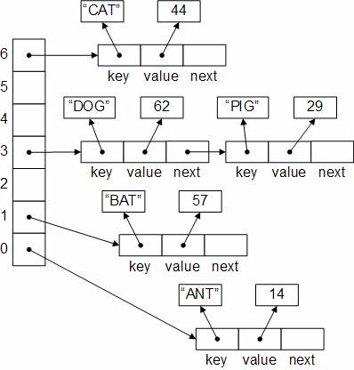

## LinkedHashMap

LinkedHashMap is also one of the implementation of the Map interface, apart from implementing Map interface LinkedHashMap also extends the [HashMap](http://netjs.blogspot.in/2015/05/how-hashmap-internally-works-in-java.html) class. So just like HashMap, **LinkedHashMap also allows one null key and multiple null values**.

How it differs from other implementations of the Map interface like HashMap and [TreeMap](http://netjs.blogspot.com/2015/11/treemap-in-java.html) is that *LinkedHashMap maintains the insertion order of the elements which means if we iterate a LinkedHashMap we'll get the keys in the order in which they were inserted in the Map*. Note that insertion order is not affected if a key is re-inserted into the map (*if a same key in inserted more than once the last time it was inserted will be taken into account*).

Map<String, String> cityTemperatureMap = new LinkedHashMap<String, String>();

cityTemperatureMap.put("Delhi", "24");

cityTemperatureMap.put("Mumbai", "32");

cityTemperatureMap.put(null, "26");

// iterating the map

for(Map.Entry<String, String> me : cityTemperatureMap.entrySet()){

System.out.println(me.getKey() + " " + me.getValue());

}

**Points to note here**

* It can be seen that the insertion order is maintained. While iterating the LinkedHashMap elements are displayed in the order they were inserted.
* Even though two null keys were inserted only one is stored (only one null key is allowed in map).
* Two values were inserted with the same key "Chennai" which results in the overwriting of the old value with the new value (as the calculated hash will be the same for the keys). Thus the last one is displayed while iterating the values.

LinkedHashMap can be used to Least Recently Used cache –

Where access order is passed in the constructor.

Map<String, String> cityMap = new LinkedHashMap<String, String>(16, 0.75f, true);

Here it can be seen that **access-order** parameter is passed as true, that means ordering mode is Access order, if passed as **false** that would mean ordering mode is insertion order.

LinkedHashMap is not thread-safe, is fail fast (if structurally modified at any time after the iterator is created then the iterator will throw **ConcurrentModificationExcpetion**.

## TreeMap

TreeMap is also one of the implementation of the Map interface like HashMap and [LinkedHashMap](http://netjs.blogspot.com/2015/11/linkedhashmap-in-java.html).

How it differs from other implementations of the Map interface like [HashMap](http://netjs.blogspot.in/2015/05/how-hashmap-internally-works-in-java.html) and LinkedHashMap is that **objects in TreeMap are stored in sorted order**. The elements are ordered using their natural ordering or a comparator can be provided at map creation time to provide custom ordering

Map<String, String> cityTemperatureMap = new TreeMap<String, String>();

cityTemperatureMap.put("Kolkata", "28");

cityTemperatureMap.put("Chennai", "36");

// iterating the map

for(Map.Entry<String, String> me : cityTemperatureMap.entrySet()){

System.out.println(me.getKey() + " " + me.getValue());

}

Though HashMap and LinkedHashMap allow one null as key, **TreeMap doesn't allow null as key**. Any attempt to add null in a TreeMap will result in a **NullPointerException**.

TreeMap is not thread-safe, is fail fast (if structurally modified at any time after the iterator is created then the iterator will throw **ConcurrentModificationExcpetion**.

SortedMap m = Collections.synchronizedSortedMap(new TreeMap(...));

//in case of using custom sorter;

Map<String, String> cityTemperatureMap = new TreeMap<String, String>(new TreeComparator());

//Comparator class

class TreeComparator implements Comparator<String>{

@Override

public int compare(String str1, String str2) {

return str2.compareTo(str1);

}

## ArrayList vs LinkedList

ArrayList is implemented as a resizable array. As more elements are added to ArrayList, its size is increased dynamically. It's elements can be accessed directly by using the get and set methods, since ArrayList is essentially an array.

LinkedList is implemented as a double linked list. Its performance on add and remove is better than Arraylist, but worse on get and set methods.

ArrayList is a better choice if your program is thread-safe. Vector and ArrayList require more space as more elements are added. Vector each time doubles its array size, while ArrayList grow 50% of its size each time. LinkedList, however, also implements Queue interface which adds more methods than ArrayList and Vector, such as offer(), peek(), poll(), etc.

Singly list has limitations which are overcome by Doubly list:

Singlylist: insertion at the front in O(1), insertion at other position O(n), need reference to previous node to insert next node, can only traverse in forward direction.

**Circular list**- in doubly linked list – point last node’s next to first, and first node’s previous to last.

Can always traverse back and forth, but drawback is infinite loop.

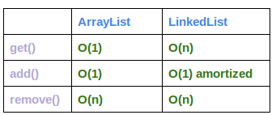

ArrayList has:

O(n) time complexity for arbitrary indices of add/remove,

but O(1) for the operation at the end of the list.

LinkedList has:

O(n) time complexity for arbitrary indices of add/remove, but O(1) for operations at end/beginning of the List.

**How does ArrayList grow dynamically**

When we add an element to an ArrayList it first verifies whether it has that much capacity in the array to store new element or not, in case there is not then the new capacity is calculated which is 50% more than the old capacity and the array is increased by that much capacity (Actually uses Arrays.copyOf which returns the original array increased to the new length).

**What happens when element is removed**

When elements are removed from an ArrayList using either remove(int i) (i.e using index) or remove(Object o), in the underlying array the gap created by the removal of an element has to be filled. That is done by Shifting any subsequent elements to the left (subtracts one from their indices). **System.arrayCopy** method is used for that.

## Singly Linked List

**class** SinglyLinkedList {

**private** Node head;

/*

* Add new Node

*/

**public** **void** addNode(**int** d){

Node newNode = **new** Node(d);

**if**(head == **null**){

head = newNode;

**return**;

}

Node current = head;

**while**(current.next != **null**){

current = current.next;

}

current.next=newNode;

}

**public** **int** legnthOfList(){

**int** count = 0;

**if**(head == **null**) //assume it's head node or empty list

**return** count;

**else** **if** (head.next == **null**)

**return** 1;

**else**

{

count =1;

Node current = head;

**while**(current.next != **null**){

count +=1;

current = current.next;

}

}

**return** count;

}

**public** **int** legnthOfListRecusively(){

**return** LengthRecursively(head);

}

**public** **int** LengthRecursively(Node node){

**int** count = 0;

**if**(node == **null**) //assume it's head node or empty list

**return** count;

**else** **if** (node.next == **null**)

**return** 1;

**else**

count = 1 + LengthRecursively(node.next);

**return** count;

}

/**

* Print singly link list in the natual order

*/

**public** **void** printLinkedList(){

**if**(head == **null**)

**return**;

Node current = head;

**while**(current != **null**){

System.***out***.println("Data: " + current.data);

current = current.next;

}

}

**public** **void** reverseAndPrintLinkedList(){

Node newHead = reverseLinkedList();

head=newHead;

printLinkedList();

}

**public** Node reverseLinkedList()

{

Node currentNode = head;

// For first node, previousNode will be null

Node previousNode=**null**;

Node nextNode;

**while**(currentNode!=**null**){

nextNode=currentNode.next;

//reversing the link

currentNode.next=previousNode;

//moving currentNode and previousNode by 1 node

previousNode=currentNode;

currentNode=nextNode;

}

**return** previousNode;

}

**public** **void** middleNodeinList(){

Node middle = findMiddleNode();

System.***out***.println("Middle Node is: " + middle.data);

}

**public** Node findMiddleNode(){

Node slowPointer, fastPointer;

slowPointer = fastPointer = head;

**while**(fastPointer !=**null**) {

fastPointer = fastPointer.next;

**if**(fastPointer != **null** && fastPointer.next != **null**) {

slowPointer = slowPointer.next;

fastPointer = fastPointer.next;

}

}

**return** slowPointer;

}

**public** Node nthFromLastNode(**int** n)

{

Node firstPtr=head;

Node secondPtr=head;

**for** (**int** i = 0; i < n; i++) {

firstPtr=firstPtr.next;

}

**while**(firstPtr!=**null**)

{

firstPtr=firstPtr.next;

secondPtr=secondPtr.next;

}

**return** secondPtr;

}

// Reverse linked list in pair

**public** **void** reverseLinkedListInPairs() {

Node currentNode = head;

/* Traverse only till there are atleast 2 nodes left */

**while** (currentNode != **null** && currentNode.next != **null**) {

/* Swap the data */

**int** k = currentNode.data;

currentNode.data = currentNode.next.data;

currentNode.next.data = k;

currentNode = currentNode.next.next;

}

}

}

## Doubly Linked List

**public** **void** addFirst(**int** d){

DNode node = **new** DNode(d);

**if**(head == **null**){

head = node;

head.next=**null**;

head.prev=**null**;

}

**else**{

node.next = head;

head.prev = node;

head=node;

}

}

/**

* Iterate though current.next != null then just add newNode as curr.next, set prev link.

* **@param** d

*/

**public** **void** addLast(**int** d){

DNode node = **new** DNode(d);

**if**(head == **null**){

head = node;

head.next=**null**;

head.prev=**null**;

}

**else**{

DNode current = head;

**while**(current.next != **null**){

current = current.next;

}

current.next = node;

node.prev = current;

}

}

**public** **void** reverse() {

DNode temp = **null**;

DNode current = head;

/* swap next and prev for all nodes of

doubly linked list */

**while** (current != **null**) {

temp = current.prev;

current.prev = current.next;

current.next = temp;

current = current.prev;

}

/* Before changing head, check for the cases like empty

list and list with only one node */

**if** (temp != **null**) {

head = temp.prev;

}

}

**Remove Duplicates From linked list:**

Keep 2 pointers—one for outer loop and 2nd for inner loop (p2 = p1.next )

/* Function to remove duplicates from an

       unsorted linked list */

    void remove_duplicates() {

        Node ptr1 = null, ptr2 = null, dup = null;

        ptr1 = head;

        /* Pick elements one by one */

        while (ptr1 != null && ptr1.next != null) {

            ptr2 = ptr1;

            /* Compare the picked element with rest

                of the elements */

            while (ptr2.next != null) {

                /* If duplicate then delete it */

                if (ptr1.data == ptr2.next.data) {

                    /* sequence of steps is important here */

                    dup = ptr2.next;

                    ptr2.next = ptr2.next.next;

                    System.gc();

                } else /* This is tricky */ {

                    ptr2 = ptr2.next;

                }

            }

            ptr1 = ptr1.next;

        }

    }

## Tree

public int heightOfBinaryTree(Node node)

{

if (node == null)

{

return 0;

}

else

{

return 1 +

Math.max(heightOfBinaryTree(node.left),

heightOfBinaryTree(node.right));

}

}

Given a (Input) Binary tree, Find the size of the tree.

* Very Sim­ple solution
* Start from the root.
* Size = 1 (for the root) + Size Of left Sub-Tree + Size Of right Sub-Tree
* solve the left sub-tree and right sub-tree recursively.

**Time Com­plex­ity : O(n)**

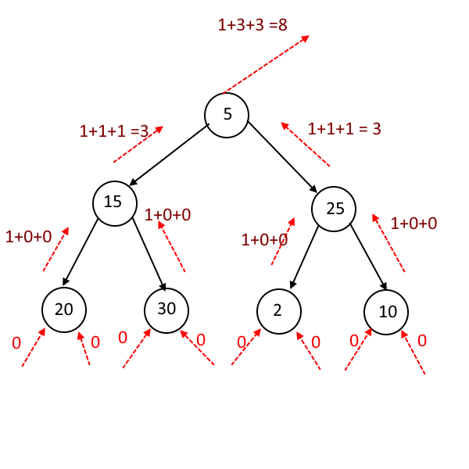

|  |  |
| --- | --- |
|  | |
|  | | if(root==null){ |
|  | | return 0; |
|  | | } |
| |  | | --- | | public static void main(String args[]){ | |  | Node root = new Node(5); | |  | root.left = new Node(15); | |  | root.right = new Node(25); | |  | root.left.left = new Node(20); | |  | root.left.right = new Node(30); | |  | root.right.left = new Node(2); | |  | root.right.right = new Node(10); | |  |  | |  | SizeofTree t = new SizeofTree(); | |  | System.out.println("Size of the Tree is : " + t.getSize(root)); | |  | } | | | return 1 + getSize(root.left) + getSize(root.right); |
|  | | } |
| |  | | --- | | public int getSize(Node root){ | |  | if(root==null){ | |  | return 0; | |  | } | |  | return 1 + getSize(root.left) + getSize(root.right); | |  | } | |
|  | int data; |
|  | Node left; |
|  | Node right; |
|  | public Node(int data){ |
|  | this.data = data; |
|  | this.left = null; |

|  |  |  |  |  |  |  |  |  |  |  |  |  |  |  |  |  |  |  |  |  |  |  |  |  |  |  |  |  |  |  |  |  |  |  |  |  |  |  |  |  |  |  |  |  |  |  |  |  |  |  |  |  |  |  |  |  |  |  |  |  |  |  |  |  |  |  |  |  |  |  |  |  |  |  |  |  |  |  |  |  |  |  |  |  |  |  |  |  |  |  |  |  |  |  |  |  |  |  |  |
| --- | --- | --- | --- | --- | --- | --- | --- | --- | --- | --- | --- | --- | --- | --- | --- | --- | --- | --- | --- | --- | --- | --- | --- | --- | --- | --- | --- | --- | --- | --- | --- | --- | --- | --- | --- | --- | --- | --- | --- | --- | --- | --- | --- | --- | --- | --- | --- | --- | --- | --- | --- | --- | --- | --- | --- | --- | --- | --- | --- | --- | --- | --- | --- | --- | --- | --- | --- | --- | --- | --- | --- | --- | --- | --- | --- | --- | --- | --- | --- | --- | --- | --- | --- | --- | --- | --- | --- | --- | --- | --- | --- | --- | --- | --- | --- | --- | --- | --- | --- |
| Binary Search Tree **The basic idea is that at each node we compare with the value being inserted.**  **If the value is lesser then we traverse through the left sub tree and if the value is greater we**  **traverse through the right subtree**  Image result for Binary search tree   |  | | --- | | public class Node<T> { |  |  |  | | --- | --- | | 2 | public int value; |  |  |  | | --- | --- | | 3 | public Node left; |  |  |  | | --- | --- | | 4 | public Node right; |  |  |  | | --- | --- | | 5 |  |  |  |  | | --- | --- | | 6 | public Node(int value) { |  |  |  | | --- | --- | | 7 | this.value = value; |  |  |  | | --- | --- | | 8 | } |  |  |  | | --- | --- | | 9 |  |  |  |  | | --- | --- | | 10 | } | |  |  | | public class BinarySearchTree { | | |  |  |  | | --- | --- | | 2 | public Node root; |  |  |  | | --- | --- | | 3 |  |  |  |  | | --- | --- | | 4 | public void insert(int value){ |  |  |  | | --- | --- | | 5 | Node node = new Node<>(value); |  |  |  | | --- | --- | | 6 |  |  |  |  | | --- | --- | | 7 | if ( root == null ) { |  |  |  | | --- | --- | | 8 | root = node; |  |  |  | | --- | --- | | 9 | return; |  |  |  | | --- | --- | | 10 | } |  |  |  | | --- | --- | | 11 |  |  |  |  | | --- | --- | | 12 | insertRec(root, node); |  |  |  | | --- | --- | | 13 |  |  |  |  | | --- | --- | | 14 | } |  |  |  | | --- | --- | | 15 |  |  |  |  | | --- | --- | | 16 | private void **insertRec**(Node latestRoot, Node node){ |  |  |  | | --- | --- | | 17 |  |  |  |  | | --- | --- | | 18 | if ( **latestRoot.value > node.value**){ |  |  |  | | --- | --- | | 19 |  |  |  |  | | --- | --- | | 20 | if ( latestRoot.left == null ){ |  |  |  | | --- | --- | | 21 | latestRoot.left = node; |  |  |  | | --- | --- | | 22 | return; |  |  |  | | --- | --- | | 23 | } |  |  |  | | --- | --- | | 24 | else{ |  |  |  | | --- | --- | | 25 | **insertRec(latestRoot.left, node);** |  |  |  | | --- | --- | | 26 | } |  |  |  | | --- | --- | | 27 | } |  |  |  | | --- | --- | | 28 | **else{** |  |  |  | | --- | --- | | 29 | if (latestRoot.right == null){ |  |  |  | | --- | --- | | 30 | latestRoot.right = node; |  |  |  | | --- | --- | | 31 | return; |  |  |  | | --- | --- | | 32 | } |  |  |  | | --- | --- | | 33 | else{ |  |  |  | | --- | --- | | 34 | **insertRec(latestRoot.right, node);** |  |  |  | | --- | --- | | 35 | } |  |  |  | | --- | --- | | 36 | } |  |  |  | | --- | --- | | 37 | } |  |  |  | | --- | --- | | 38 | } | | 12 |

|  |
| --- |
| /** |

|  |  |
| --- | --- |
| 2 | * Returns the **minimum** value in the Binary Search Tree. |

|  |  |
| --- | --- |
| 3 | */ |

|  |  |
| --- | --- |
| 4 | public int findMinimum(){ |

|  |  |
| --- | --- |
| 5 | if ( root == null ){ |

|  |  |
| --- | --- |
| 6 | return 0; |

|  |  |
| --- | --- |
| 7 | } |

|  |  |
| --- | --- |
| 8 | Node currNode = root; |

|  |  |
| --- | --- |
| **9** | **while(currNode.left != null){** |

|  |  |
| --- | --- |
| **10** | **currNode = currNode.left;** |

|  |  |
| --- | --- |
| **11** | **}** |

|  |  |
| --- | --- |
| 12 | return currNode.value; |

|  |  |
| --- | --- |
| 13 | } |

|  |  |
| --- | --- |
| 14 |  |

|  |  |
| --- | --- |
| 15 | /** |

|  |  |
| --- | --- |
| 16 | * Returns the **maximum** value in the Binary Search Tree |

|  |  |
| --- | --- |
| 17 | */ |

|  |  |
| --- | --- |
| 18 | public int findMaximum(){ |

|  |  |
| --- | --- |
| 19 | if ( root == null){ |

|  |  |
| --- | --- |
| 20 | return 0; |

|  |  |
| --- | --- |
| 21 | } |

|  |  |
| --- | --- |
| 22 |  |

|  |  |
| --- | --- |
| 23 | Node currNode = root; |

|  |  |
| --- | --- |
| **24** | **while(currNode.right != null){** |

|  |  |
| --- | --- |
| **25** | **currNode = currNode.right;** |

|  |  |
| --- | --- |
| **26** | **}** |

|  |  |
| --- | --- |
| 27 | return currNode.value; |

|  |  |
| --- | --- |
| 28 | } |

## Heap – (min Heap, max Heap)

## Graph Data Structure

## Trie

# Sorting Algorithm

|  |  |  |  |  |  |
| --- | --- | --- | --- | --- | --- |
| **Algorithm** | **Data structure** | **Time complexity:Best** | **RunTime** |  |  |
| Merge sort | Array | O(n log(n)) |  |  |  |
| Heap sort | Array | O(n log(n)) |  |  |  |
| Smooth sort | Array | O(n) |  |  |  |
| Bubble sort | Array | O(n) | O(n2) |  |  |

Insertion Sort Array O(n2)

## Bubble Sort

In bubble sort, we start at the beginning of the array and swap the first two elements if the first is greater than the second. Then, we go to the next pair, and so on, continuously making sweeps of the array until it is sorted. In doing so, the smaller items slowly "bubble" up to the beginning of the list.

It iteratively compares each element (starting first to last elements) by comparing with adjacent element and swapping them if they are not in order. Each iteration puts the ***next larger*** value to its correct place.

Best case: O(n)

Average case: O(nˆ2)

Worst case: O(nˆ2)

Memory: 0(1)

## Selection Sort

Selection sort is the child's algorithm: simple, but inefficient. Find the smallest element using a linear scan

and move it to the front (swapping it with the front element). Then, find the second smallest and move it,

again, doing a linear scan. Continue doing this until all the elements are in place.

Bestcase:O(N^2)  
Averagecase:O(N^2)  
Worst case : O(N^2)

**Memory:** 0(1)

## Merge Sort

Merge sort divides the array in half, sorts each of those halves, and then merges them back together. Each of those halves has the same sorting algorithm applied to it. Eventually, you are merging just two single element arrays. It is the "merge" part that does all the heavy lifting.

**Best for Linked List merge as we don’t have to add extra space due to random memory for list vs. array;s continuous memory location.**

**Bestcase:** O(nlogn) Or O(n)  
**Averagecase:** O(nlogn)  
**Worst case:** O(nlogn)

Memory: it Depends

## Insertion Sort

**Insertion Sort** – sort an array like a playing cards in hand. – pick a one and iterate through each to find the correct slot. It can start with 2nd element, compare with first one. Then swap if needed. Then, pick 3rd and compare with 2nd, 1st etc.

**Best case:** O(n)

**Average case:** O(nˆ2)

**Worst case:** O(nˆ2)

**Algorithm**  
// Sort an arr[] of size n  
insertionSort(arr, n)  
Loop from i = 1 to n-1.  
……a) Pick element arr[i] and insert it into sorted sequence arr[0…i-1]

**Time Complexity:** O(n*n)

**Auxiliary Space:**O(1)

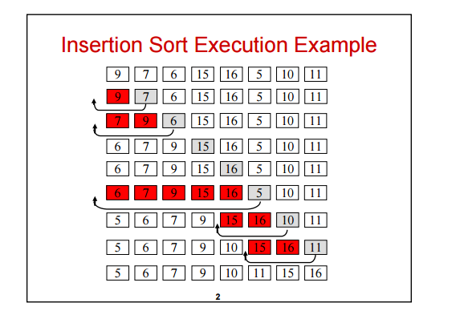

// Java program for implementation of Insertion Sort

class InsertionSort

{

    /*Function to sort array using insertion sort*/

    void sort(int arr[])

    {

        int n = arr.length;

        for (int i=1; i<n; ++i)

        {

            int key = arr[i];

            int j = i-1;

            /* Move elements of arr[0..i-1], that are

               greater than key, to one position ahead

               of their current position */

            while (j>=0 && arr[j] > key)

            {

                arr[j+1] = arr[j];

                j = j-1;

            }

            arr[j+1] = key;

        }

    }

    /* A utility function to print array of size n*/

    static void printArray(int arr[])

    {

        int n = arr.length;

        for (int i=0; i<n; ++i)

            System.out.print(arr[i] + " ");

        System.out.println();

    }

    // Driver method

    public static void main(String args[])

    {

        int arr[] = {12, 11, 13, 5, 6};

        InsertionSort ob = new InsertionSort();

        ob.sort(arr);

        printArray(arr);

    }

} /* This code is contributed by Rajat Mishra. */

## Quick Sort:

**Quick Sort:**  a.k.a partition exchange sort which is using Divide and Conquer algorithm. It picks an element as pivot and partitions the given array around the picked pivot.

**Quick Sort** I **Runtime:** O(nlog(n)) **average,** O(n2 ) **worst case. Memory:** 0(log(n)).

In quick sort we pick a random element and partition the array, such that all numbers that are less than the partitioning element come before all elements that are greater than it. The partitioning can be performed efficiently through a series of swaps (see below).

If we repeatedly partition the array (and its sub-arrays) around an element, the array will eventually become sorted. However, as the partitioned element is not guaranteed to be the median (or anywhere near the median), our sorting could be very slow. This is the reason for the 0(n2) worst case runtime.

## Binary Search

**Binary Search** = repeatedly dividing the search interval in half.

Time Complexity of a Linear Search is O(n).

The idea of binary search is to use the information that the array is sorted and reduce the time complexity to O(Logn).

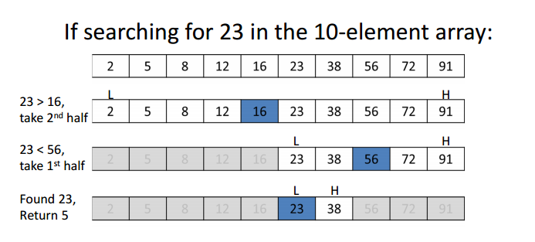

// Java implementation of recursive Binary Search

class BinarySearch

{

    // Returns index of x if it is present in arr[l..r], else

    // return -1

    int binarySearch(int arr[], int l, int r, int x)

    {

        if (r>=l)

        {

            int mid = l + (r - l)/2;

            // If the element is present at the middle itself

            if (arr[mid] == x)

               return mid;

            // If element is smaller than mid, then it can only

            // be present in left subarray

            if (arr[mid] > x)

               return binarySearch(arr, l, mid-1, x);

            // Else the element can only be present in right

            // subarray

            return binarySearch(arr, mid+1, r, x);

        }

        // We reach here when element is not present in array

        return -1;

    }

    // Driver method to test above

    public static void main(String args[])

    {

        BinarySearch ob = new BinarySearch();

        int arr[] = {2,3,4,10,40};

        int n = arr.length;

        int x = 10;

        int result = ob.binarySearch(arr,0,n-1,x);

        if (result == -1)

            System.out.println("Element not present");

        else

            System.out.println("Element found at index "+result);

    }

}

## Heap Sort

# Recursion

*Recursion* is a basic programming technique you can use in Java, in which a method calls itself to solve some problem

private static long factorial(int n)

{

if (n == 1)

return 1;

else

return n * factorial(n-1);

}

# Spring

Spring Framework: Light weight framework, loose coupling, integrated framework to address complexity of the enterprise application development. Lightweight, IOC, AOP, container, MVC, transaction management.

IOC, Dependency Injection: higher level components DO Not depend on smaller components. Smaller/lower level components are injects/created to the higher level as dependency. IOC container creates those objects (wire/configure via xml file) and handed over. Container manages complete Lifecyle from construction till destruction.

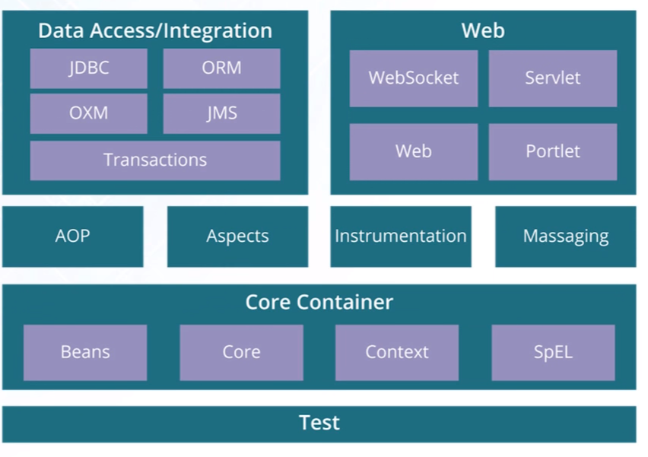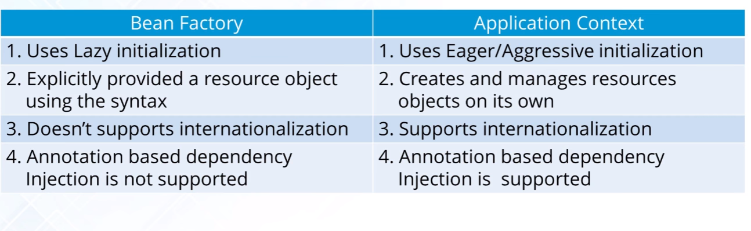

@Component:

@Controller

@Repository: classes to represent Persistence Layer

@Service:

@Required: required during injection in the spring config.

@Autowired:

@Qualifier:

@RequestMapping: to map incoming HTTP requests with method.

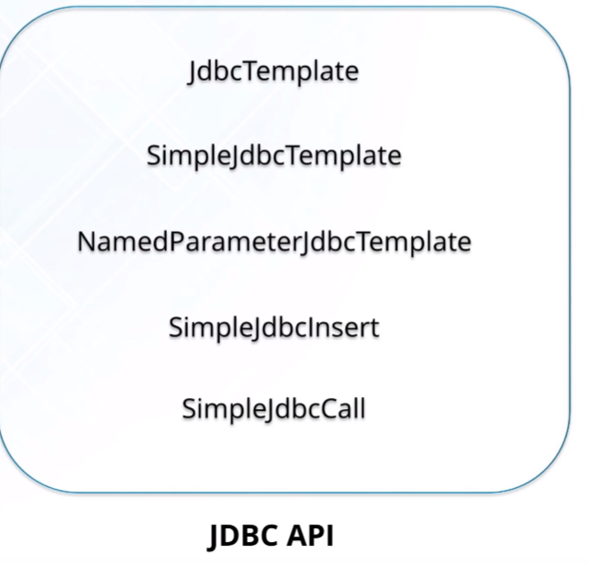

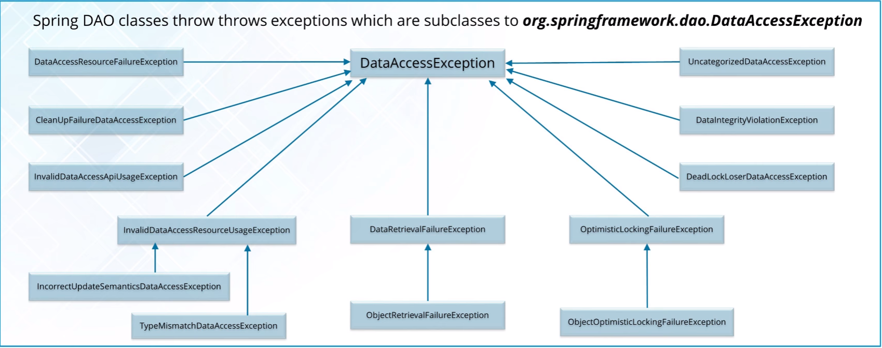

**Spring AOP:**

**Aspect**: concern with to weave in.

**Join Point**: A point during execution of a program such as execution of a method or handling of the exception.

**Advice**: Action taken by an aspect at a particular join point. Such as: around, before, after

Spring AOP vs AspectJ:

**Spring AOP**: **Runtime** weaving through **Proxy**. Support only **method** level PointCut. DTD Based.

**AspectJ**: compile time weaving through AspectJ, Support Field Level pointcuts. Schema based and Annotation configuration.

# REST

Representational State Transfer. – architectural style for designing network applications.

Stateless, client-server protocol.

Whenever you ask for a resource from REST API and provide http header “**accept: application/json**“, you will get back the json representation of resource.

@RestController = @Controller + @ResponseBody

@RestController

public class EmployeeRESTController

{

 @RequestMapping(value = "/employees")

    public EmployeeListVO getAllEmployees()

    {

}

@RequestMapping(value = "/employees/{id}")

   public ResponseEntity<EmployeeVO> getEmployeeById (@PathVariable("id") int id)

   {

}

}

}

@SpringBootApplication

**public** **class** Application {

**public** **static** **void** main(String[] args) {

SpringApplication.*run*(Application.**class**, args);

}

}

# JSON/Protobuff

JSON stands for **JavaScript Object Notation**. JSON objects are used for transferring data between server and client.

JSON data: It basically has key-value pairs:

var chaitanya = {

"firstName" : "Chaitanya",

"lastName" : "Singh",

"age" :  "28"

};

* It is light-weight
* It is language independent and so scalable with diff platform (Ruby, Python,Perl, Java, Ajax etc)
* Easy to read and write
* Text based, human readable data exchange format
* Standard Structure
* JSON Parser available to marshal and unmarshal data.

XML is lot more verbose with elements & attribute tagging.

# Scala

General programming languages that Supports both object oriented and functional programming. It helps to be more productive due to less code, concise.

Statically type – binds type to a variable for entire scope.

Dynamically types – bind the type to the actual value referenced by a variable.

It is first dynamically assigned (type inference) but once it’s assigned it can’t be changed. i.e. int can’t be reassigned to string.

Everything in Scala is an Object (no primitives). Functions are objects in Scala too.

val – immutable

var - Mutable

# Map Reduce

Map Reduce is processing distributed data in many nodes – is a pattern used by Hadoop. It has 3 stages – Map, Shuffle & Reduce.

Word Count in file: **Map** = on each node, count words. create a map of each word and its counter is 1. This is very efficient since stateless counting. Simply count each word one time.

**Shuffle**: bring together related/similar words on same node or nearly each other in a network.

**Reduce**: Collection of similar words and reduce it. Reduce the map to similar words together and count them together.

# Hadoop

Is a framework that allows distributed processing of large data on cluster of commodity computers?

HDFS: 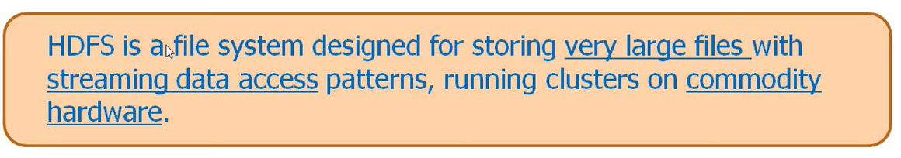

Not a good fit if low latency required very small files and too many arbitrary updates to files. Very small files will create too much meta data configuration.

Master- slave configuration (Name Node (Job Tracker) and Data Nodes (Task Tracker)).

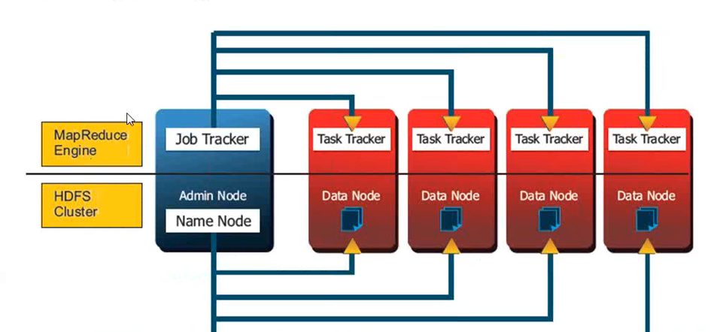

Name Node: it maintains and manages the blocks which are presents on the DataNode.

It does not do any work but maintains config like for data nodes. This hardware must be really reliable.

Data Nodes: slave nodes which are deployed on each machine and provide actual storages. These are responsible for serving read and write requests for the clients.

HDFS Clients- makes interaction via Name Node/Job Tracker.

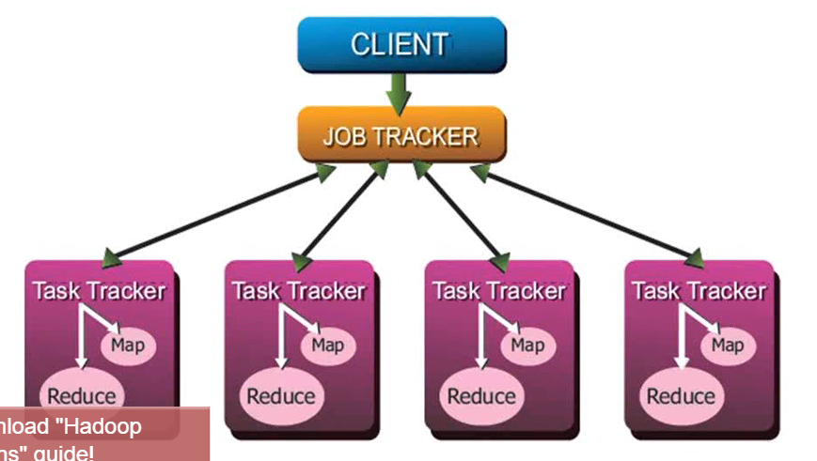

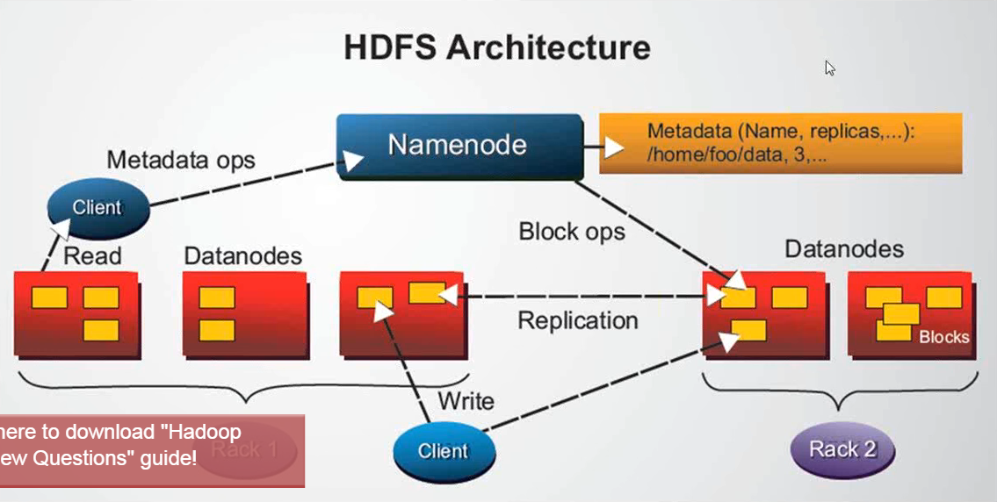

Client interacts with Name Node first (to lookup Metadata) and then Data Nodes directly.

Name Nodes keeps data in memory but second name node reads data from RAM and writes to file system. If Name Node crashes then 2nd Name Node does not take over.

In Hadoop 2 – it’s Active/Passive Setup where 2nd Name Node can take over.

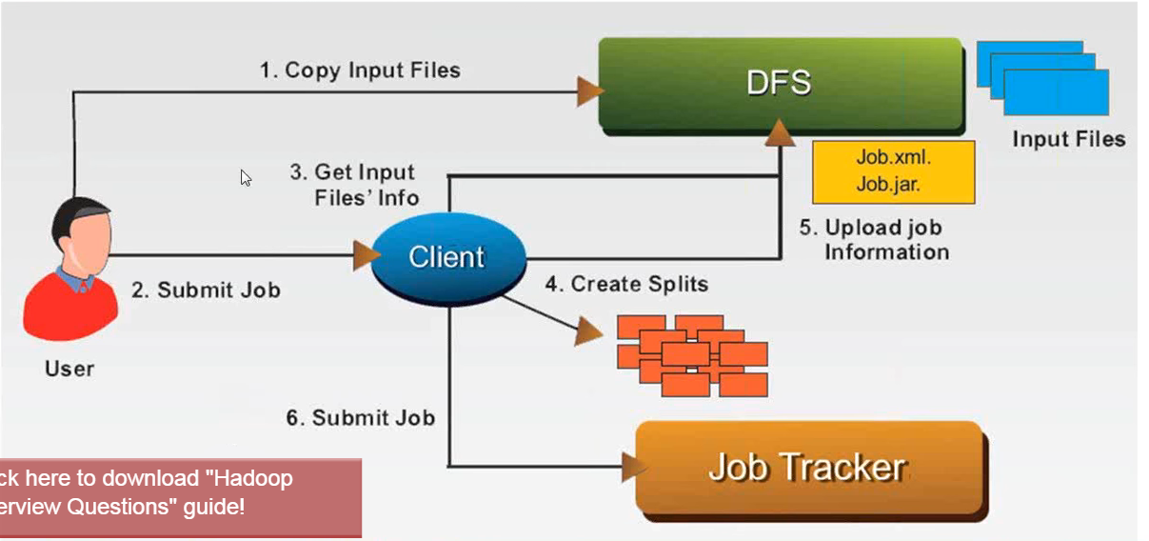

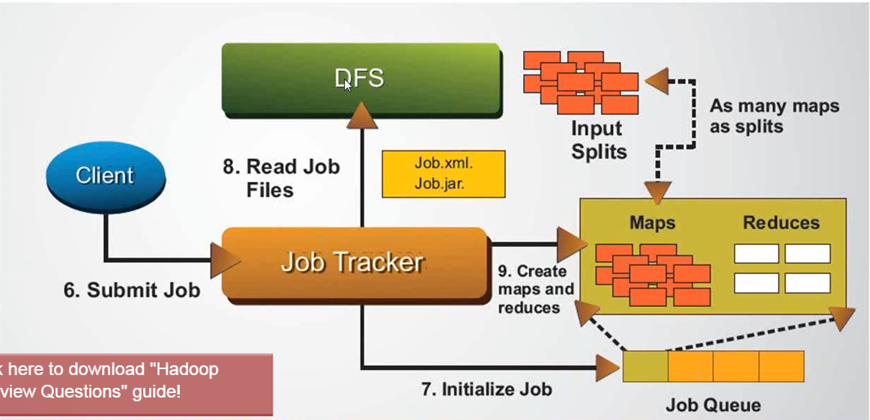

#9: once Job Trackers receives configuration from DFS, it sends jobs to Data Nodes to perform map-reduce.

Job Tracker assigns tasks to Task Trackers. As Task Trackers are running, they are sending Heartbeat to Job Tracker.

# Apache Kafka

Distributed publish-subscribe messaging system, partitions real time consumption across cluster of machines. Replicated, reliability, durability, fault tolerant, scale up/down without downtime.

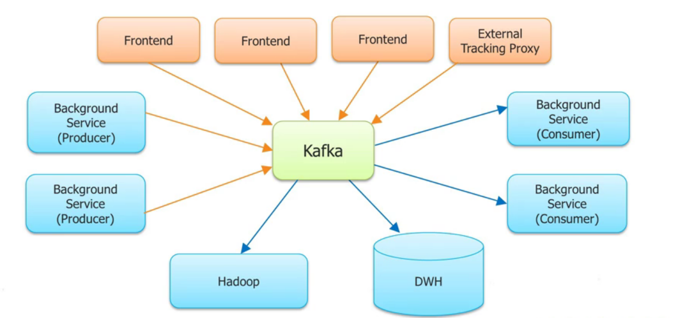

High throughput with modest hardware

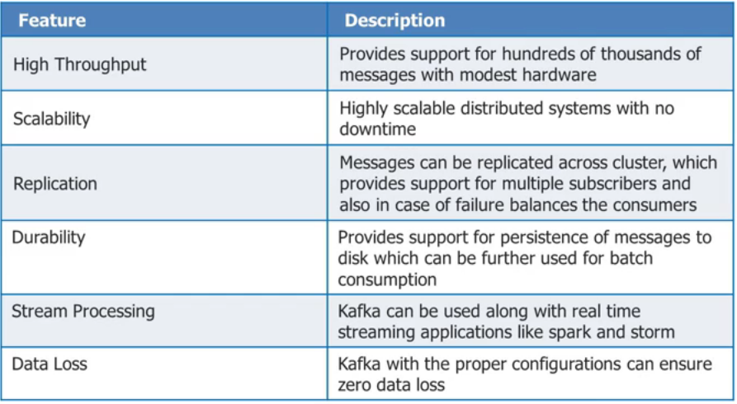

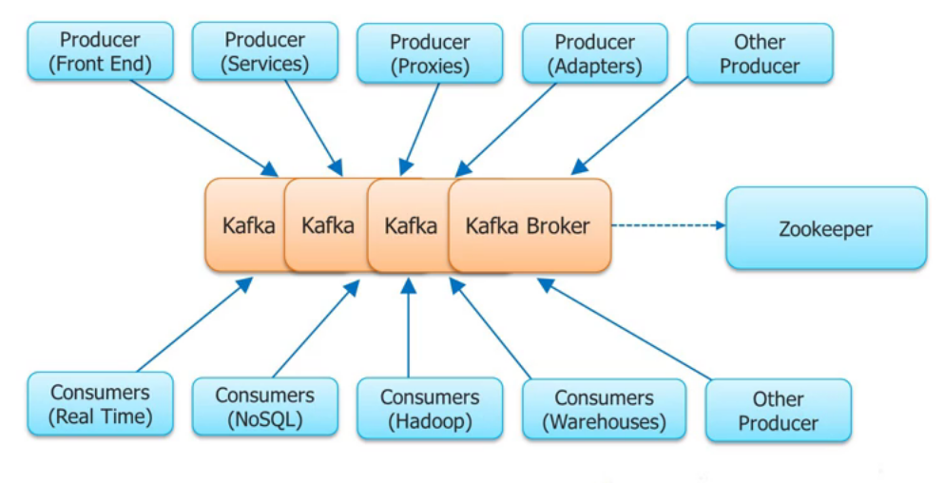

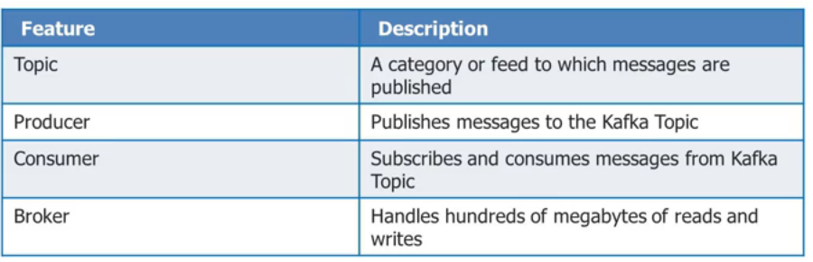

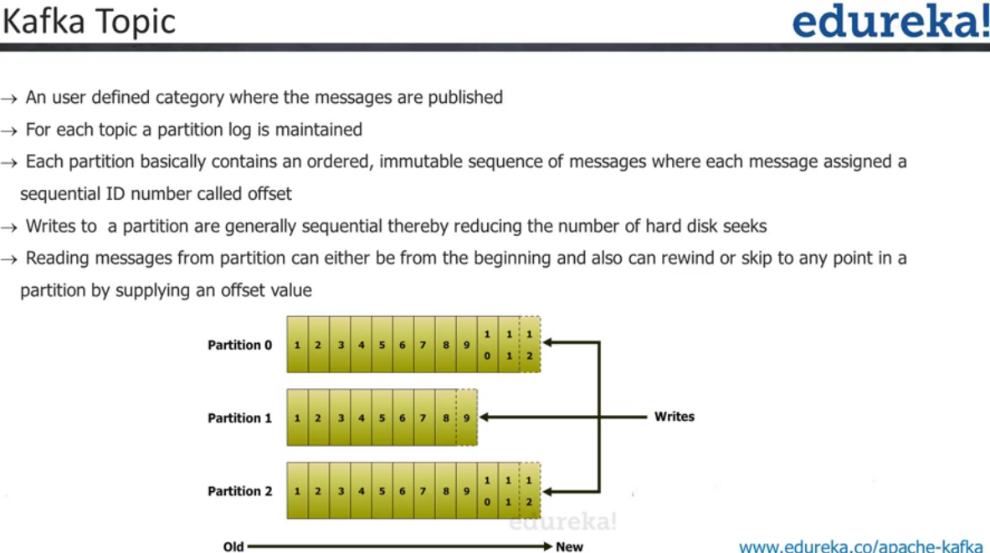

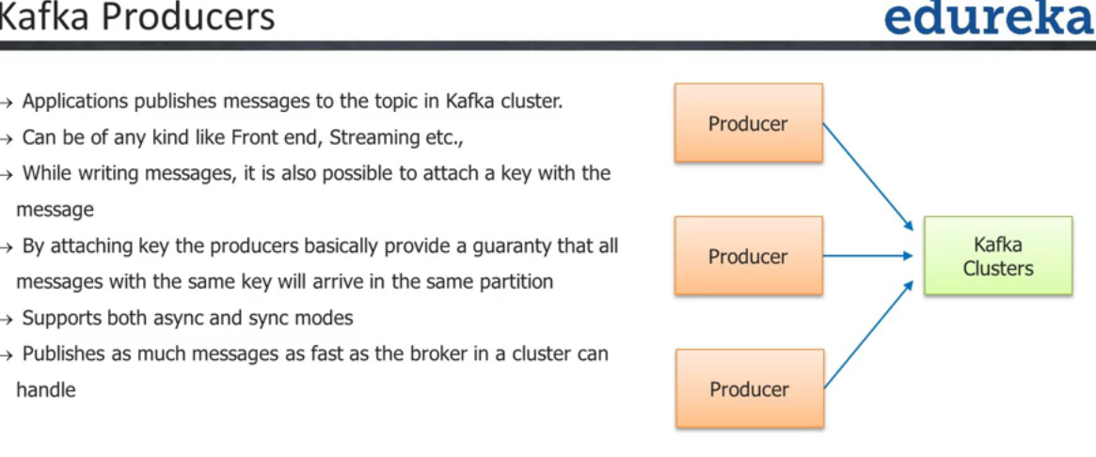

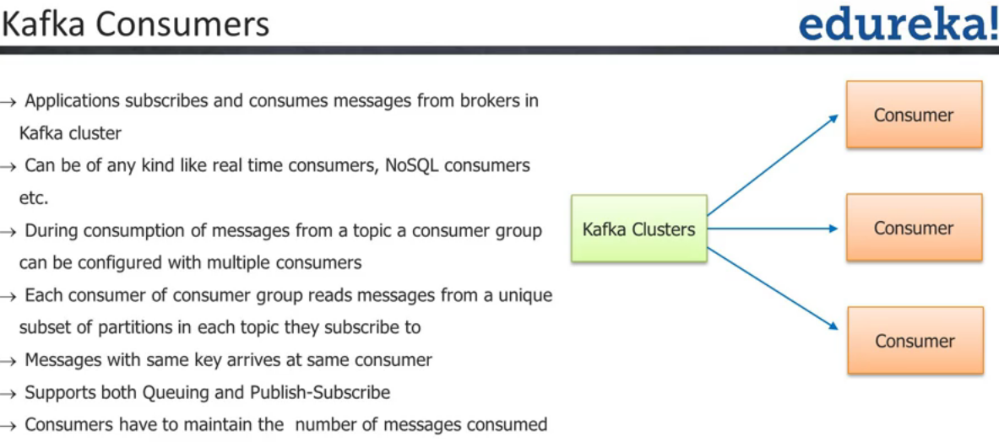

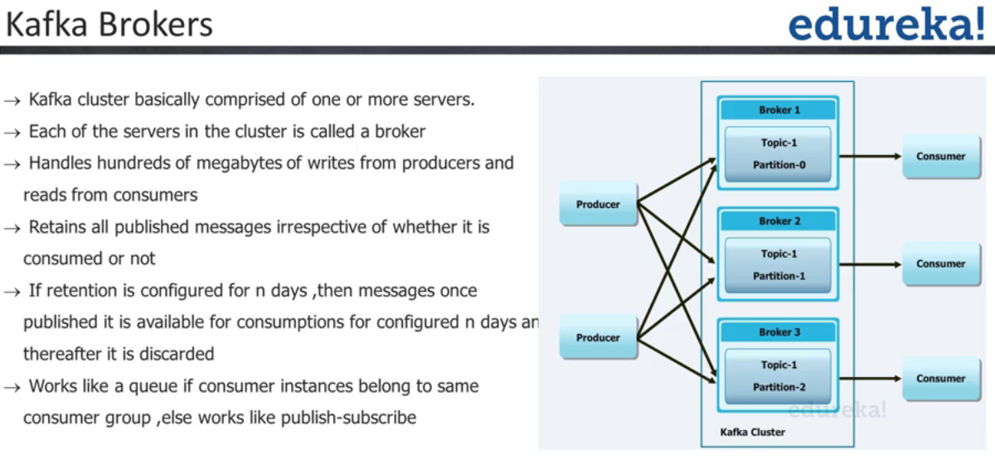

Producers push messages with a given key to target specific partition and consumer latched to specific partition will consume the messages.

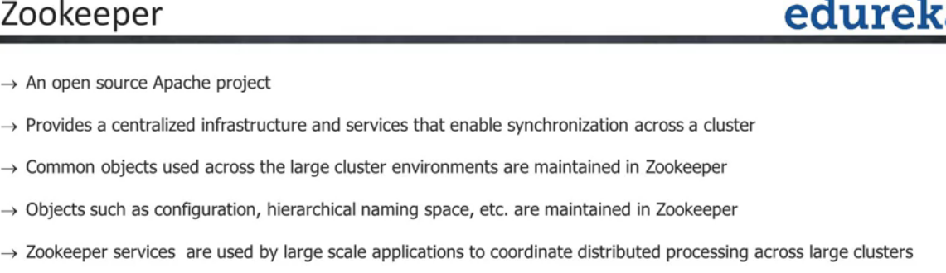

Enabling synchronized between clusters. Coordinate between distributed nodes/cluster. If any broker/node goes down and if 2 copies of a message are there as replica, then Zookeeper will ask consumer to connect to diff broker and hence it’s seamless.

It can be single point of failure of registry so recommendation is to keep odd number of zookeeper nodes. i.e. 3.5,7. You always have 1 node as Leader/active and rest of the nodes are passive/replica.

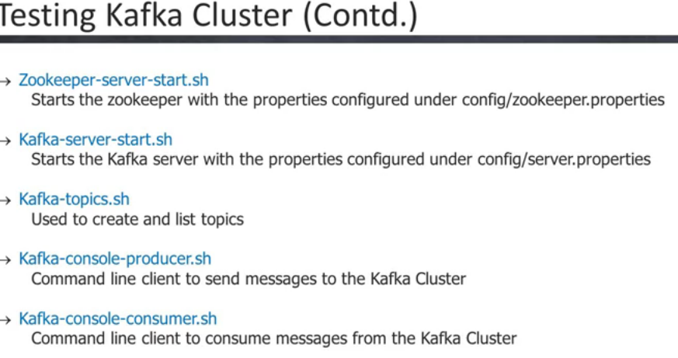

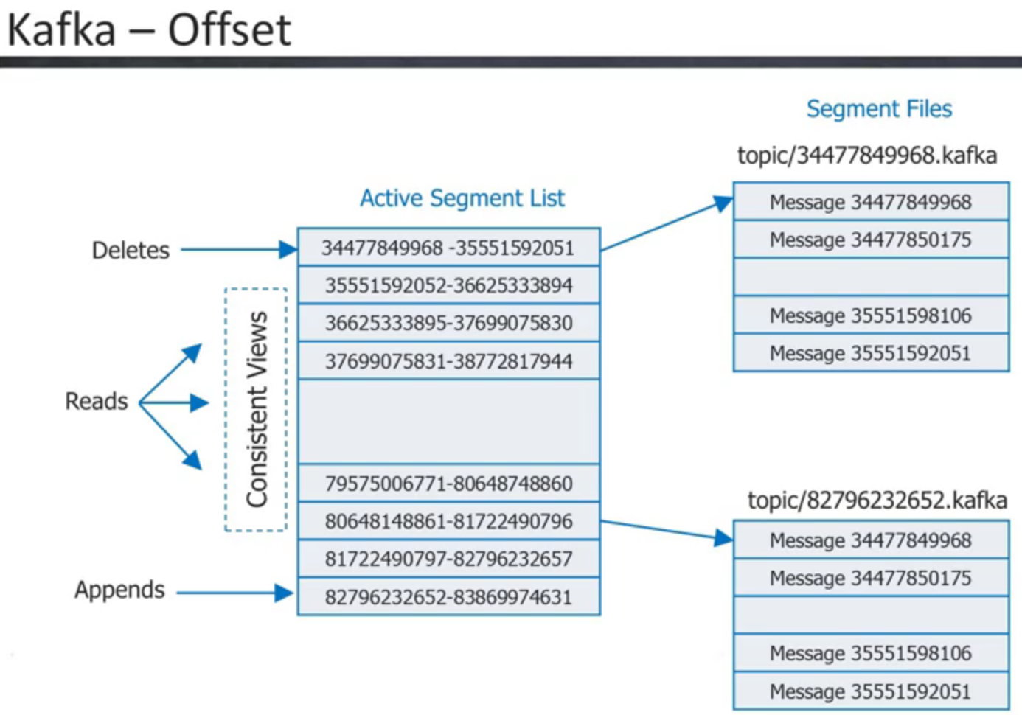

Kafka has time based time based retention policy so it can be easily rewind data.

Kafka is very fast is because keeps lot of data in the page cache and when cache is overflowed then writes to disk. Higher RAID and more spindles give higher disk throughput.

Lag= how far your consumer is behind the producers. Lag is consumer problems, too slow, too much GC, losing connection to ZooKeeper or Kafka server, operational mistakes – too much rebalancing (in server.properties-> cf.rebalance.max.retries – default 4), bug/design issues in consumers, Network utilization – communication between each brokers.

Balance of data across brokers is recommended. Counts or partitions should be balanced across brokers.

Leader Partition: there is only 1 leader active for a given partition and this broker is going to talk to Producer and Consumer. Other non-leader replicas are used as safeguard against data loss. Should be balanced properly so that each broker gets the same amount of load.

GC Optimization: OracleJDK vs OpenJDK

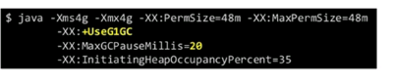

Do not create extra topic unless its required. Design for partition scheme such as each partition is independent and if it goes down then rest of the application continue functioning.

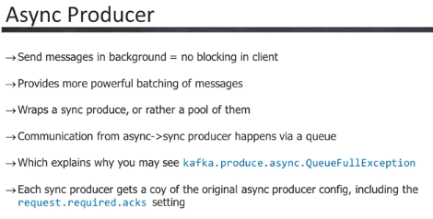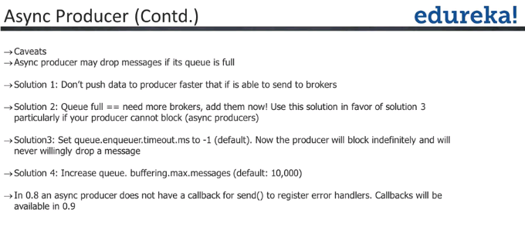

Kafka can have performance impact due to Batching and Message Ack.

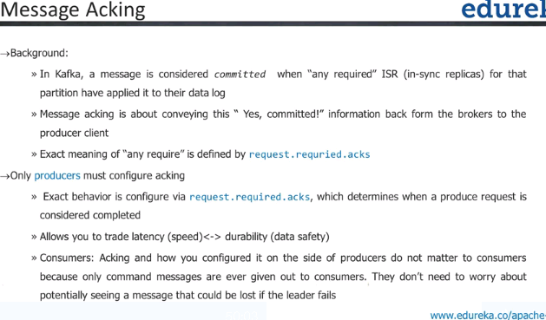

request.required.acks = values are 0,-1,1

Committed to all replica will cost performance. – it is a tradeoff between speed/latency and data safety. i.e. finance application vs. tweet

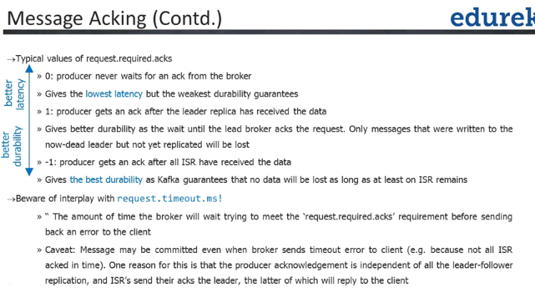

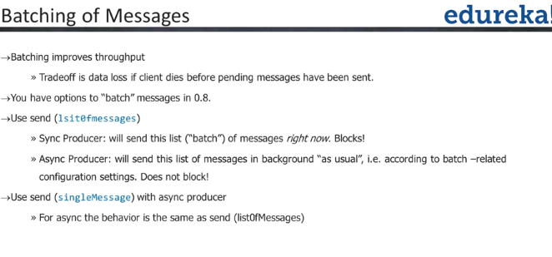

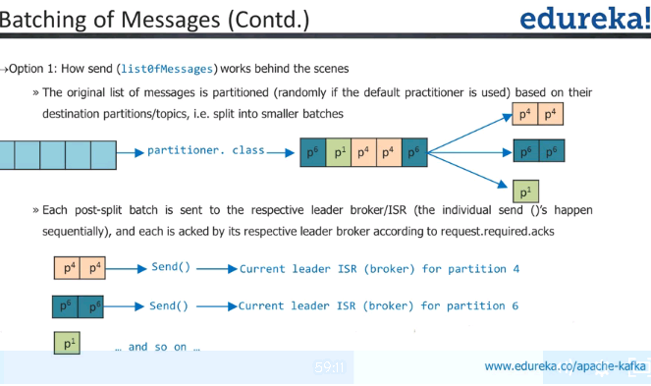

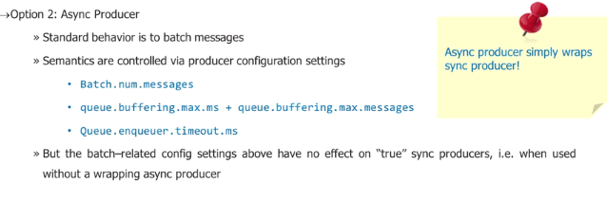

When producers are starting they find partition leader – they use bootstrapping broker list.

They do not find via ZooKeeper.

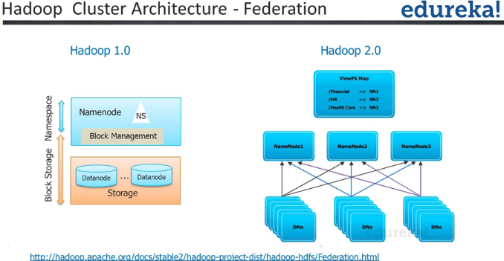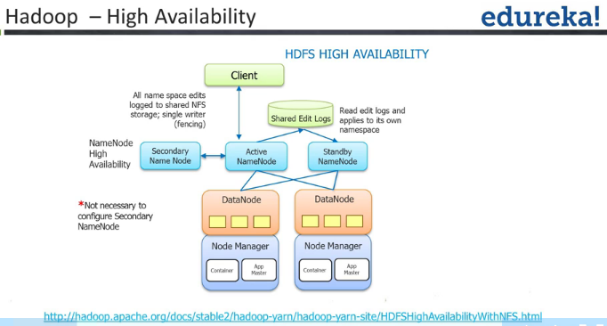

Multiple Name Node- Master and Standby for High Availability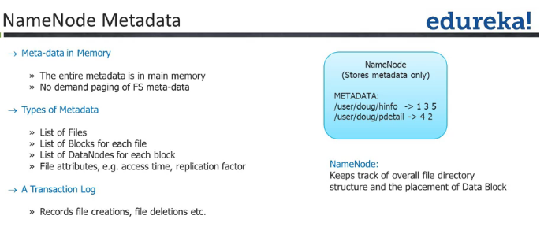

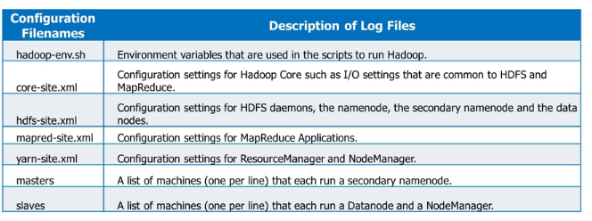

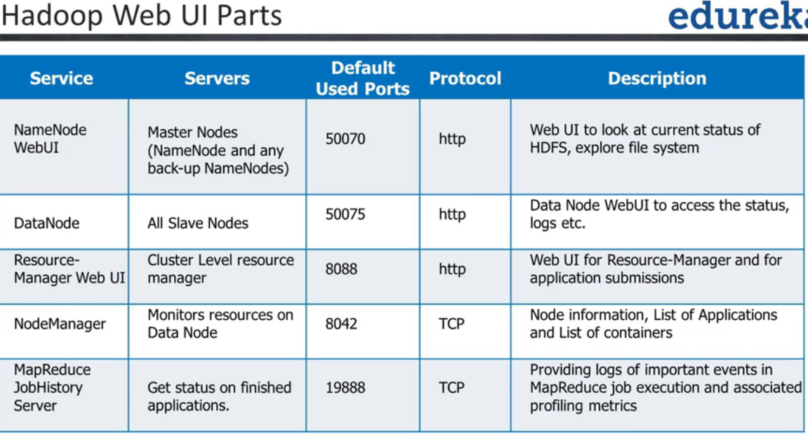

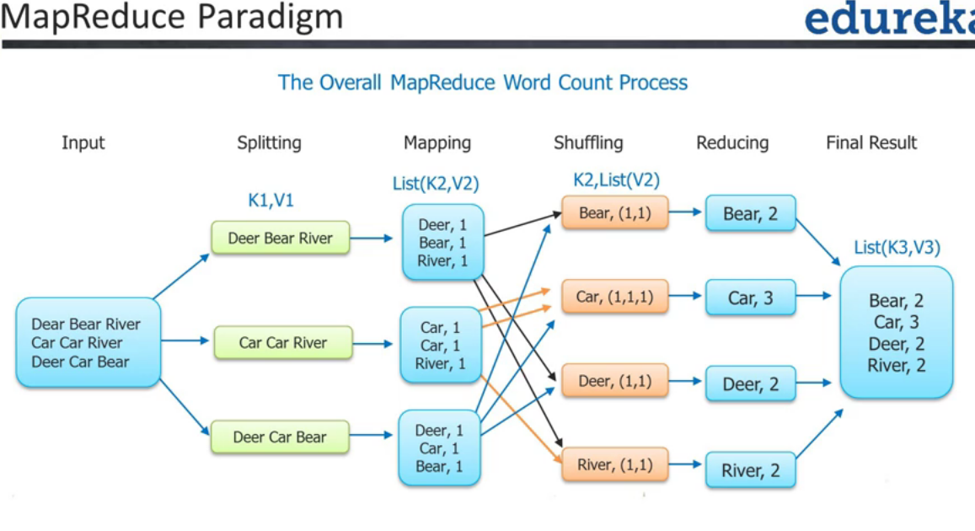

Map Reduce Program: Job submission, Job Initialization (by YARN), Tasks assignment, Memory Assignment, Status Updates, and Failure Recovery.

Kafka with Spark

Storm- provides processing data and store, but no query on top of data.

Spark – general purpose cluster to perform in-memory computations/data analytics.

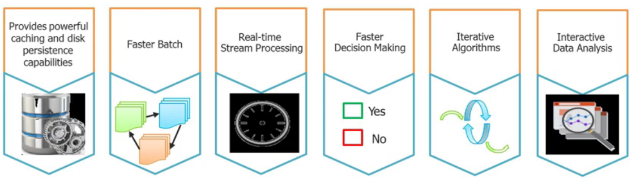

Spark cluster can be deployed through Apache Mesos, Apache Hadoop or spark cluster.

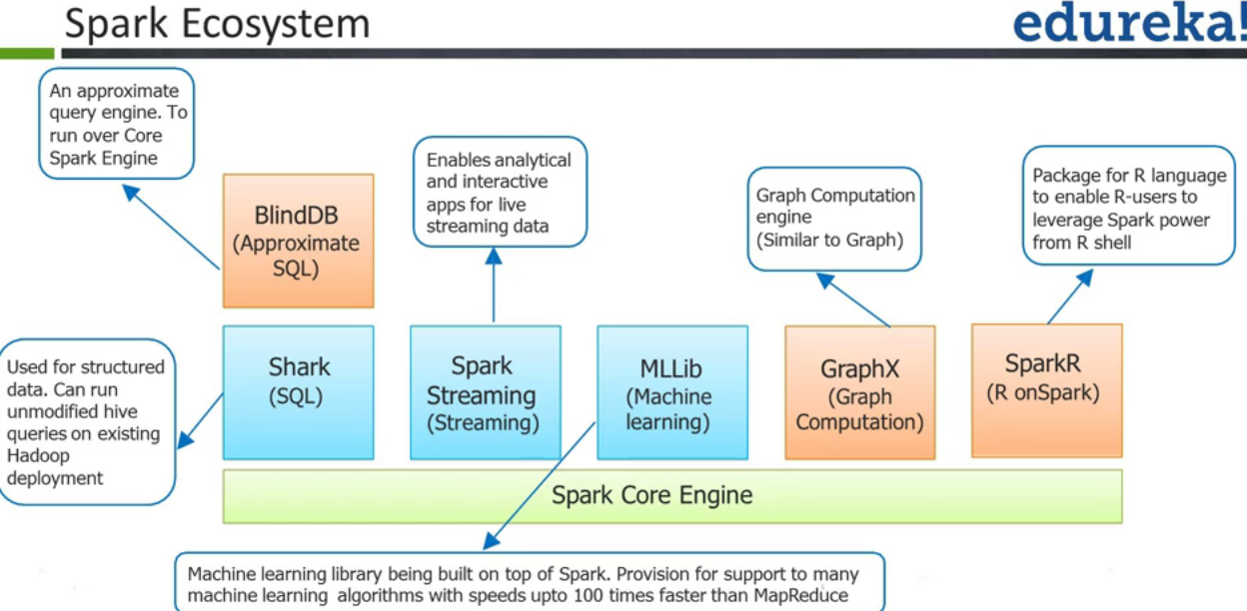

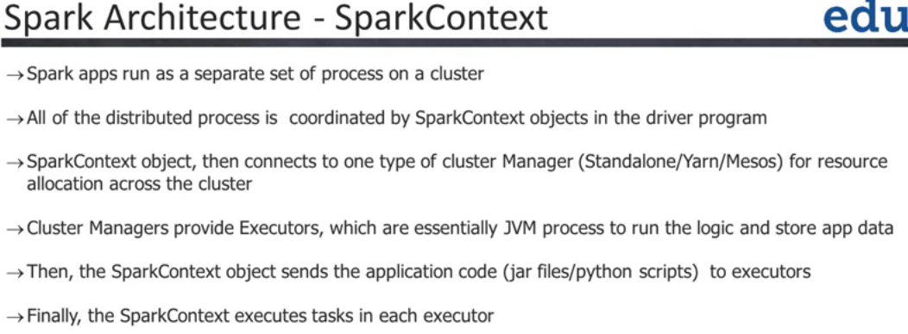

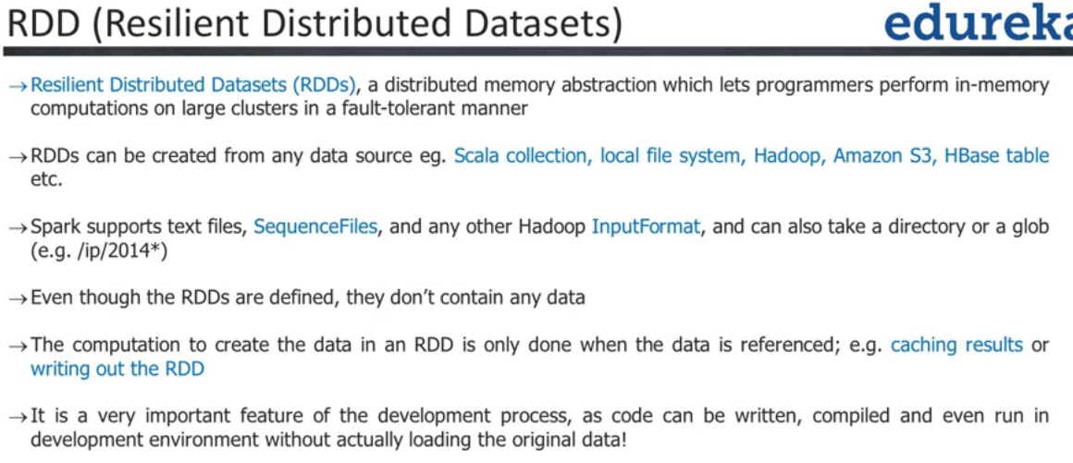

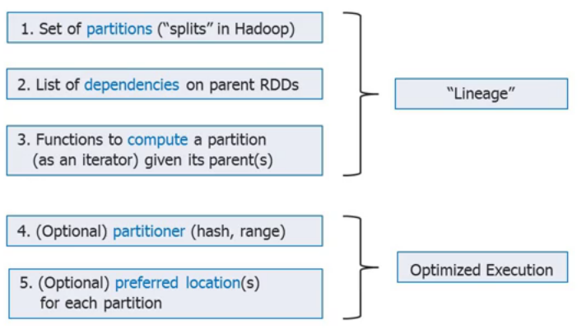

RDD is re-computed every time it is materialized. Good idea is to store RDD in cache. SparkContext has parallelize function to create RDD from collection.

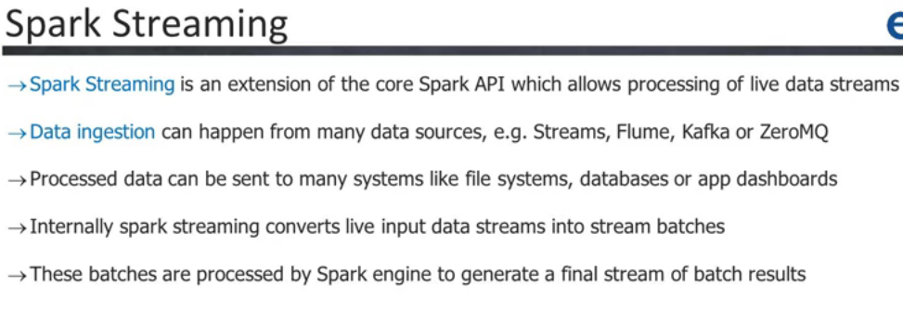

# Apache Spark

Scatter data and gather paradigm. More general data model - RDD, Dataset, DataFrame. More general programming model (transform/action). Storage Agnostic (does not require stric HDFS like Hadoop)

# Four Distributed Systems Architecture Patterns

**3 Tier Architecture:**

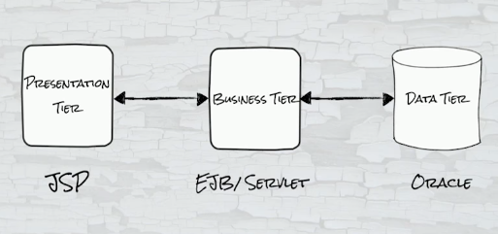

**Distributed System**

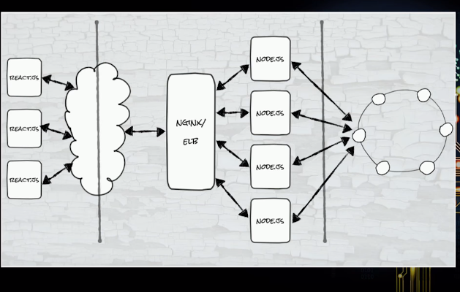

**Sharding:**

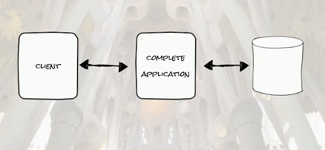

Eventually, Clients grows – too many connections. Router, chunking and sharding of application comes in.

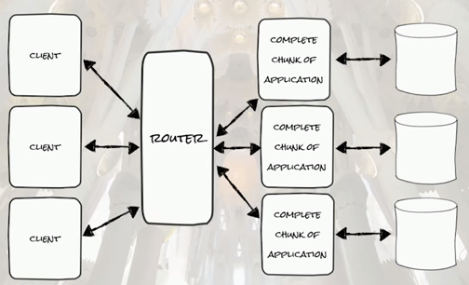

Sharding starts with read replication – from single write master to many replications for read.

Sometimes workloads work with sharding – as traffic can be directly correctly by keys. It is strategy to build small isolated application, by directly clients to specific sharding instance. It can give problems with oversized, loads, its own independent distributed system.

**Lambda Architecture**

Unbounded events, immutable data (once it’s generated, does not change).

Take such unbounded data and write to distributed storage.

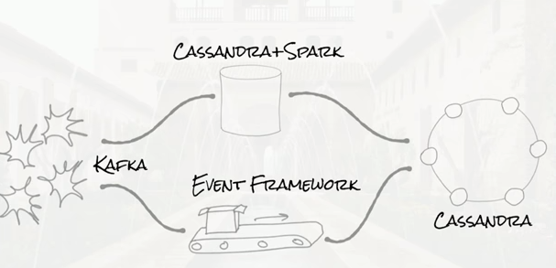

**Streaming Architecture - Kafka**

Integration is the key, liveness of data., Keep Stream computation very close to application. Kafka stores default 7 days. High throughput – great IO performance, fast writes, partitioning, replication, elastic scale.

# Apache Cassandra

Open Source, No SQL, distributed, horizontally scalable, Highly Scalable, Fault tolerant, Highly Available, Decentralized. No single point of failure.

In a cluster, all of the nodes are equal, no master node. There is a coordinating node for each client request where coordinating node delegates requests to other node to process data.

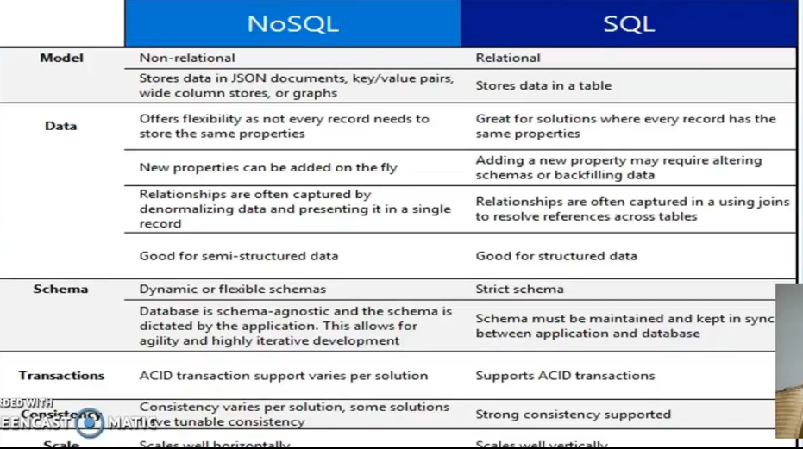

CAP Theorem – Consistence, Availability, Partition. Always want all 3 but all 3 is not possible, and can have only 2.

Cassandra is AP – and it can be made eventual consistent.

Eventually, Clients grows – too many connections. Router, chunking and sharding of application comes in.

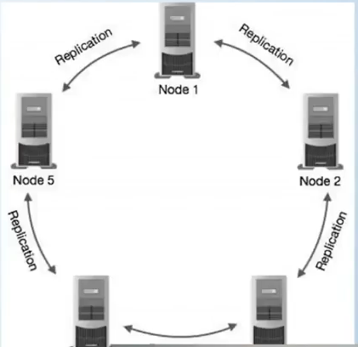 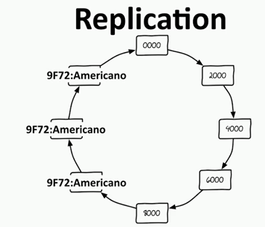

<https://academy.datastax.com/>

All nodes are same in Cassandra. Peer to Peer. No Master/Central node.

At the time of writing, consistent factor ensure that how many nodes it needs to write.

Performs read repair if data is out of date, (if one node goes down then other nodes accepts the request)

Gossip protocol to communicate with other nodes.

Sharding – to spread/partition data.

Node- single machine where data is stored.

Data Center: collections of related data nodes.

Cluster- components that contains one or more data centers.

Commit log: crash recovery mechanism in Cassandra. Every write operation is written to commit log.

Mem-table: mem-table is a memory resistance data structure. After commit log, the data will be written to the mem-table. Sometimes for a single column family, there will be multiple mem tables.

SSTable: it is a disk file to which data is flushed from the mem-table once its reaches a threshold value.

Bloom Filter: quick algorithms for an elements

keySpace – (like db schema) – collections of Tables and index.

* + CREATE KEYSPACE demo WITH replication = {‘class’:’SimpleStrategy’,’replication_factor’:3}
  + desc demo
  + drop keyspace demo; //to drop keyspace
  + CREATE TABLE EMPLOYEE (

emp_id int primary_key,

first_name first,

last_name text,

department text

);

Cqlsh – Cassendara Query Language

Collections: List, Set, Map column type can be any of these on need basis (employee skills (set), project (list), phones number for employee by Map: home, cell, office)

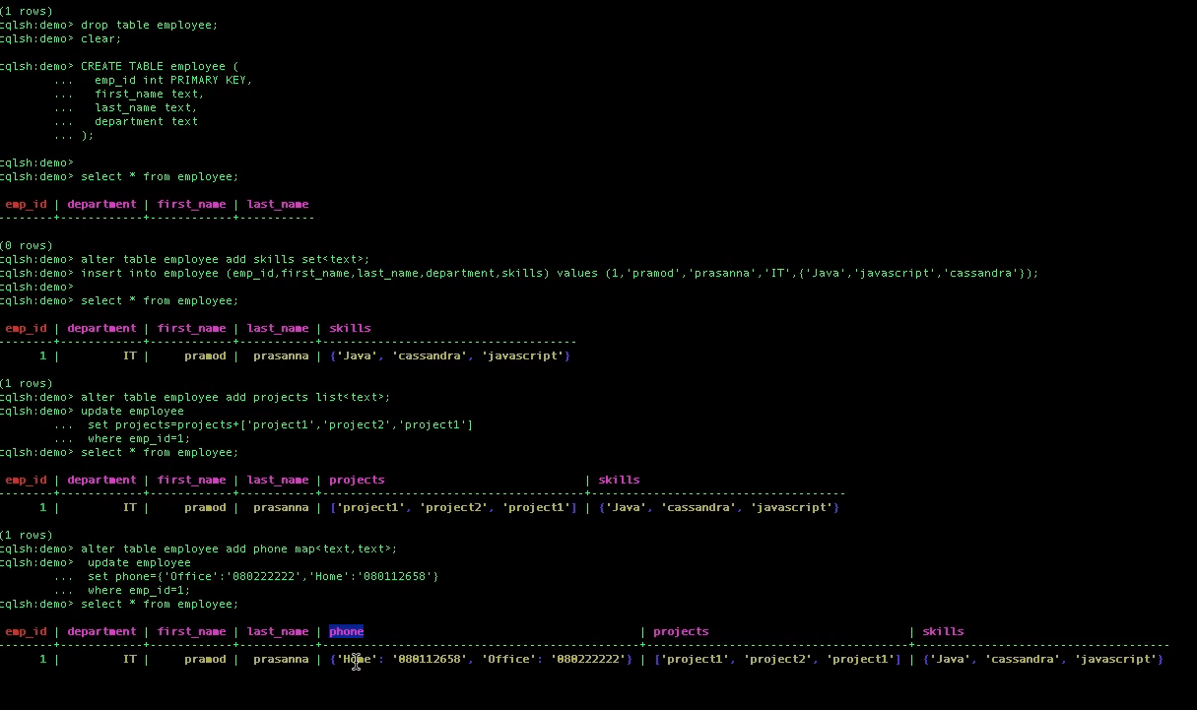

# Design Patterns

## Creational:

**Abstract Factory**: Provide an interface for creating families of related or dependent objects without specifying their concrete classes.

**Builder**; Separate the construction of a complex object from its representation so that the same construction process can create different representations.

**Factory Method**: Define an interface for creating an object, but let subclasses decide which class to instantiate. Factory Method lets a class defer instantiation to subclasses.

**Prototype**: Specify the kinds of objects to create using a prototypical instance, and create new objects by copying this prototype.

**Singleton**: Ensure a class only has one instance, and provide a global point of access to it.

## Structural:

**Adapter:** Convert the interface of a class into another interface clients expect. Adapter lets classes work together that couldn't otherwise because of incompatible interfaces.

**Bridge**: Decouple an abstraction from its implementation so that the two can vary independently.

**Composite**: Compose objects into tree structures to represent part-whole hierarchies. Composite lets clients treat individual objects and compositions of objects uniformly

**Decorator**: Attach additional responsibilities to an object dynamically. Decorators provide a flexible alternative to sub classing for extending functionality.

**Façade**: Provide a unified interface to a set of interfaces in a subsystem. Facade defines a higher-level interface that makes the subsystem easier to use.

**FlyWeight**: Use sharing to support large numbers of fine-grained objects efficiently.

**Proxy**: Provide a surrogate or placeholder for another object to control access to it.

Behavioral:

**Command Pattern**: Encapsulate a request as an object, thereby allowing you to parameterize clients with different requests, queue or log requests, and support undoable operations.

**Chain of Responsibility**: Avoid coupling the sender of a request to its receiver by giving more than one object a chance to handle the request. Chain the receiving objects and pass the request along the chain until an object handles it.

**Interpretor**: Given a language, define a representation for its grammar along with an interpreter that uses the representation to interpret sentences in the language.

**Iterator**: Provide a way to access the elements of an aggregate object sequentially without exposing its underlying representation.

**Observer**: Define a one-to-many dependency between objects so that when one object changes state, all its dependents are notified and updated automatically.

**Mediator**: Define an object that encapsulates how a set of objects interact. Mediator promotes loose coupling by keeping objects from referring to each other explicitly, and it lets you vary their interaction independently.

**Memento Pattern**: Without violating encapsulation, capture and externalize an object's internal state so that the object can be restored to this state later.

**State**: allow an object to alter its behavior when its internal state changes. The object will appear to change its class.

**Strategy**: Define a family of algorithms, encapsulate each one, and make them interchangeable. Strategy lets the algorithm vary independently from clients that use it. It is quite similar to the State pattern.

**Template**: Define the skeleton of an algorithm in an operation, deferring some steps to subclasses. Template Method lets subclasses redefine certain steps of an algorithm without changing the algorithm's structure.

**Visitor**: Represent an operation to be performed on the elements of an object structure. Visitor lets you define a new operation without changing the classes of the elements on which it operates.

## Core Design Patterns:

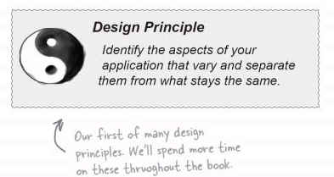

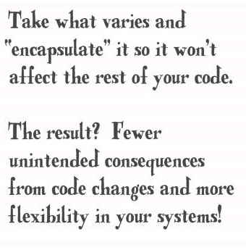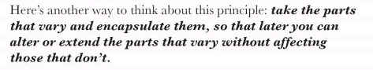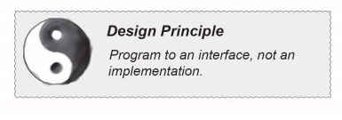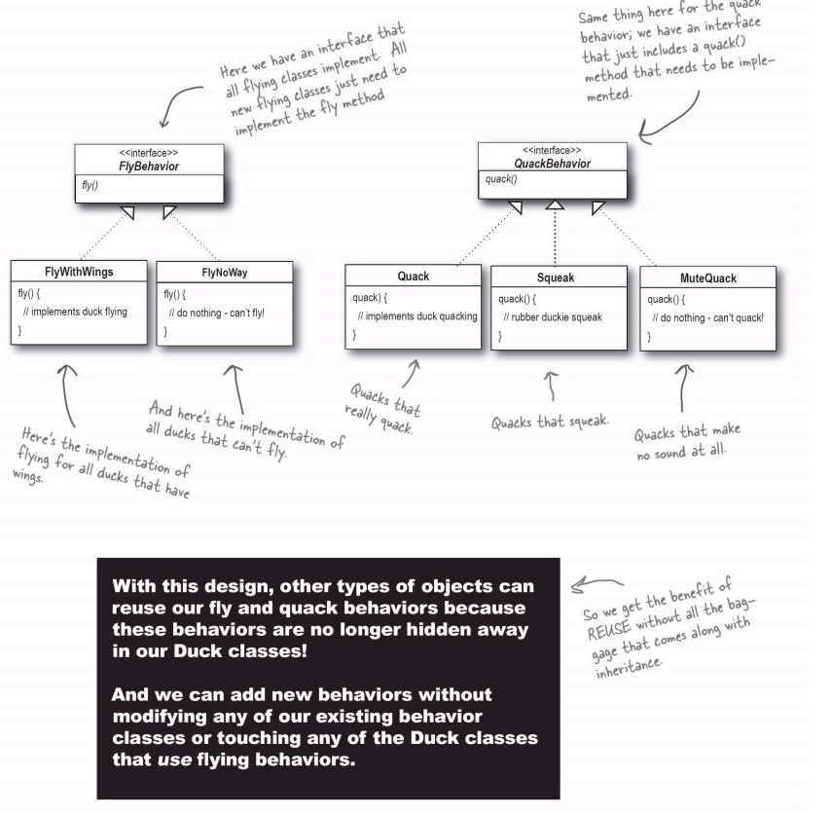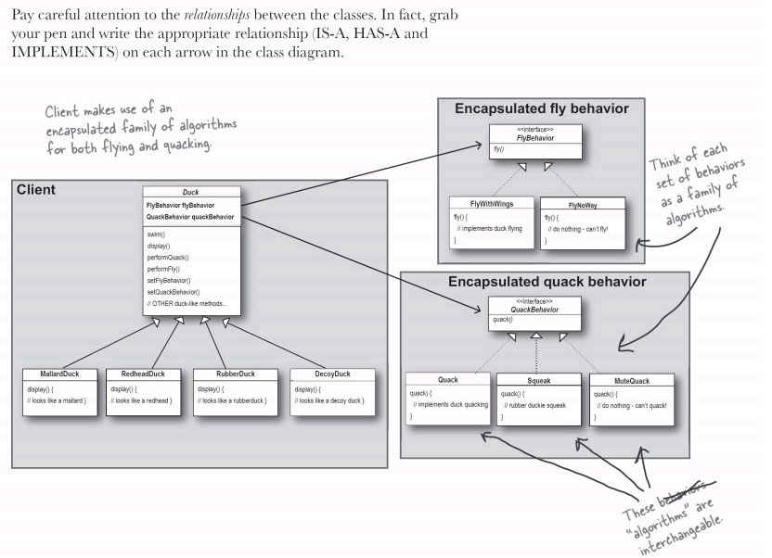

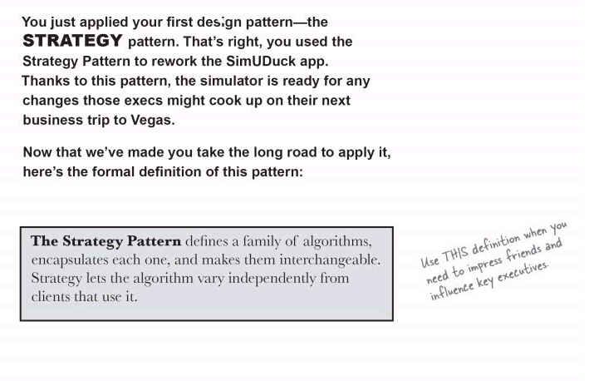

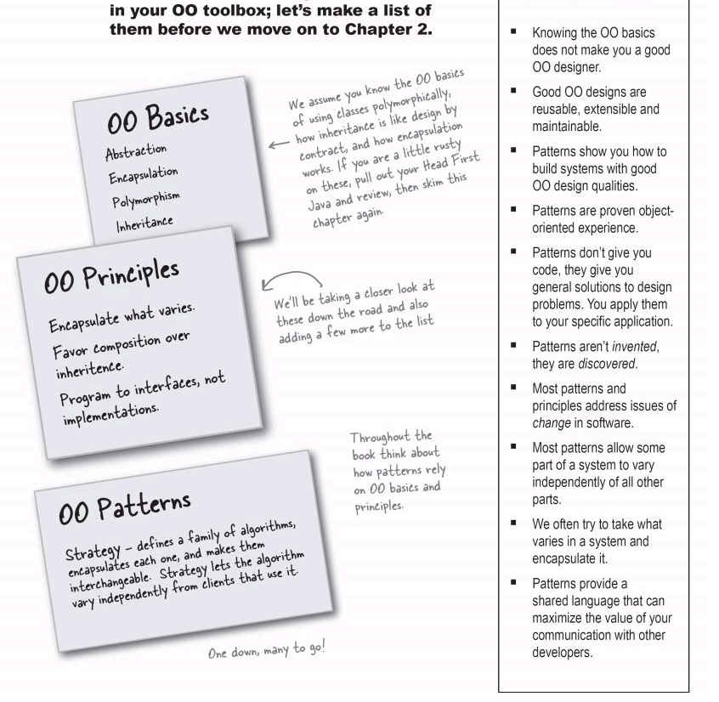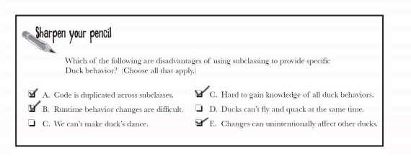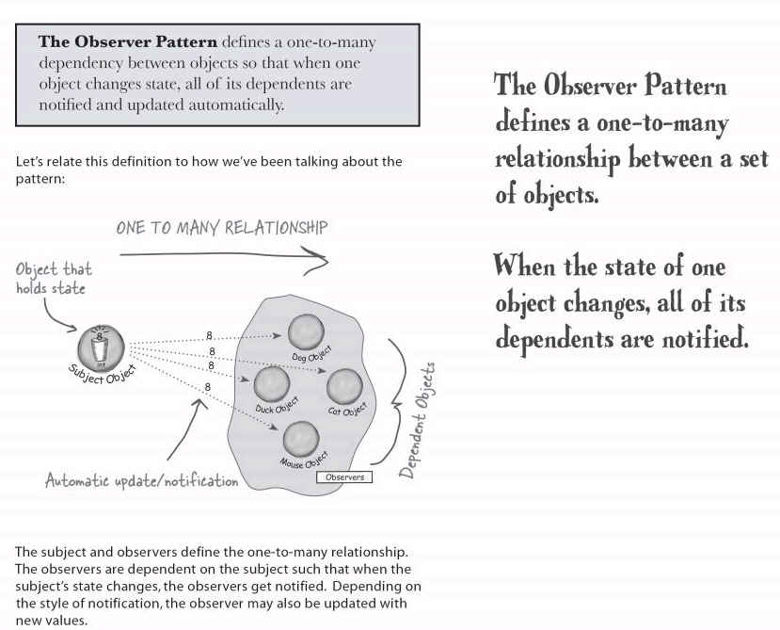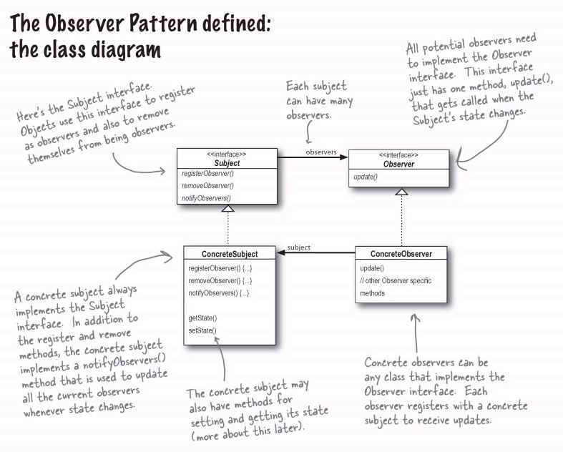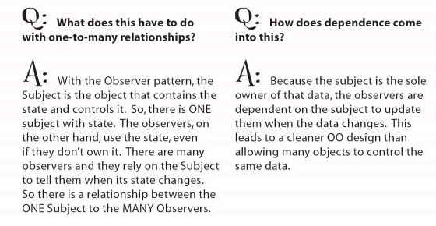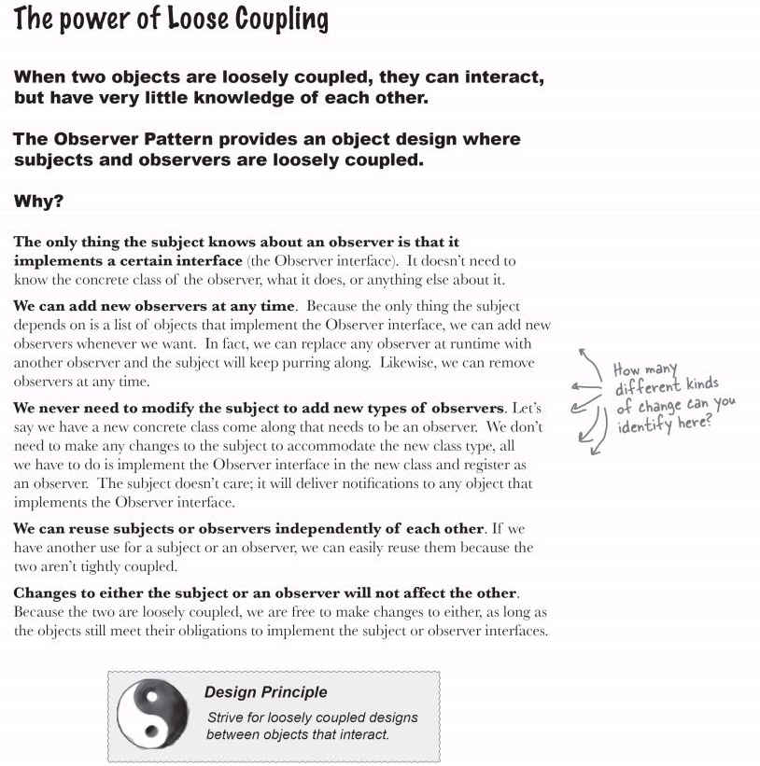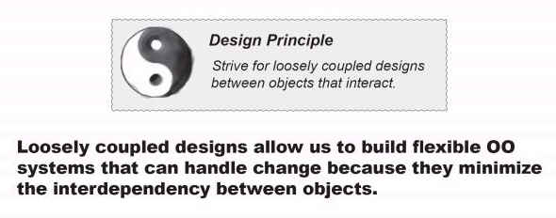

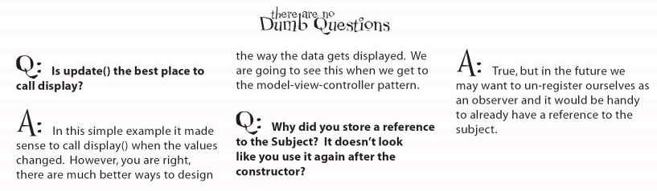

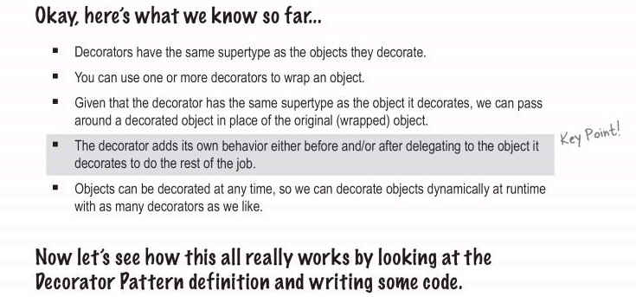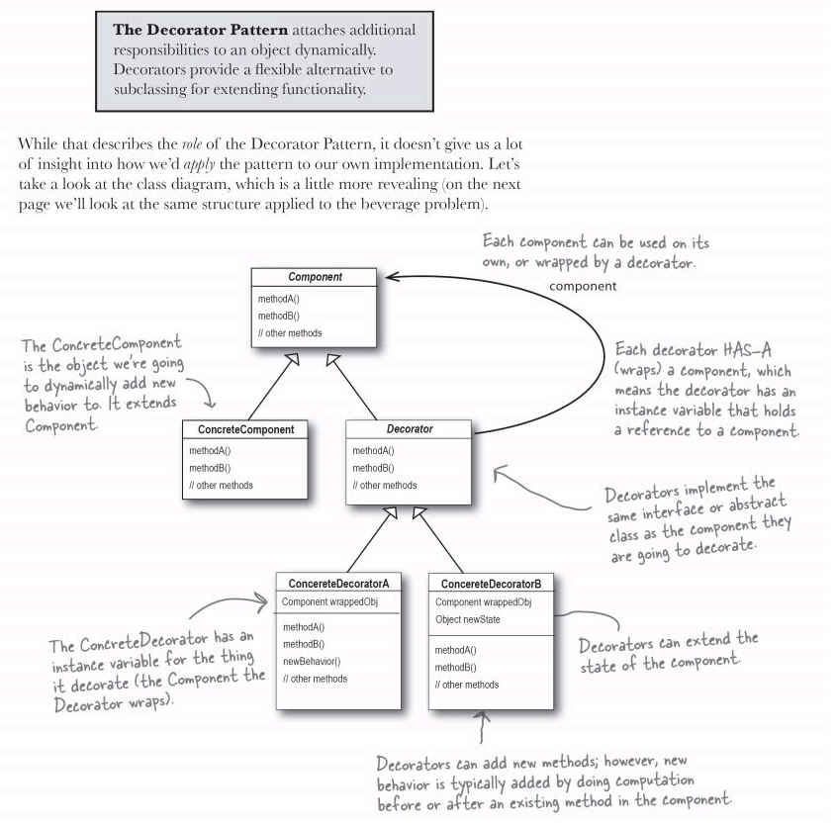

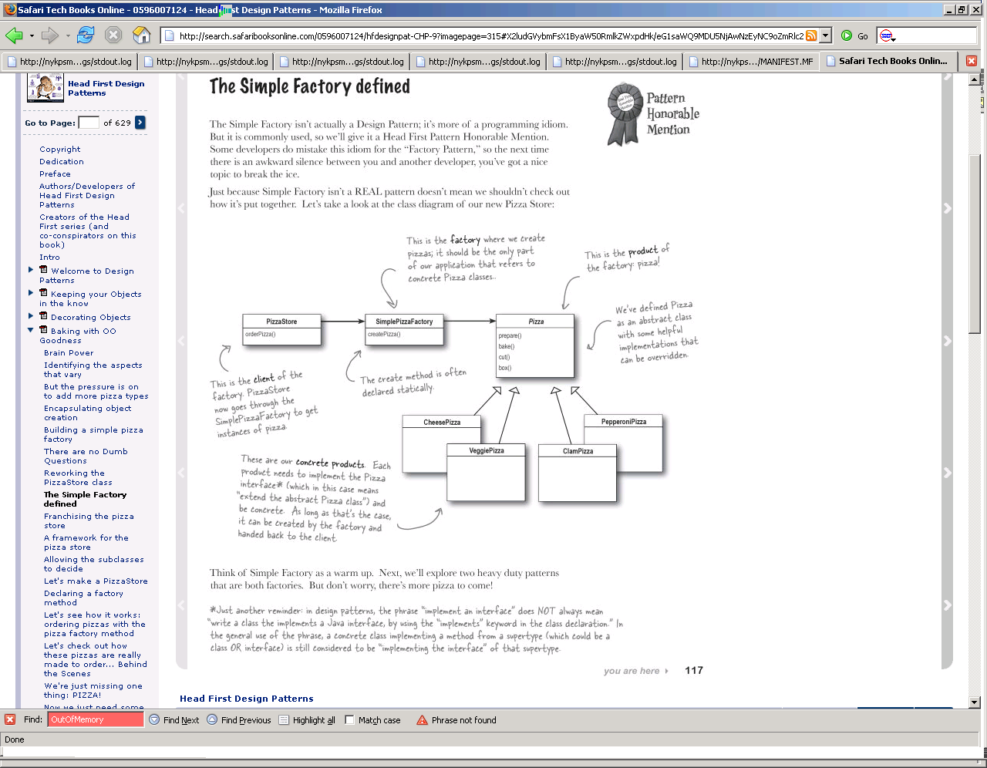

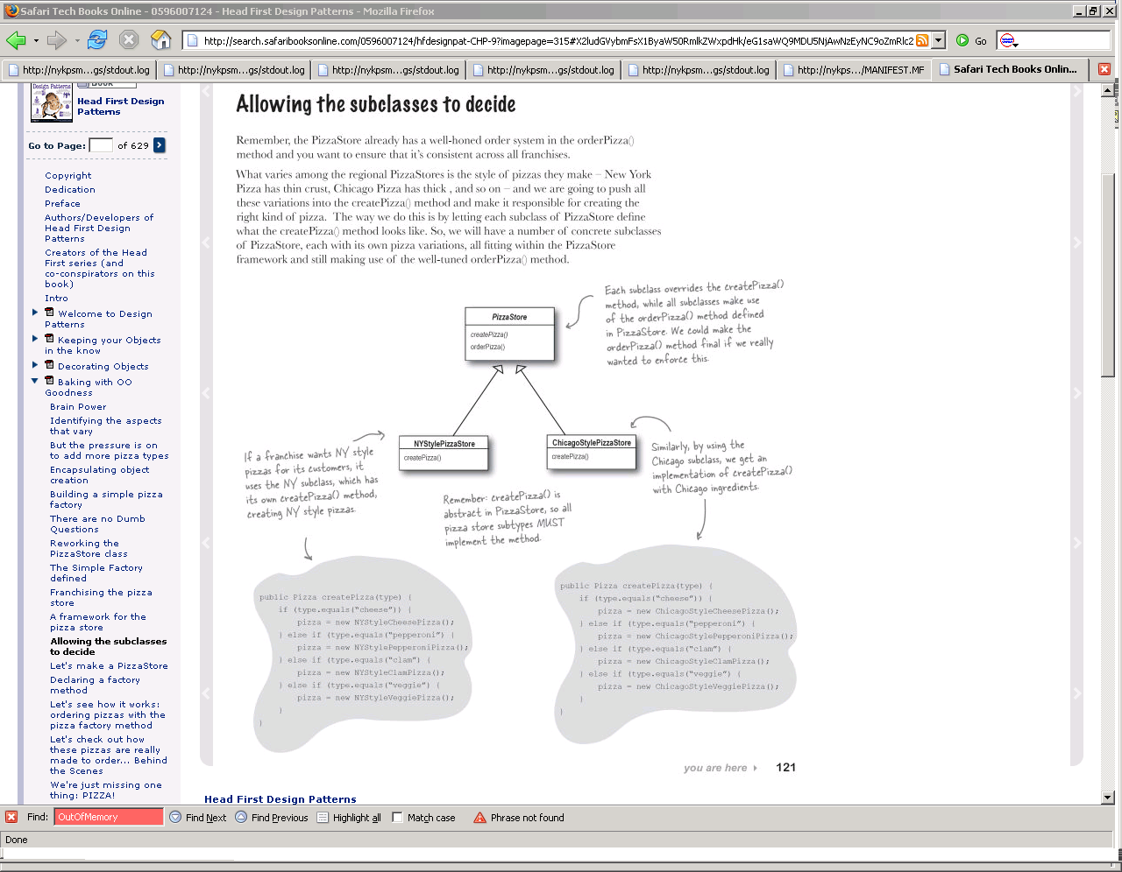

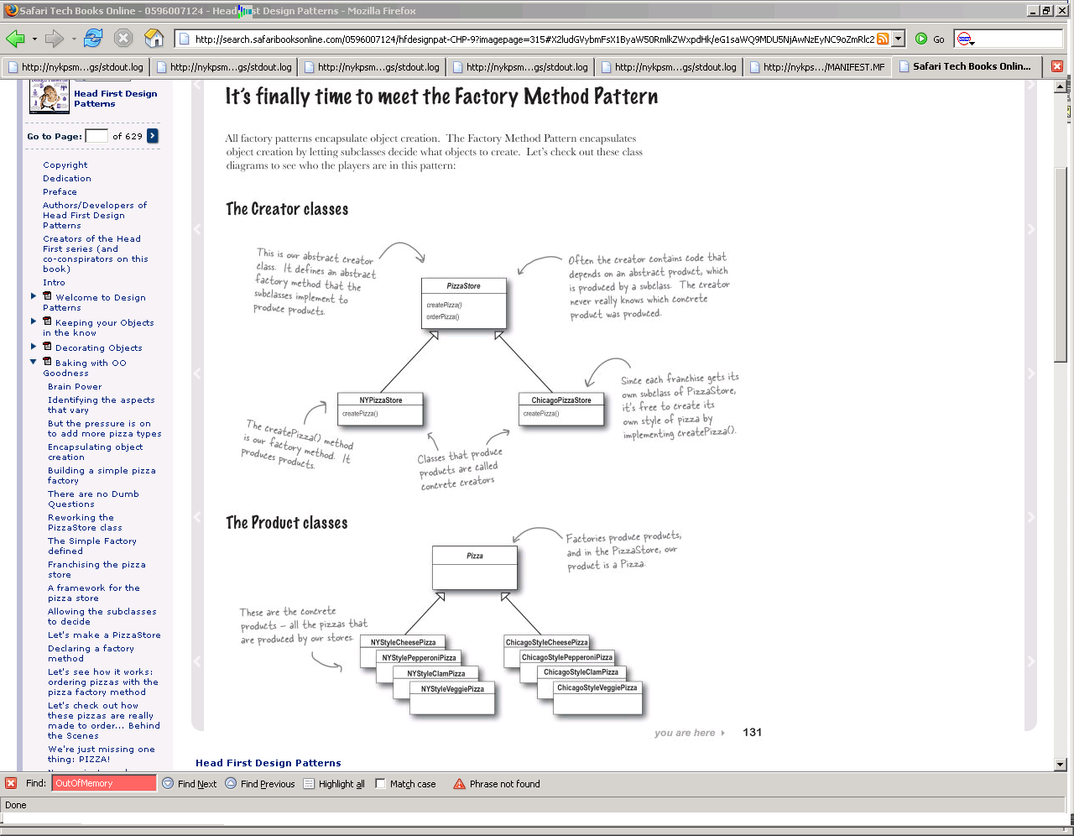

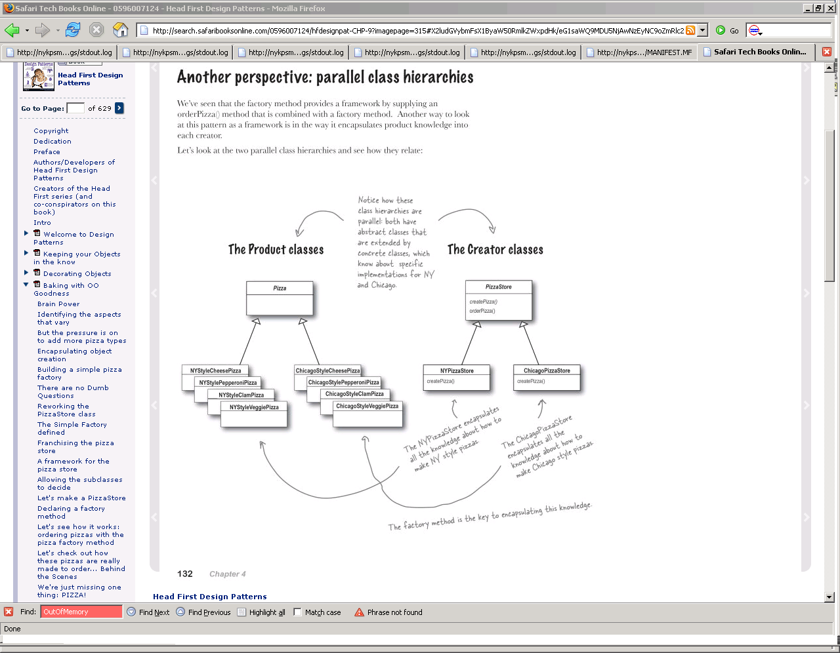

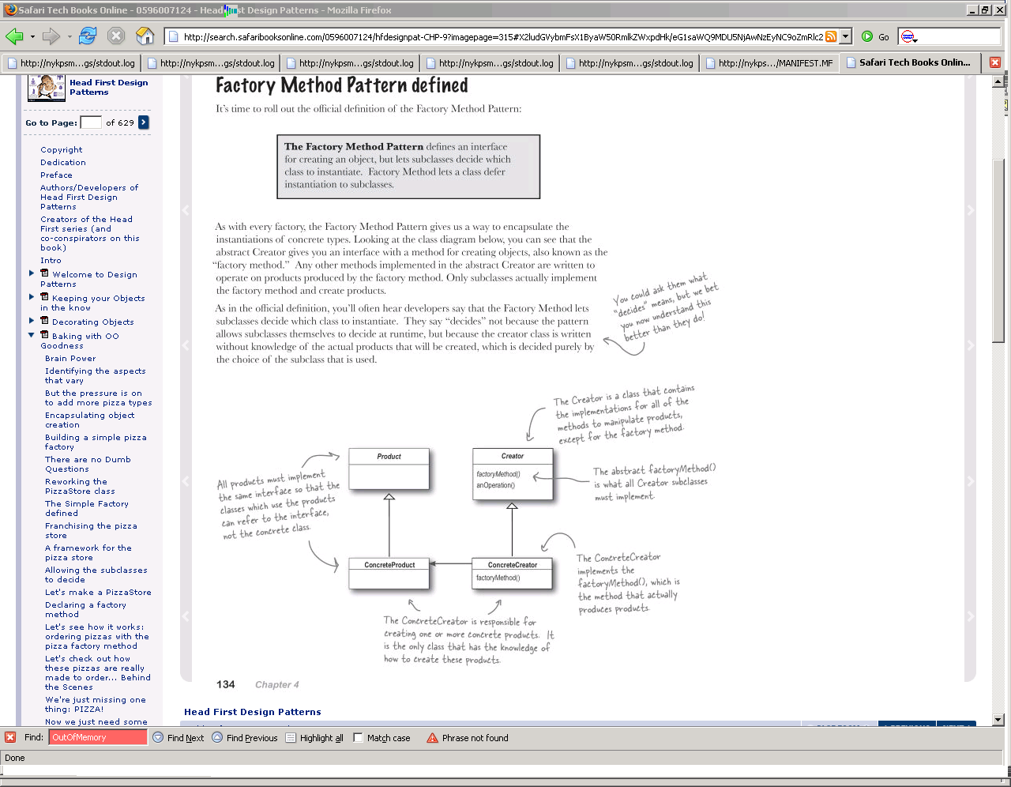

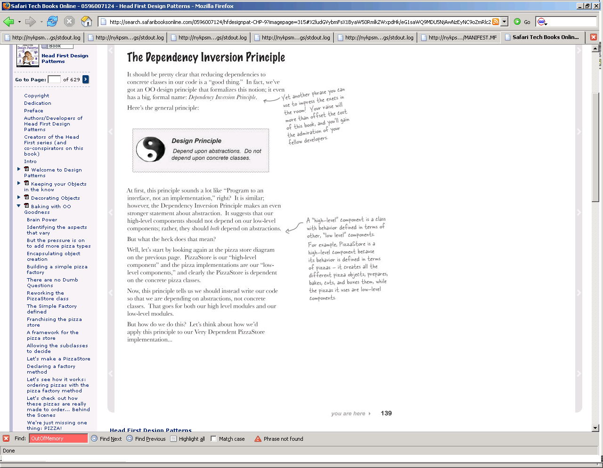

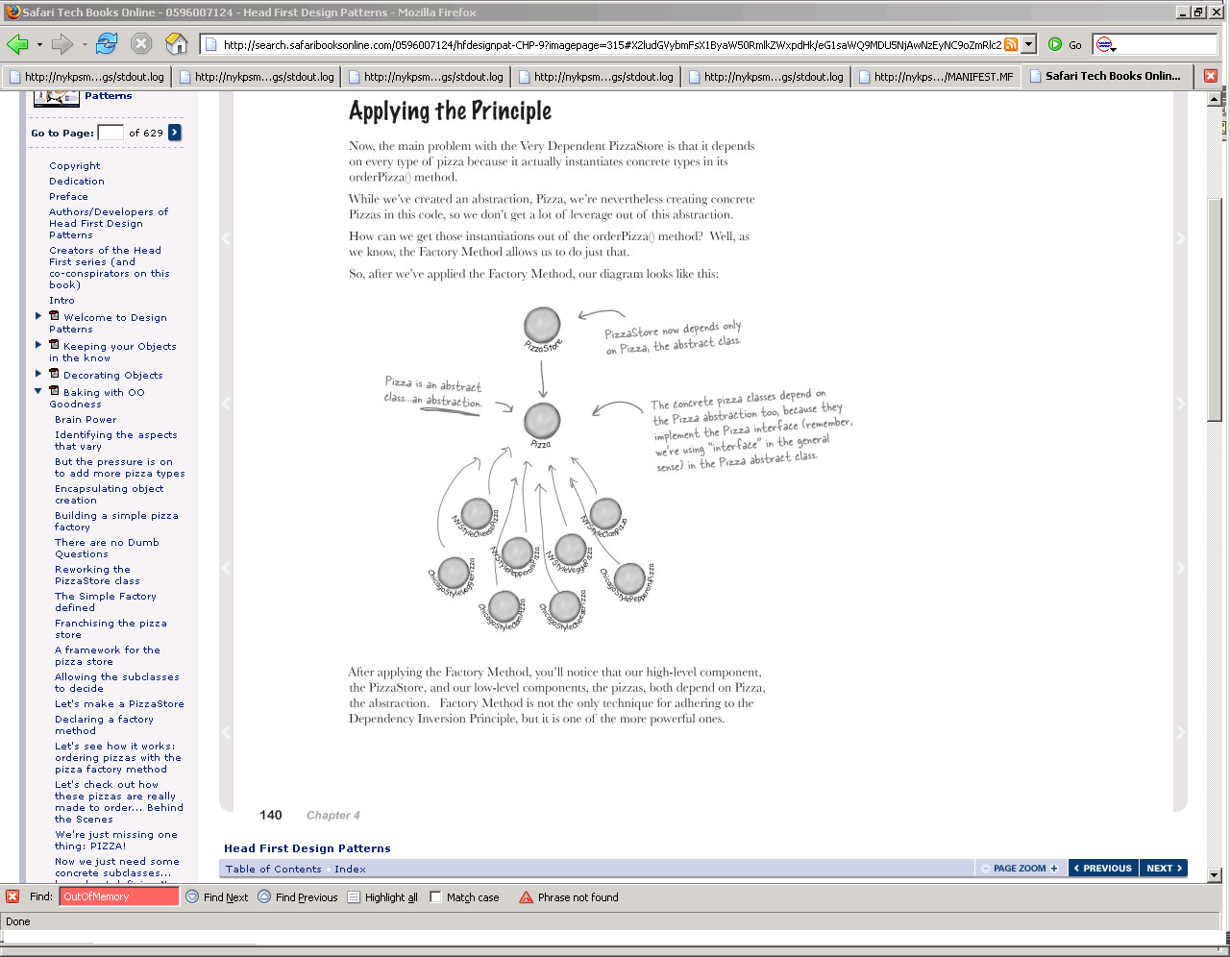

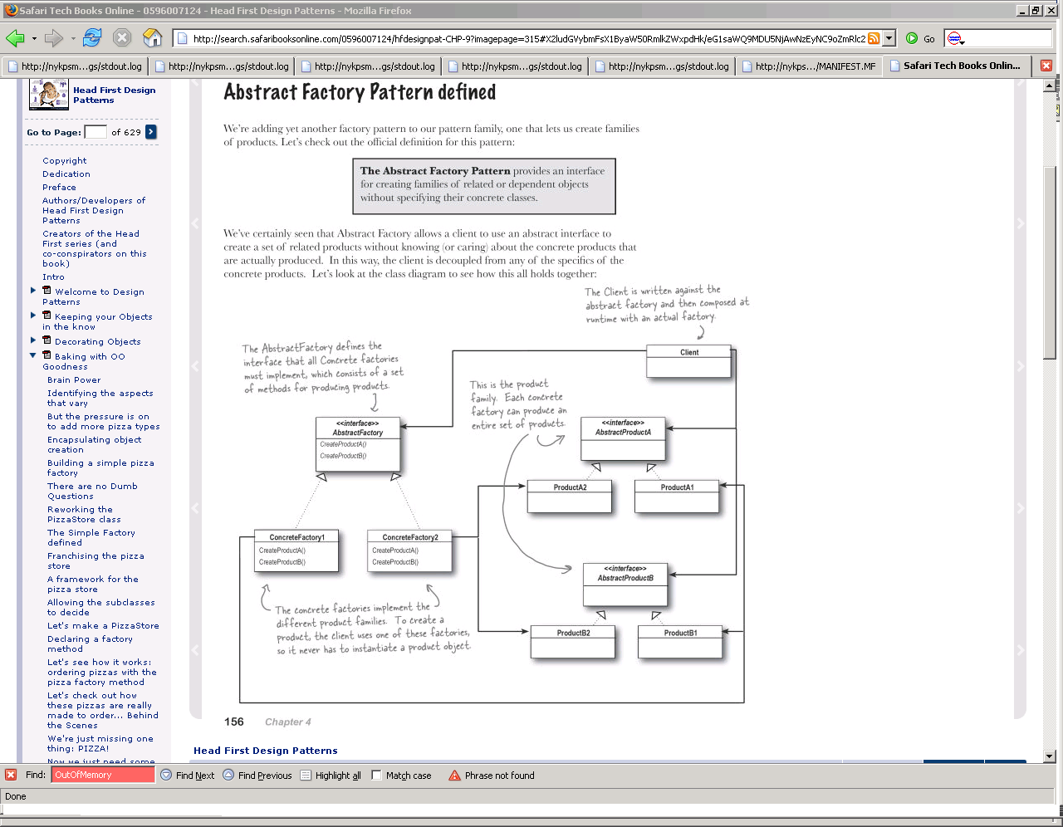

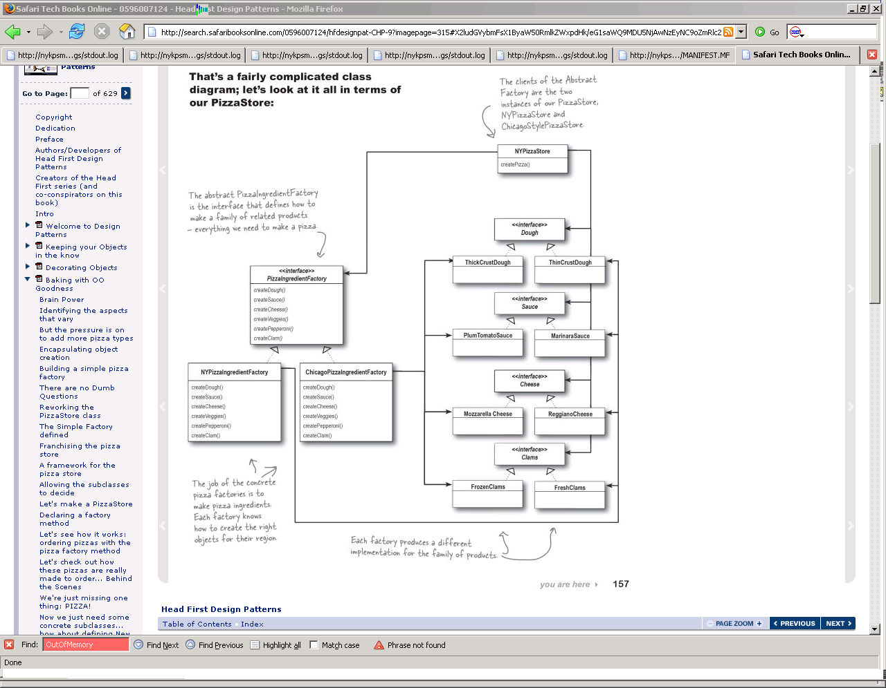

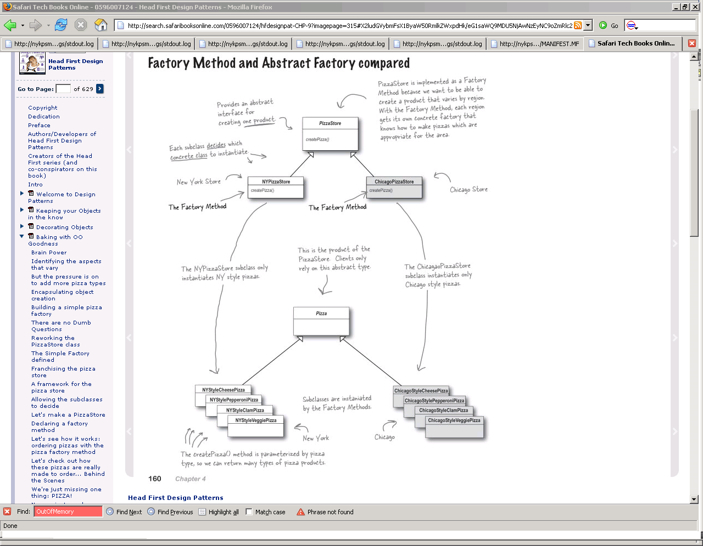

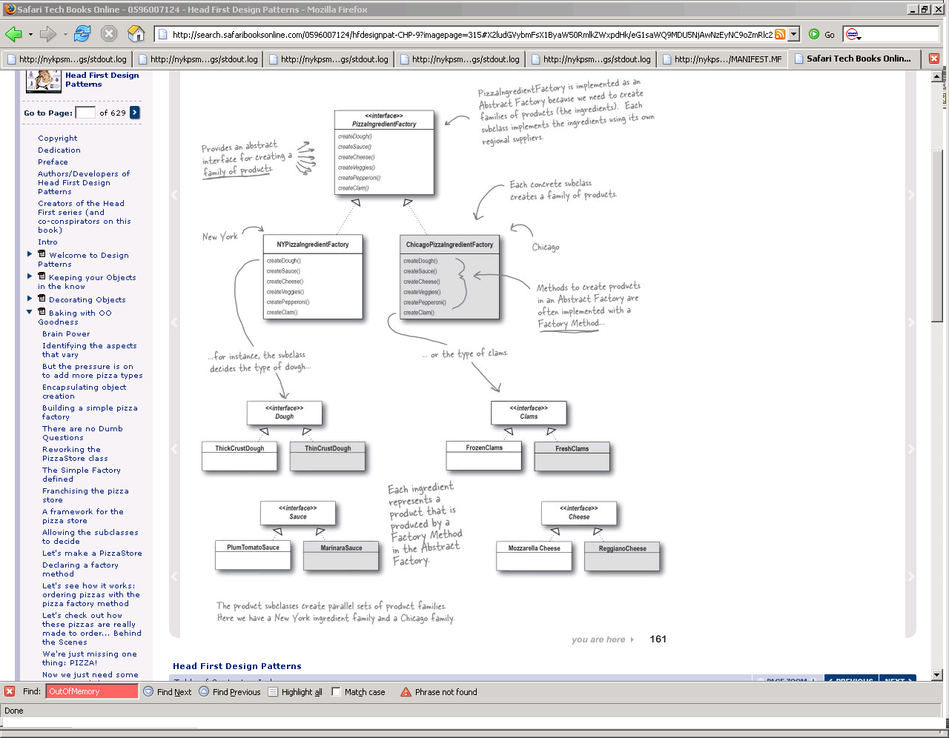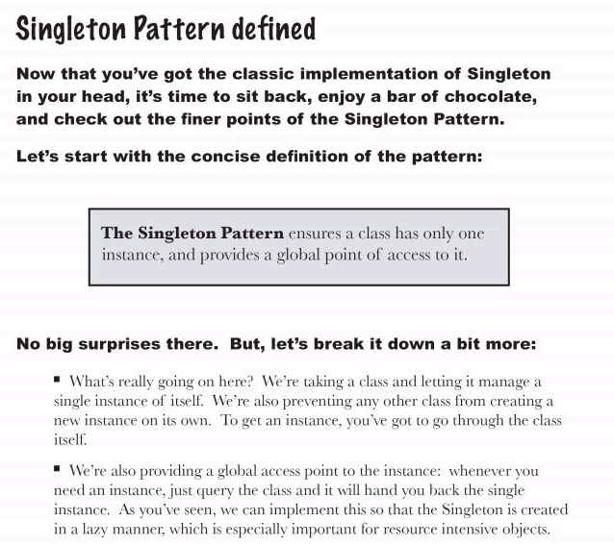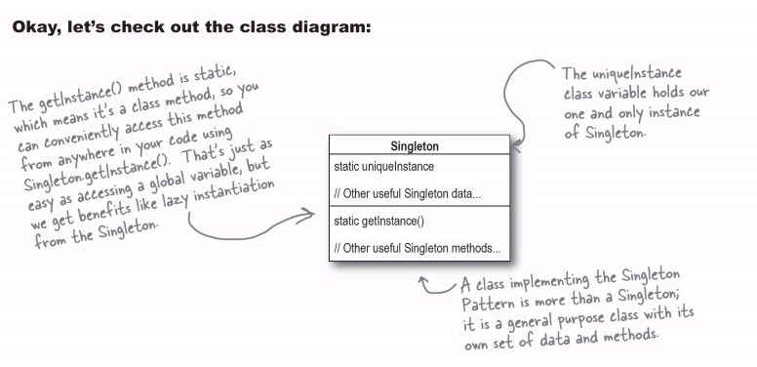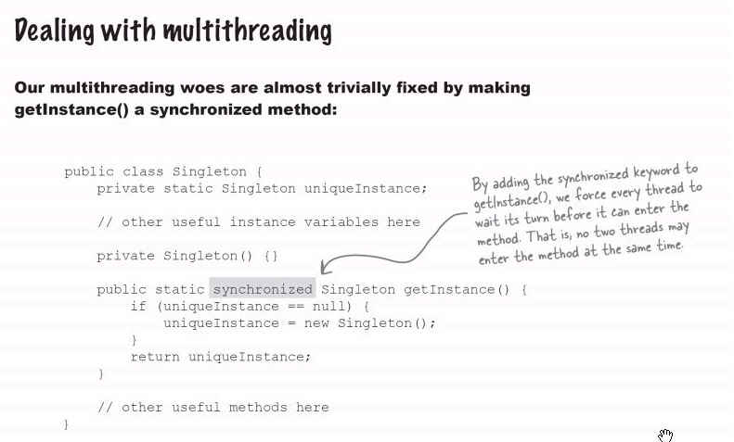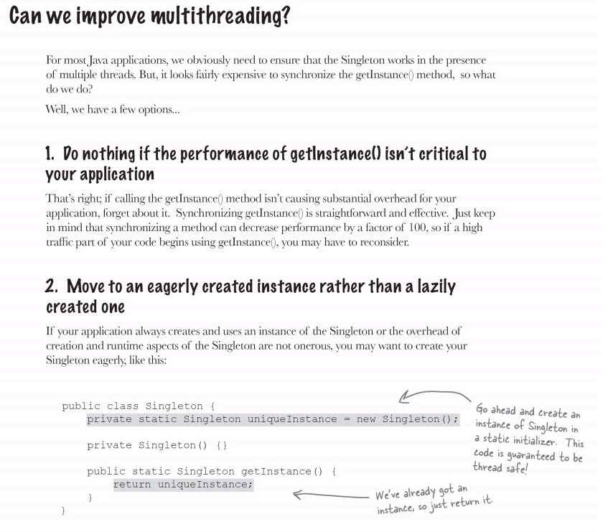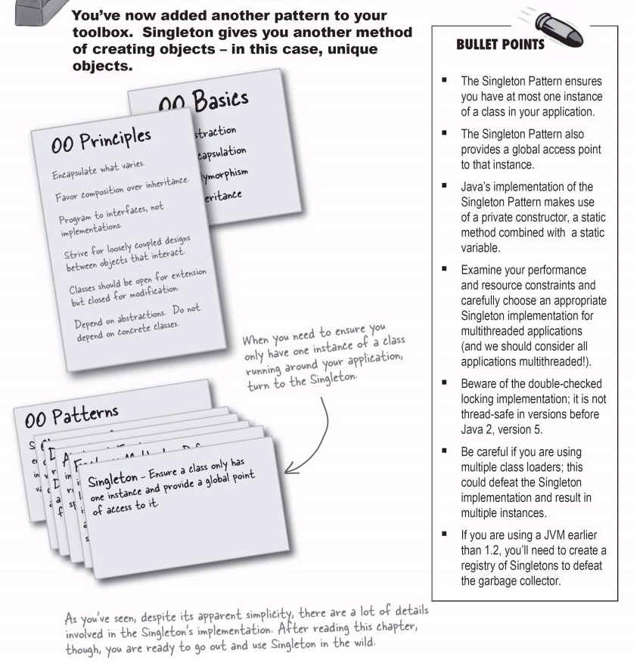

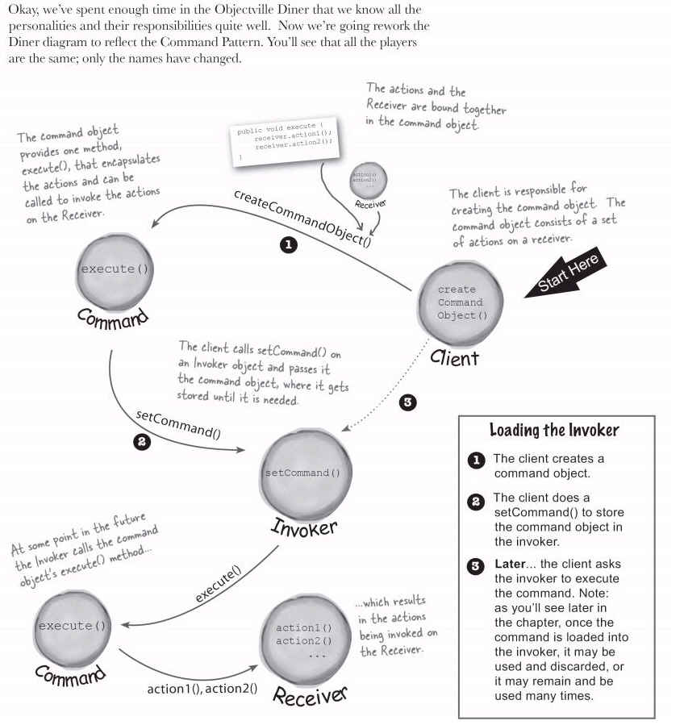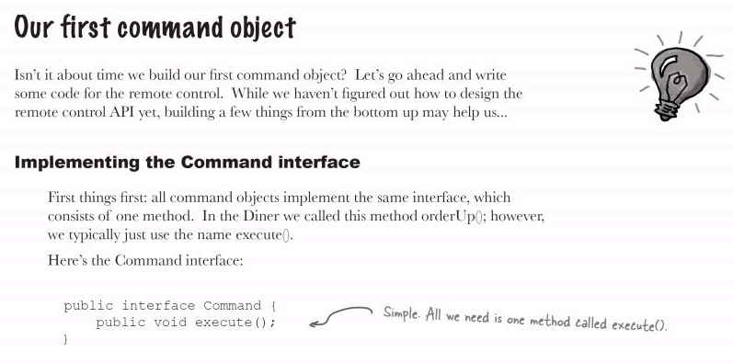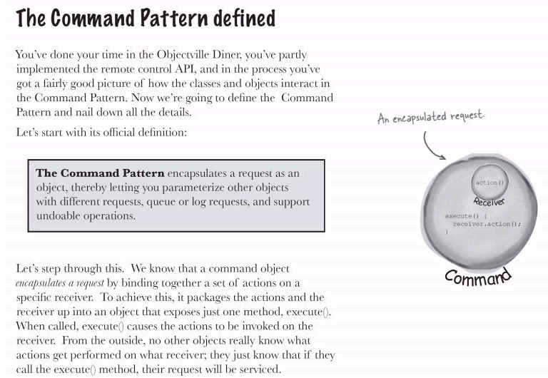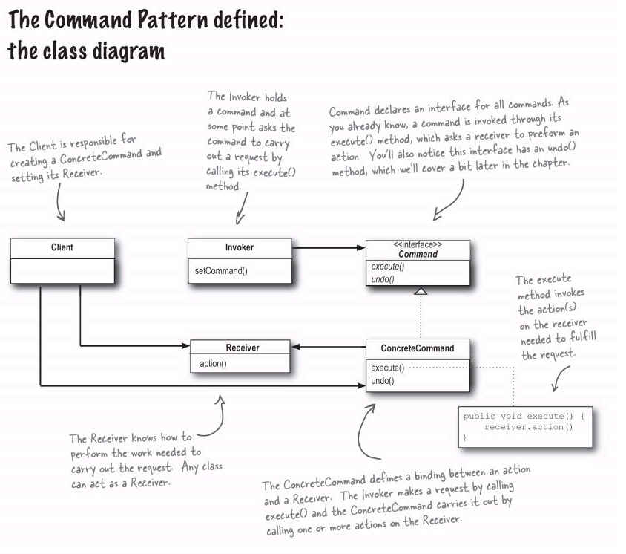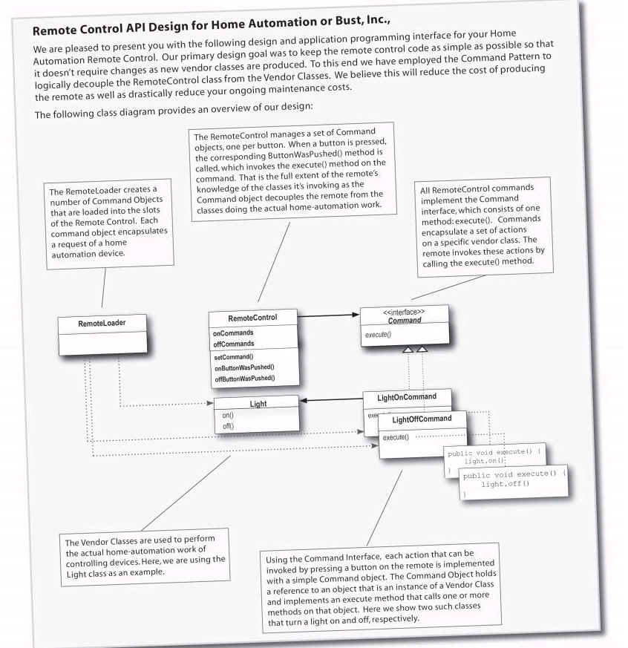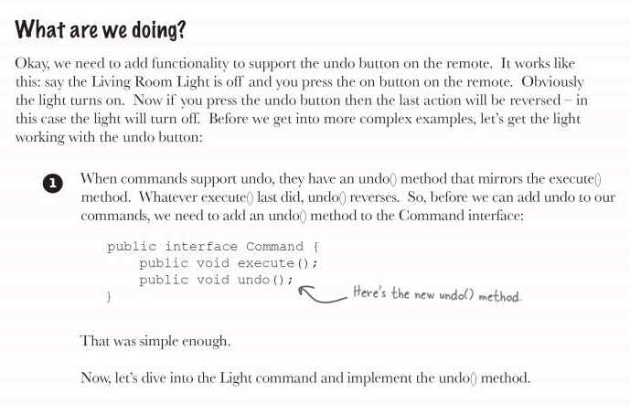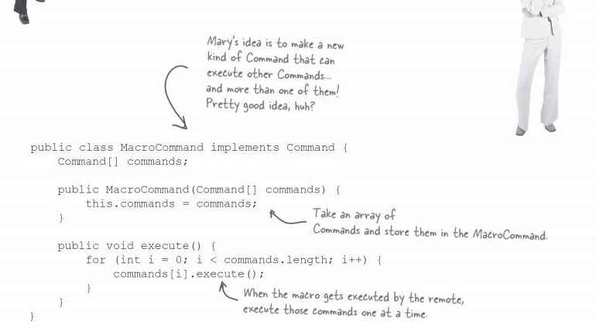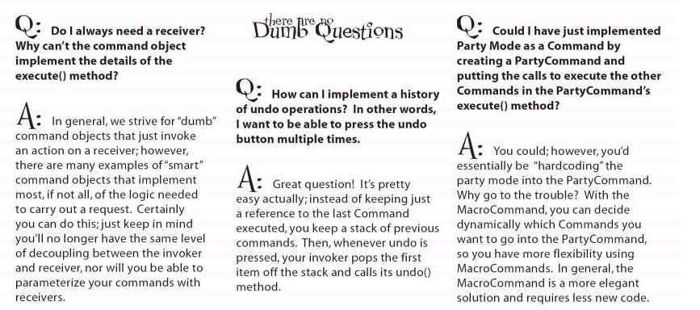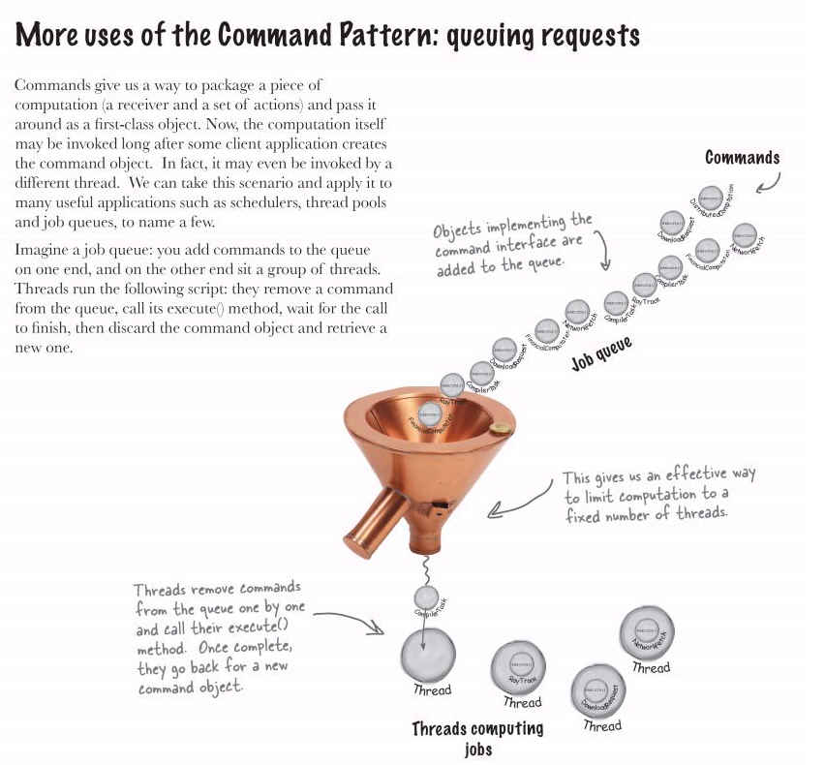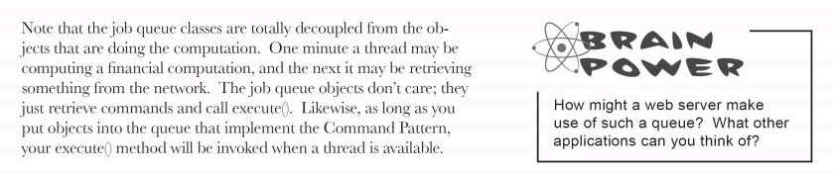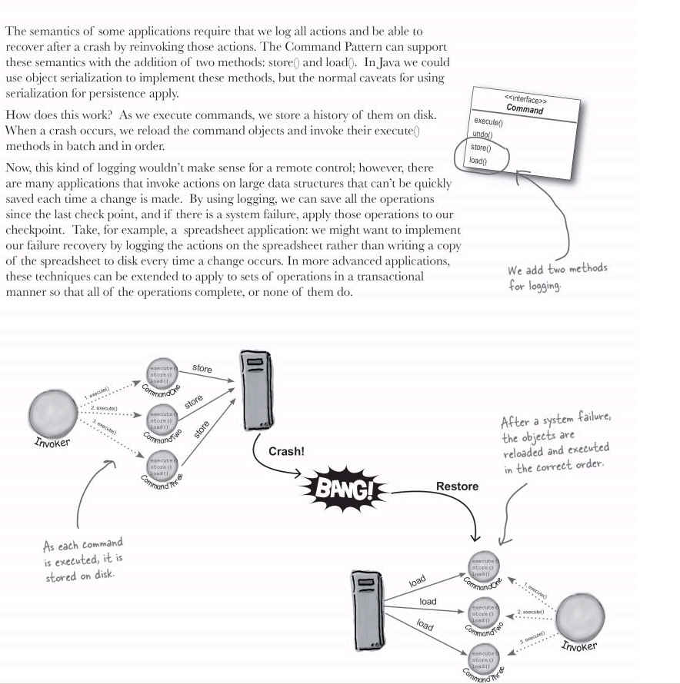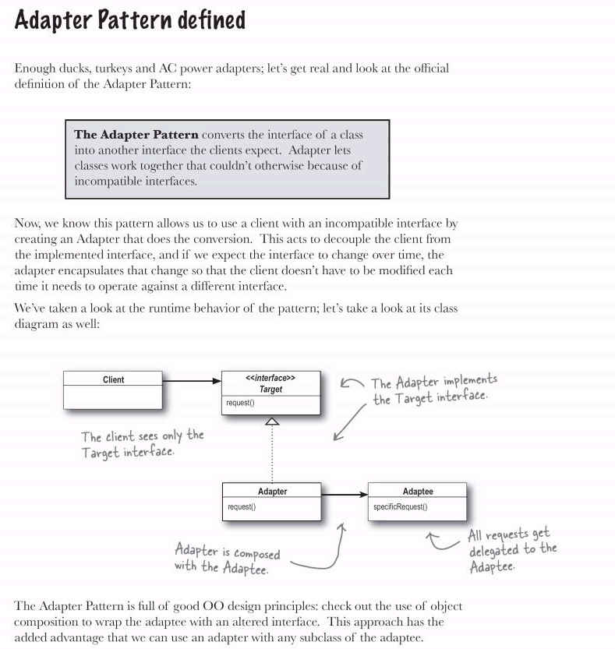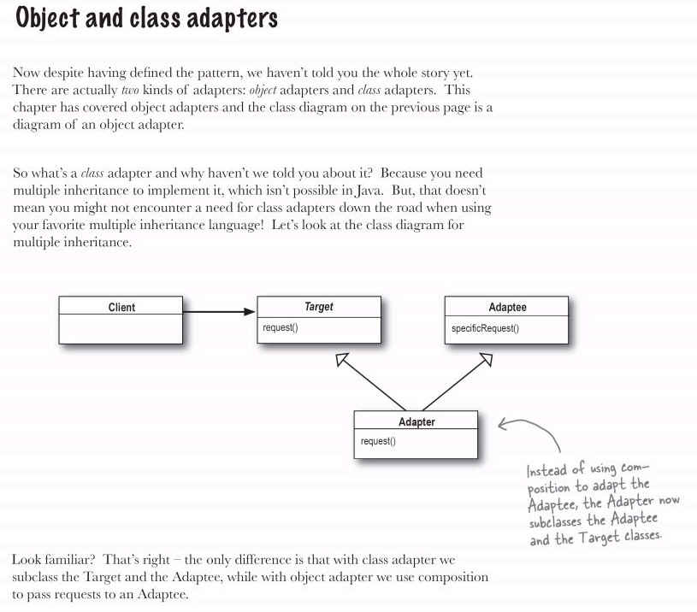

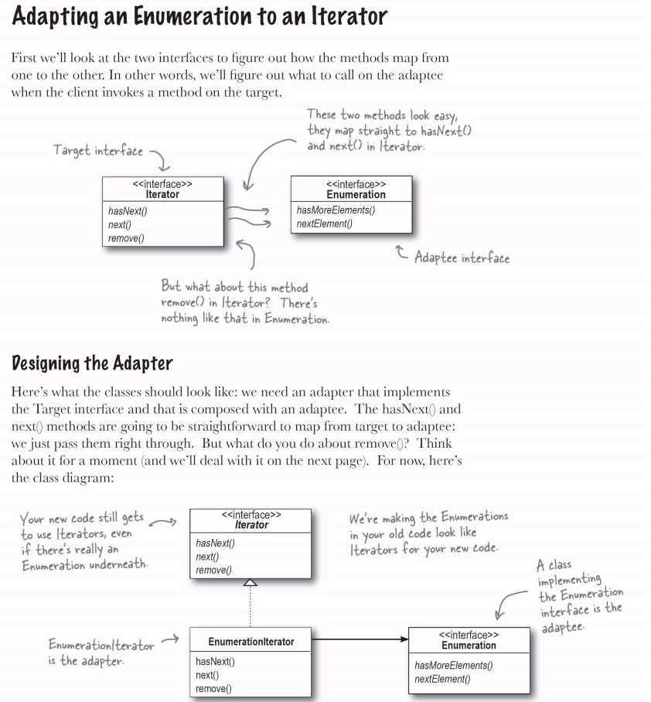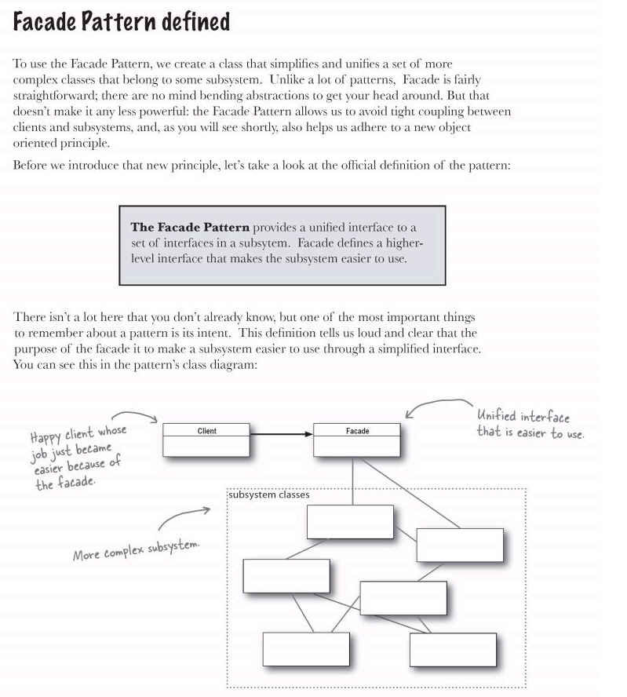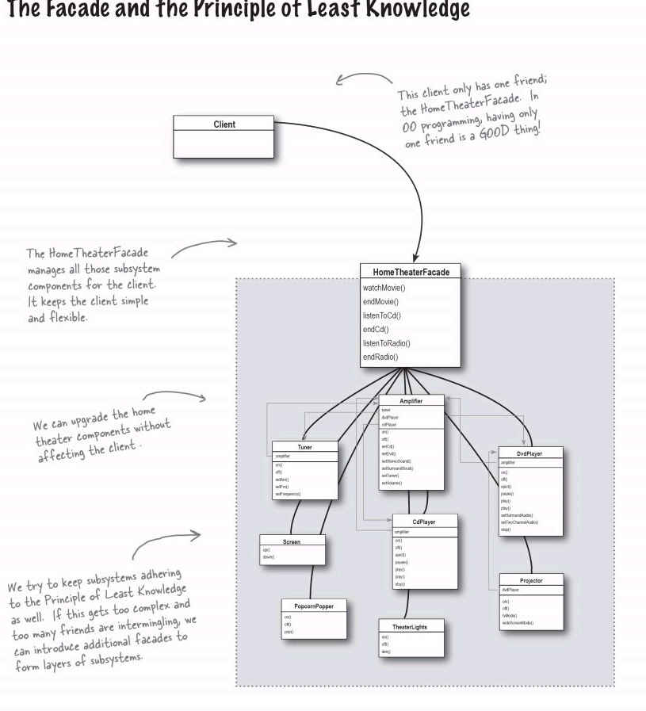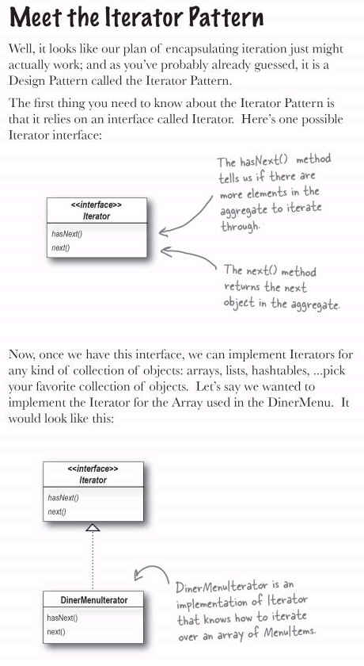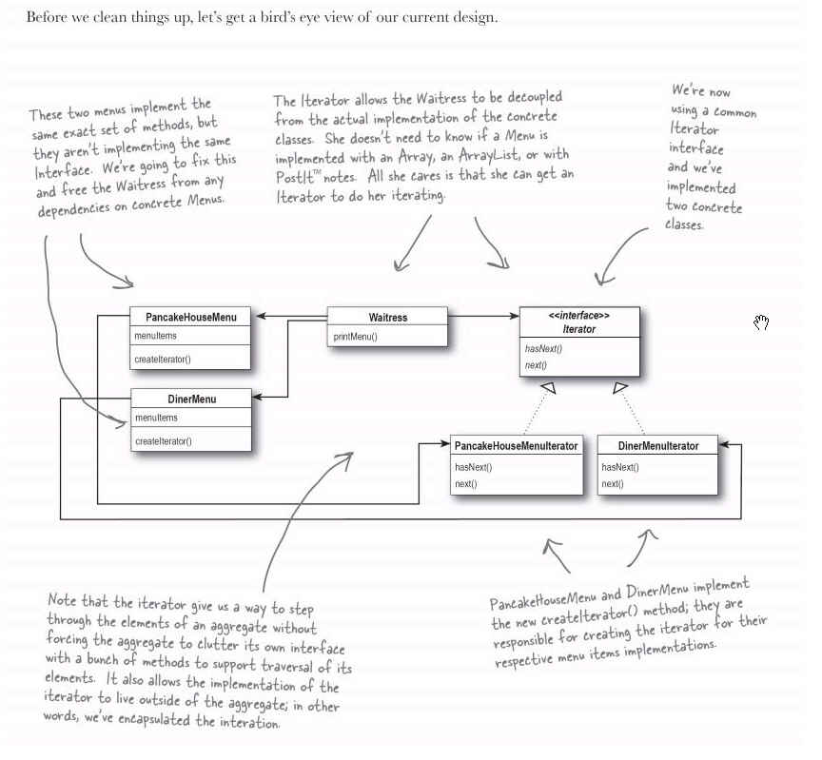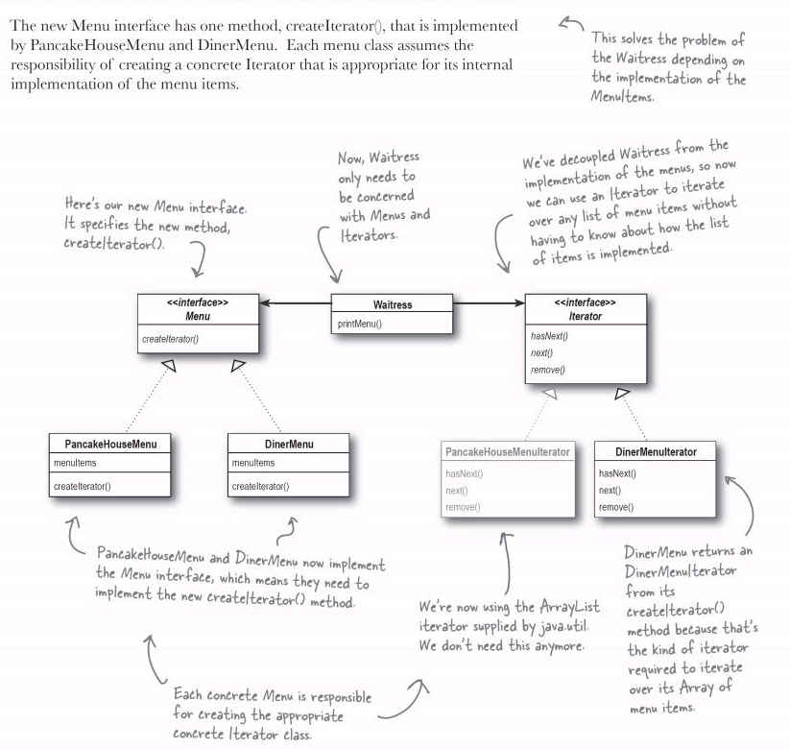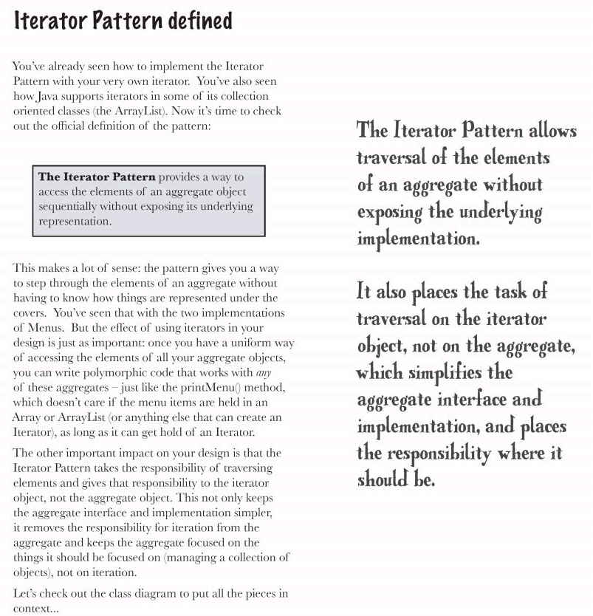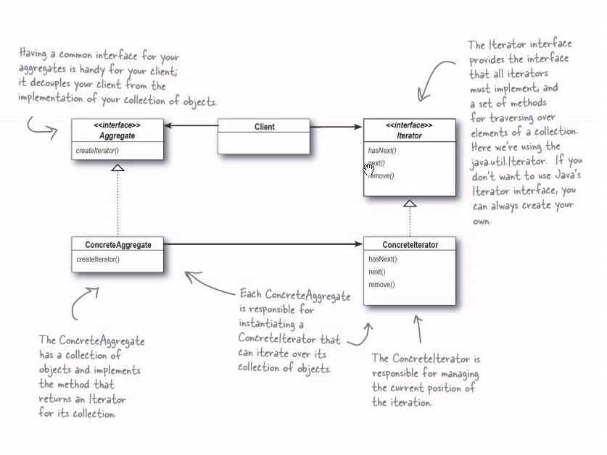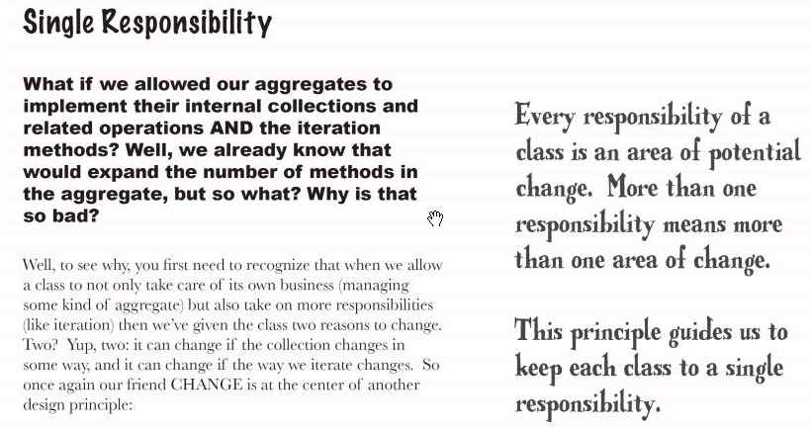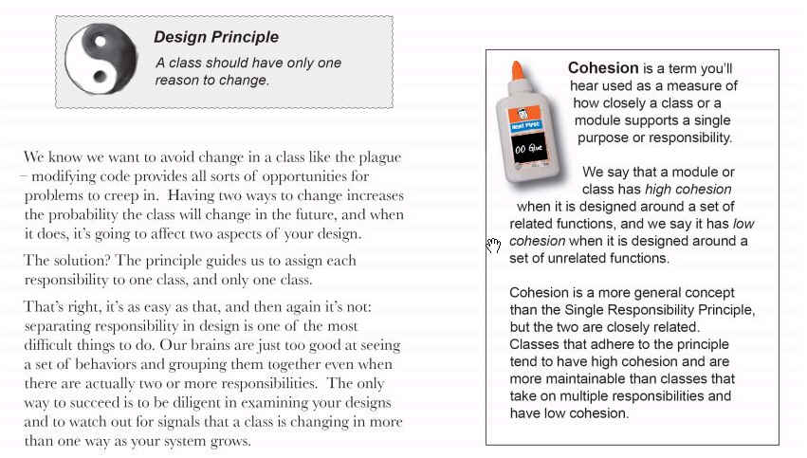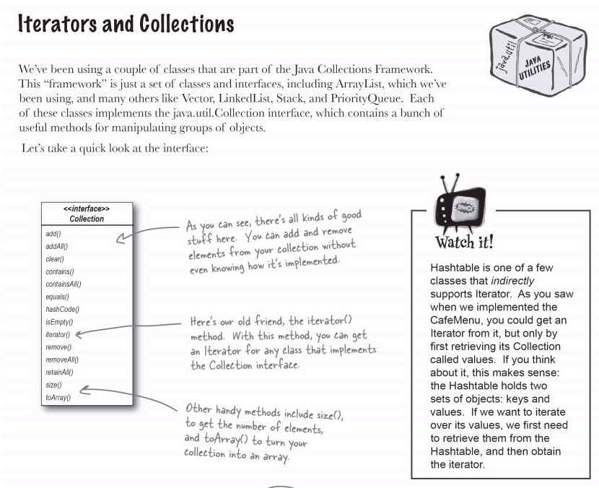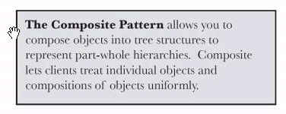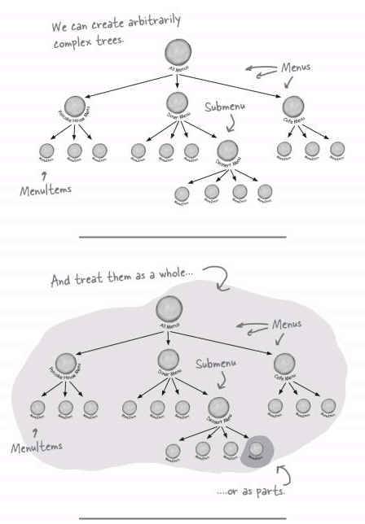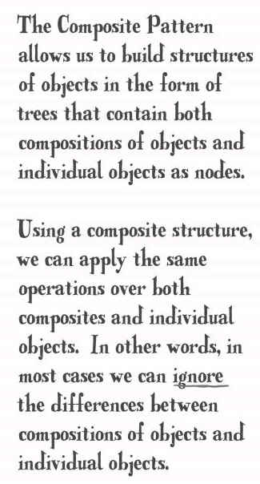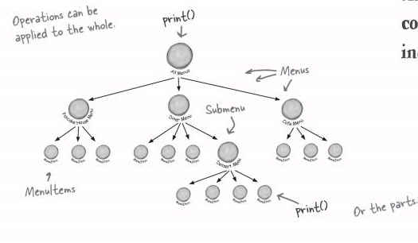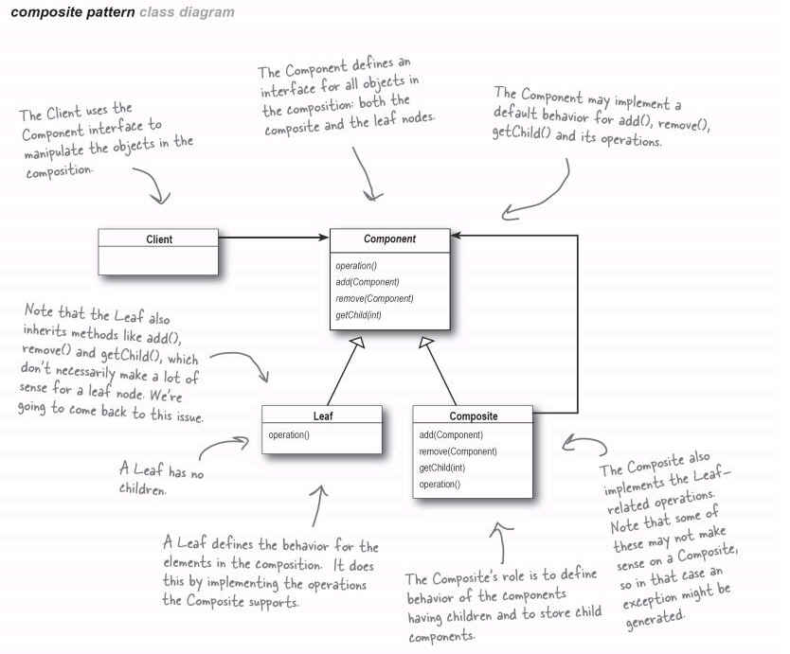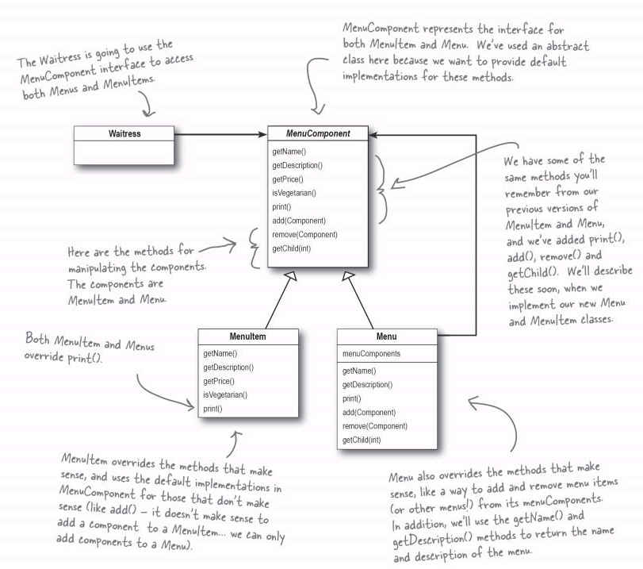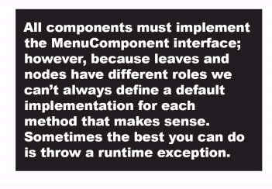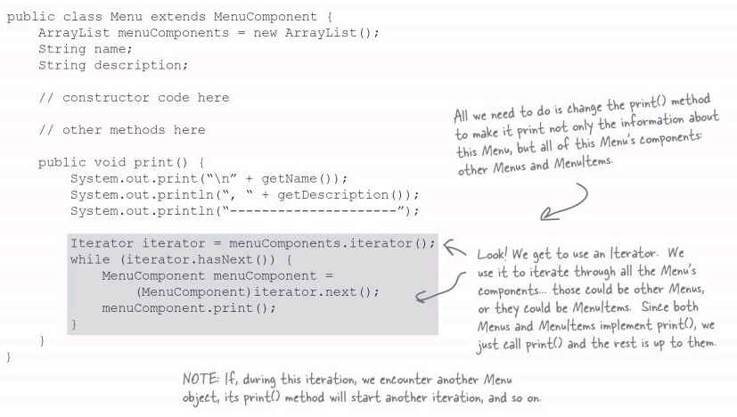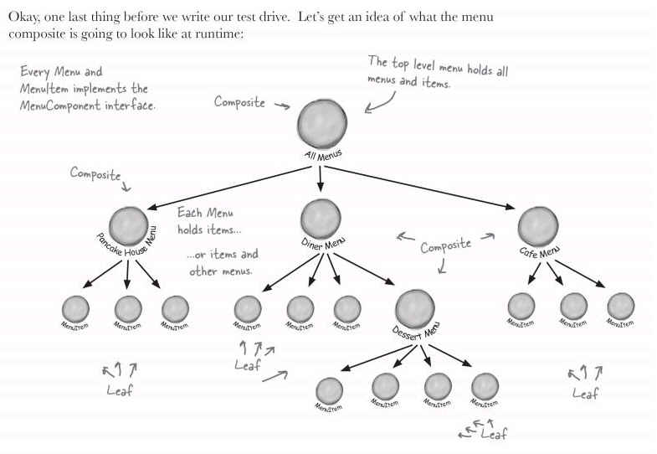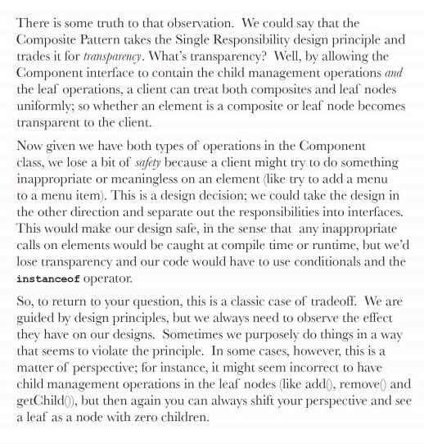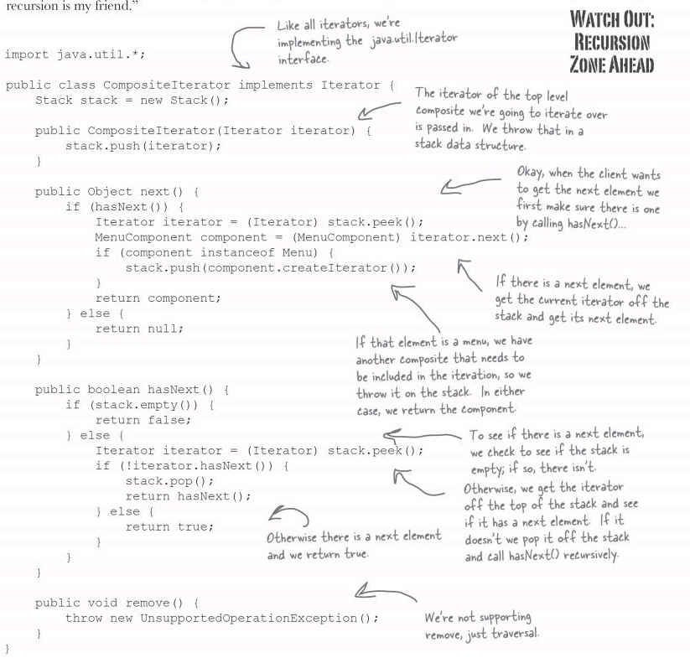

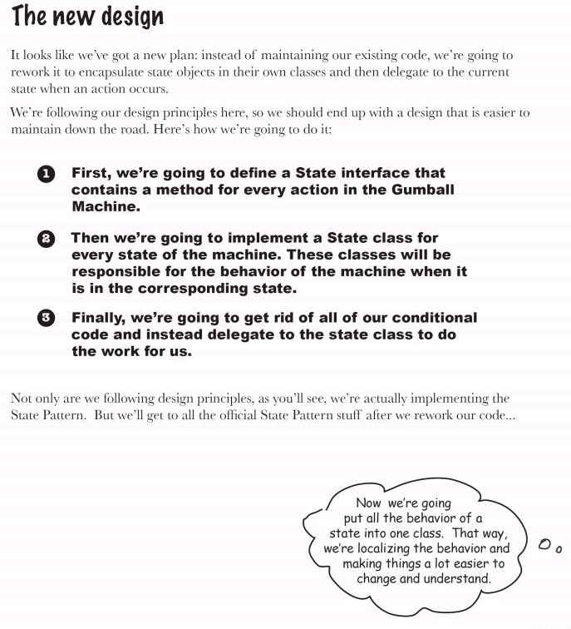

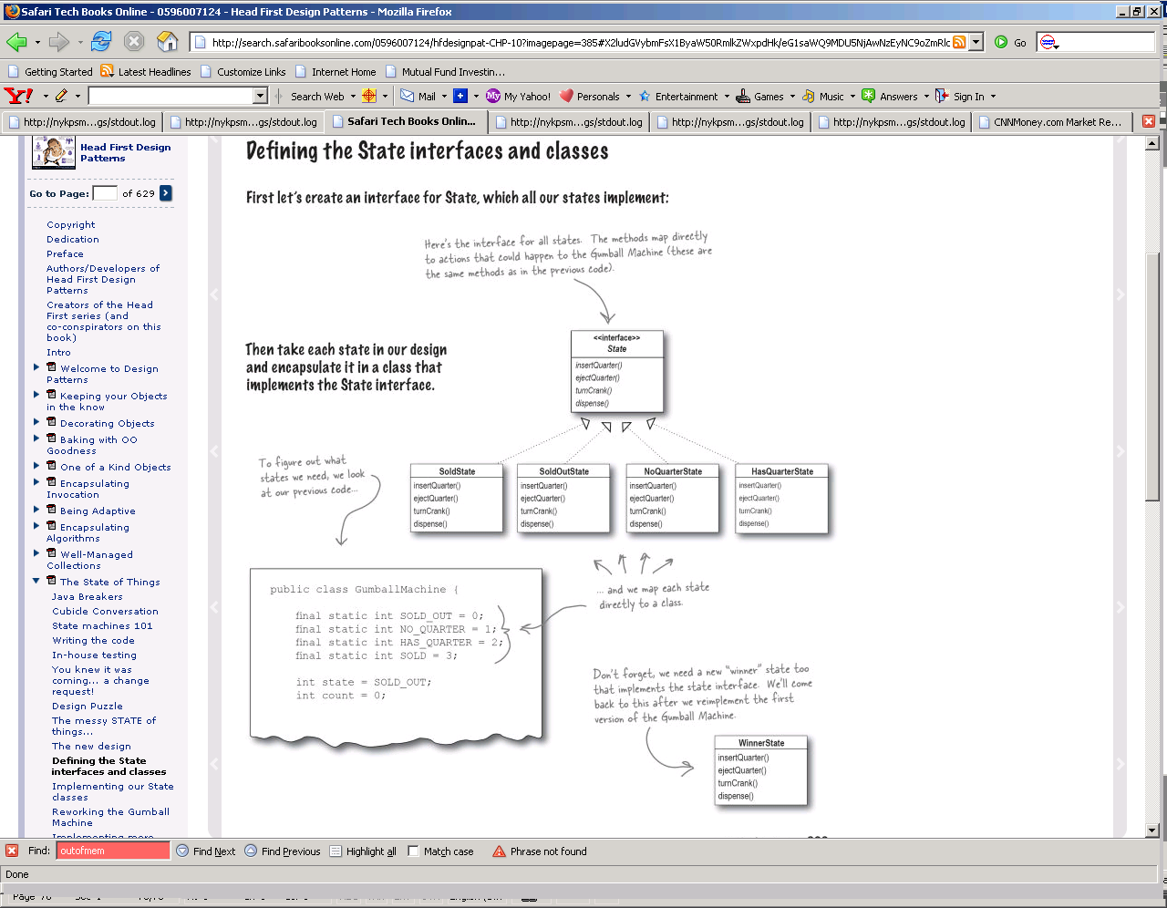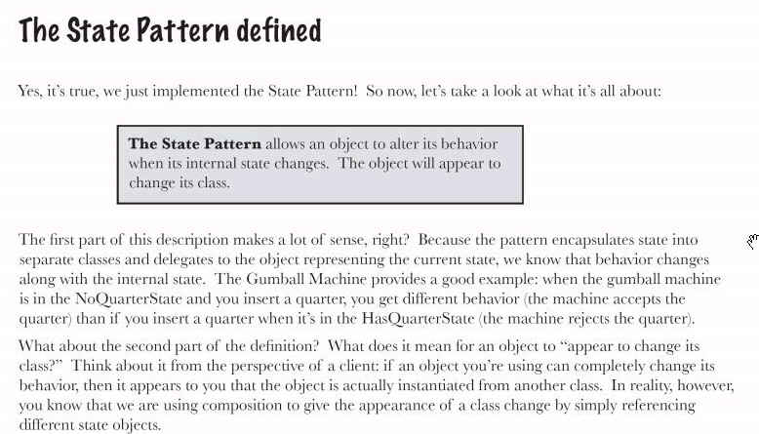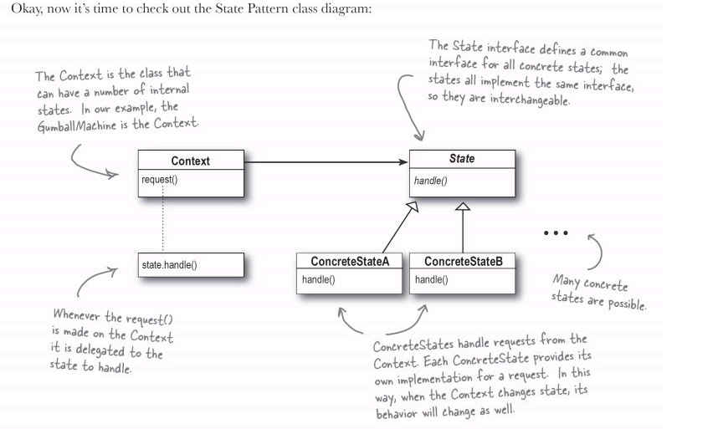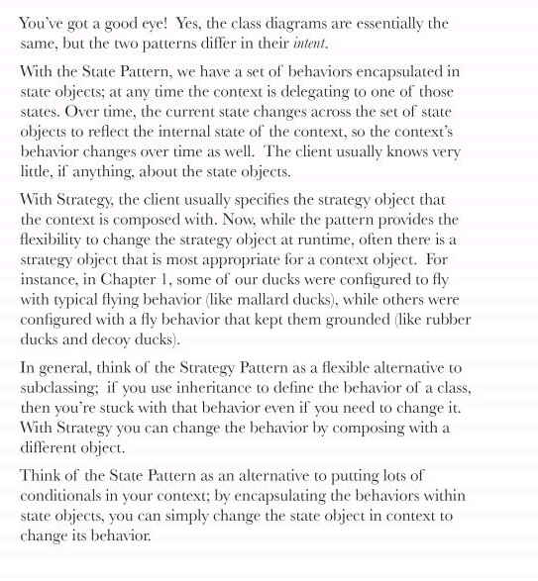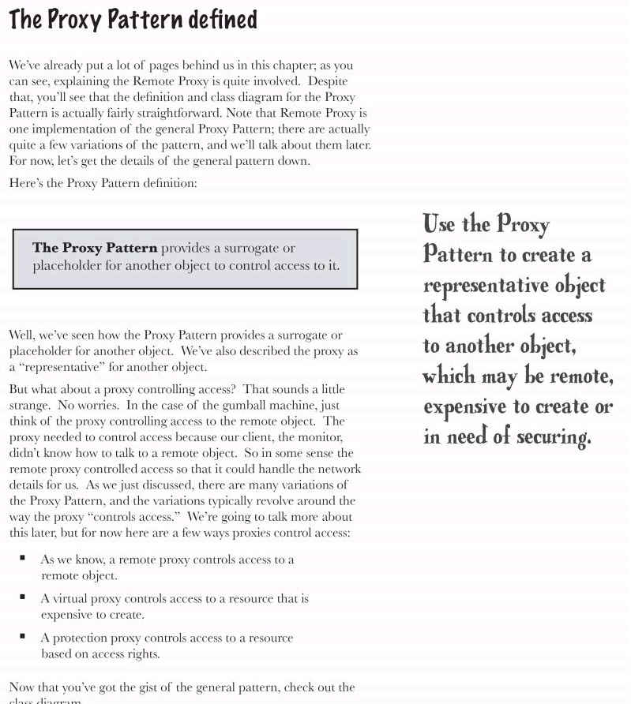

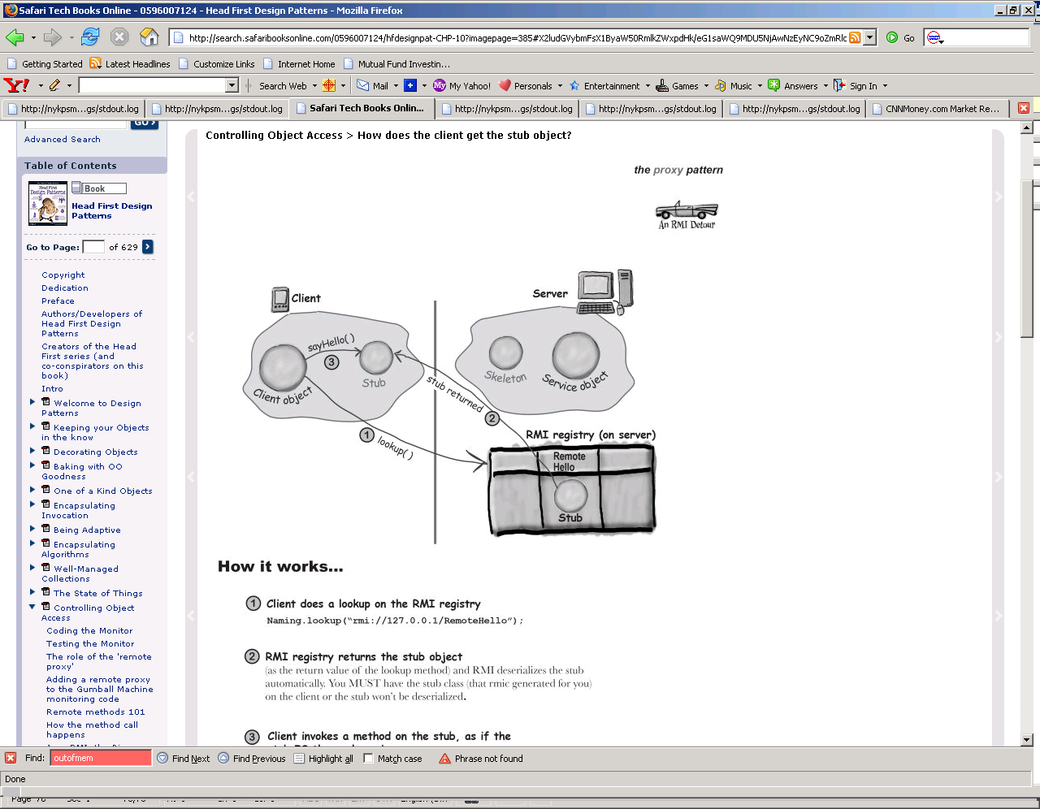

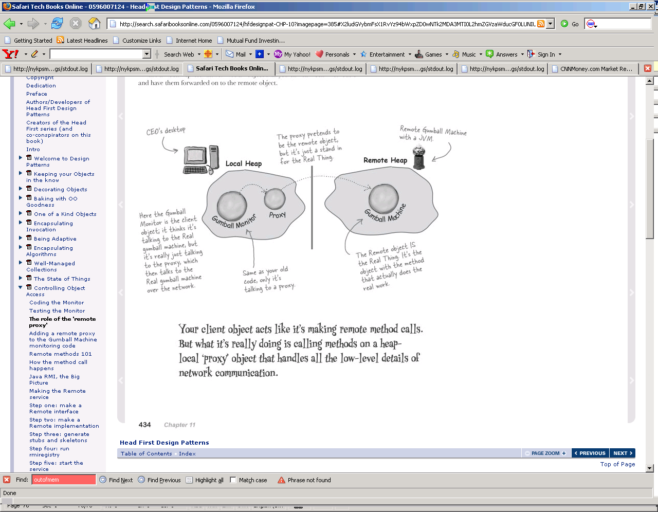

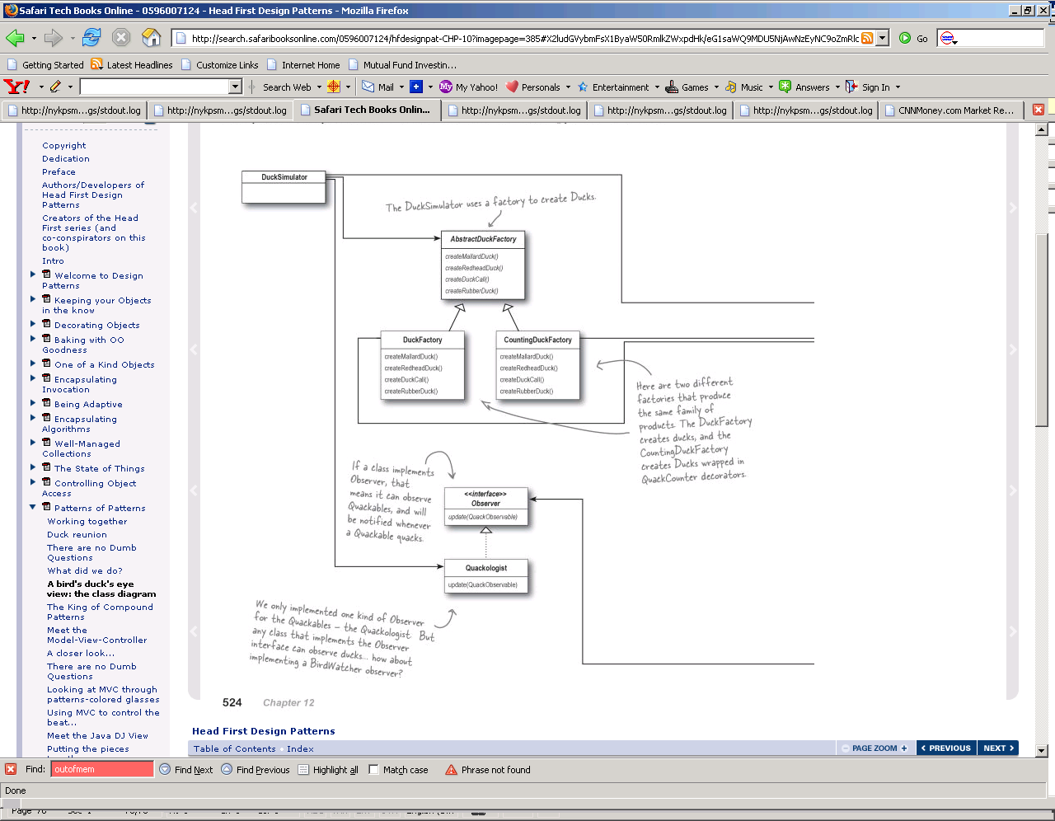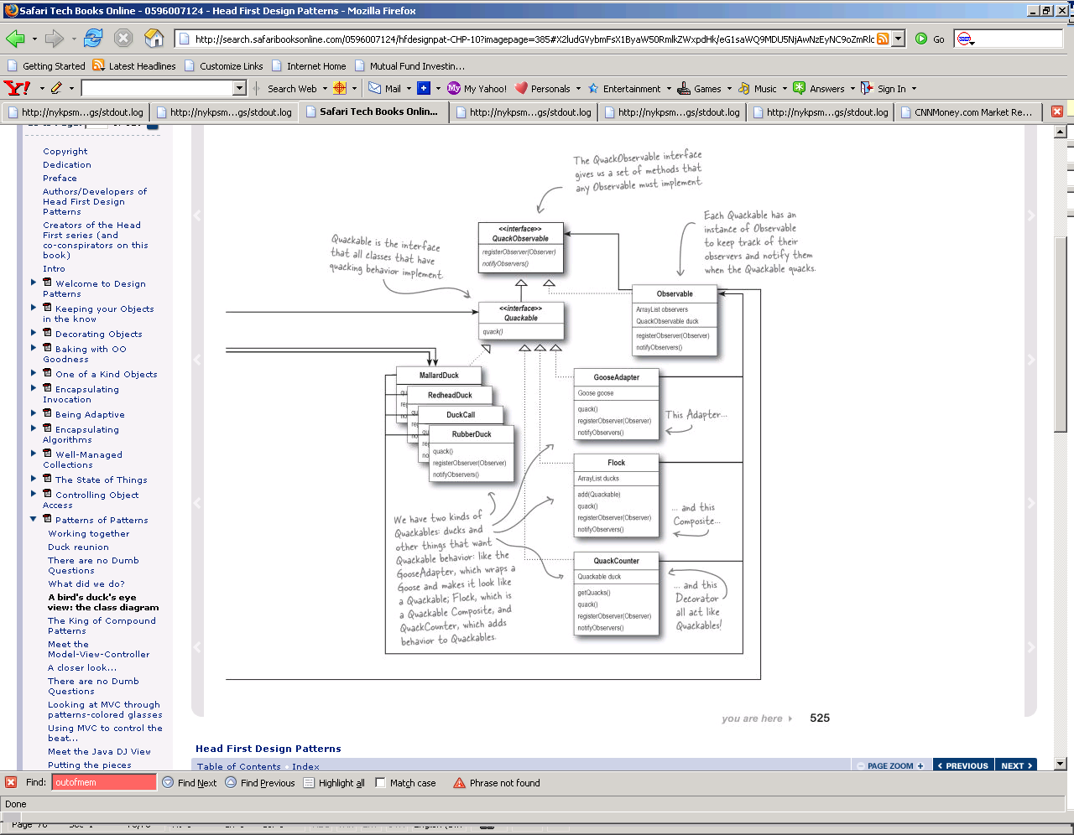

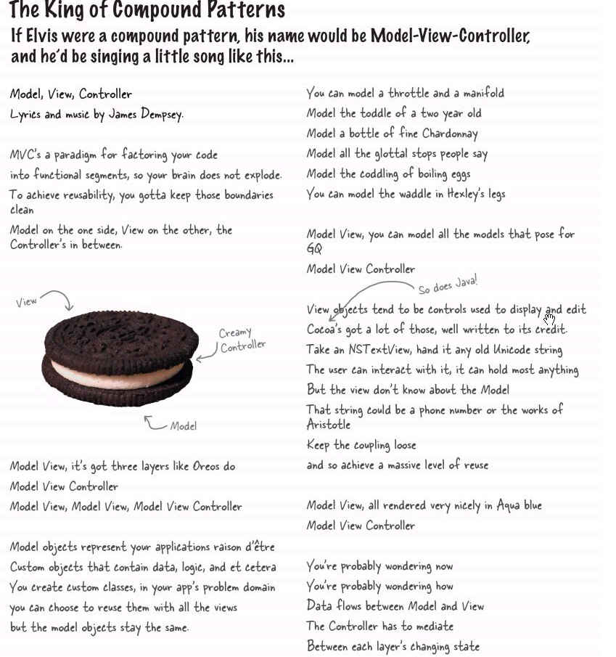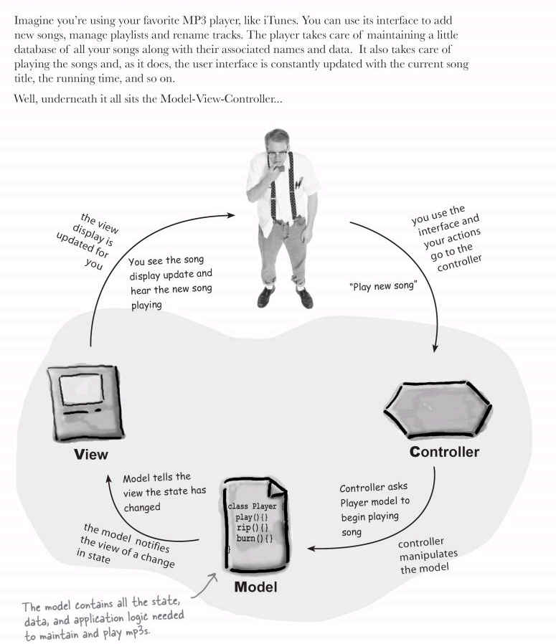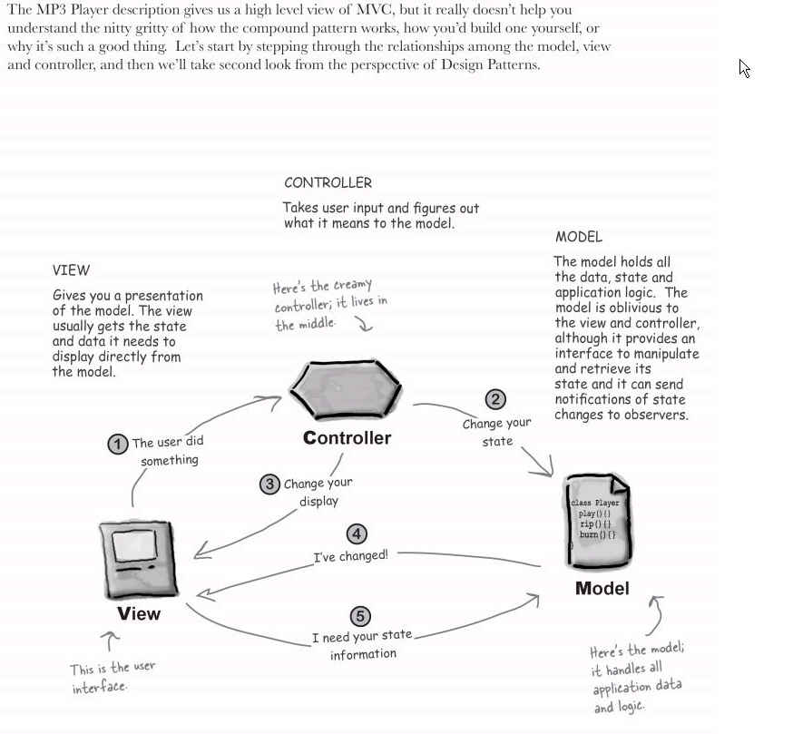

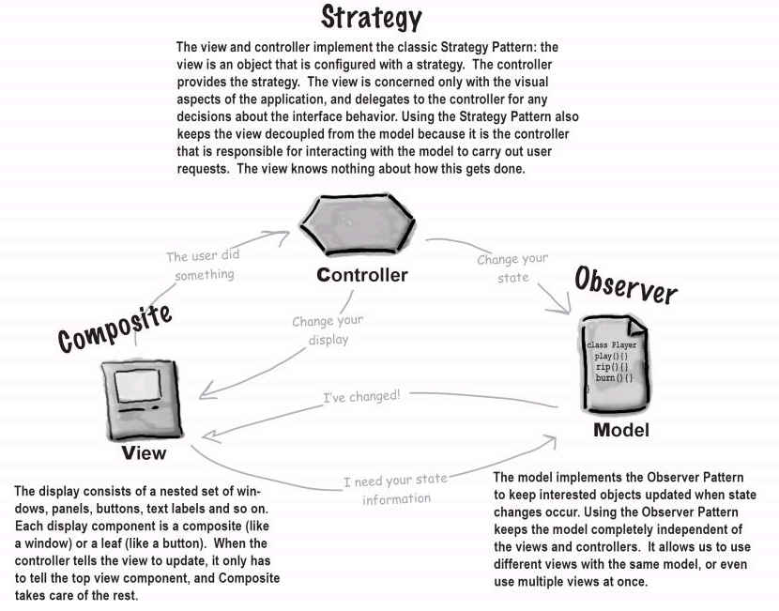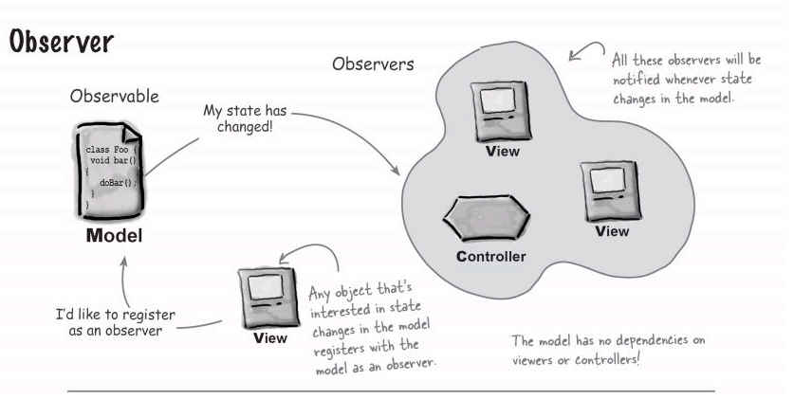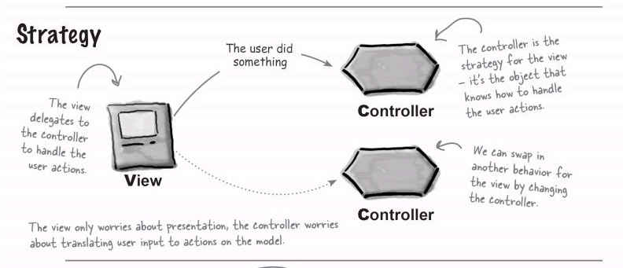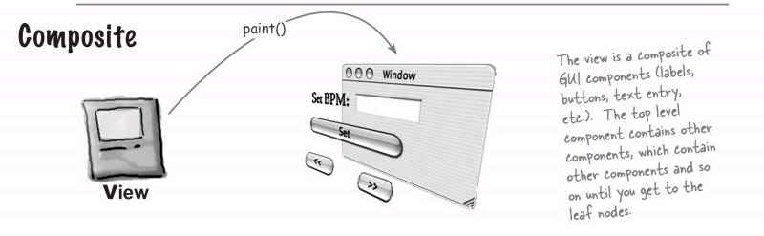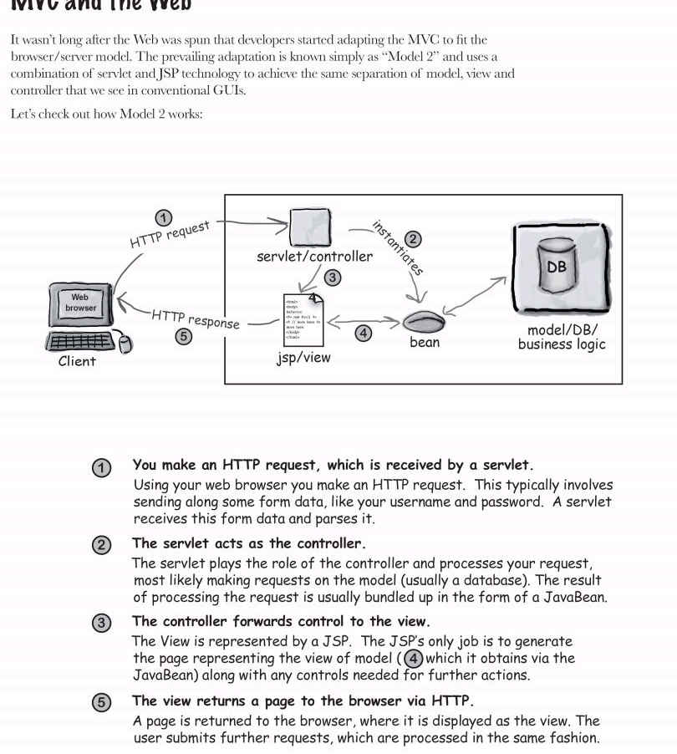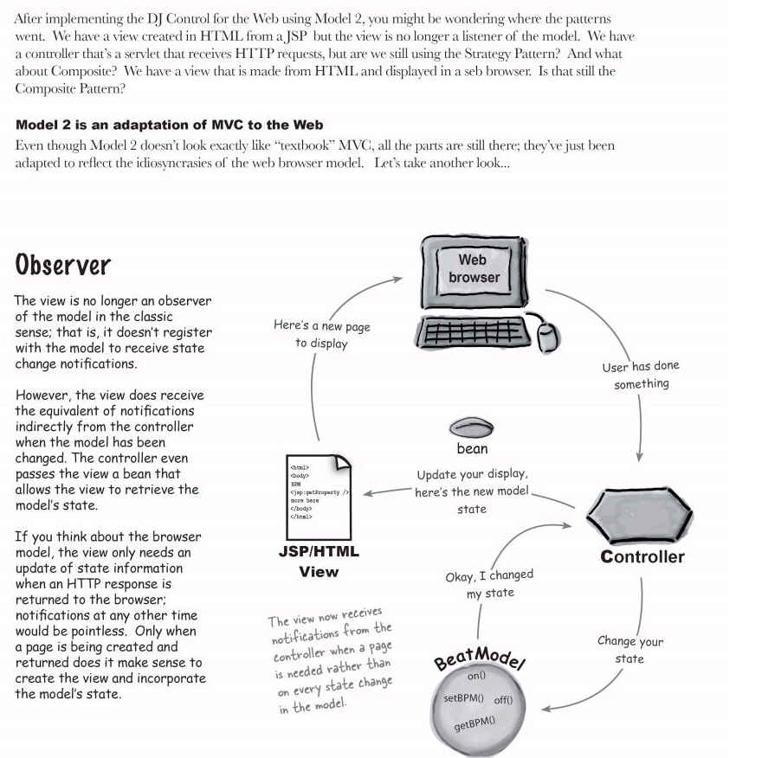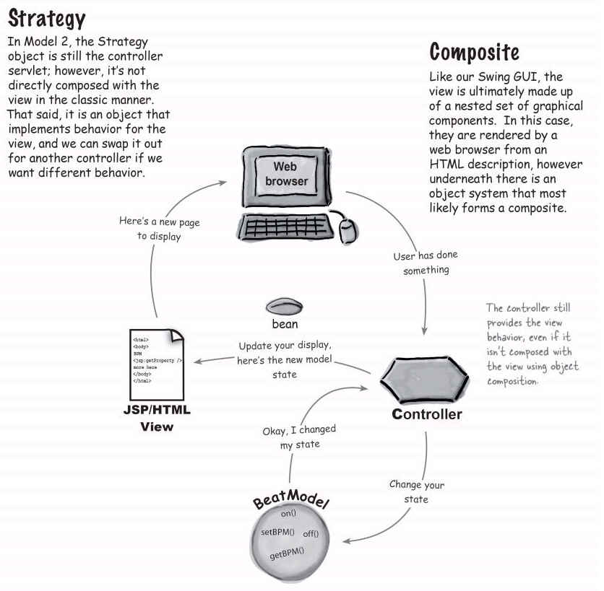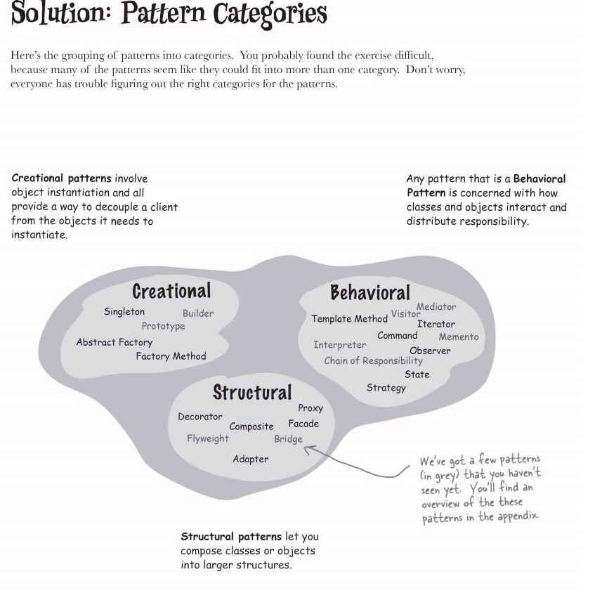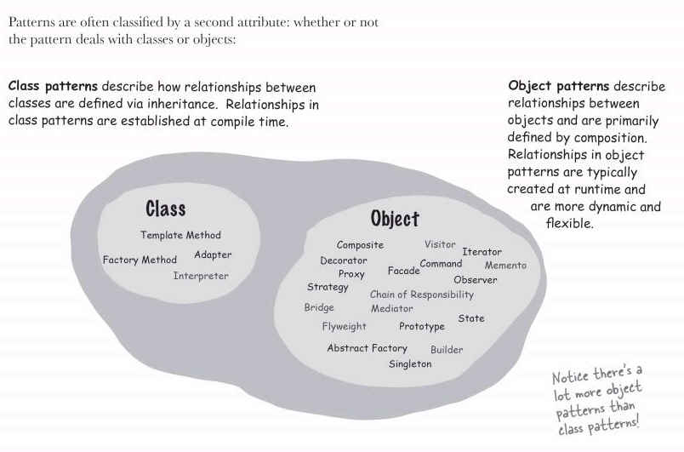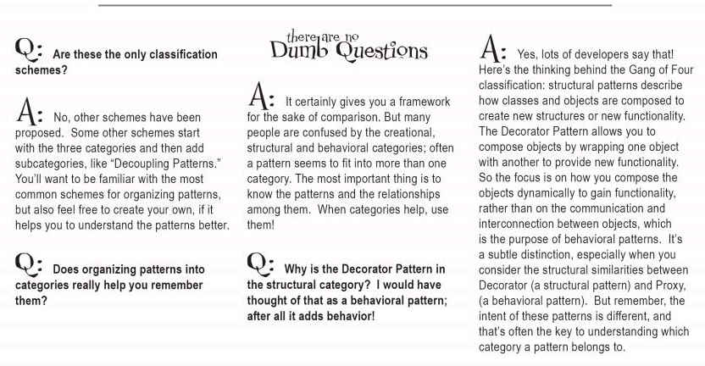

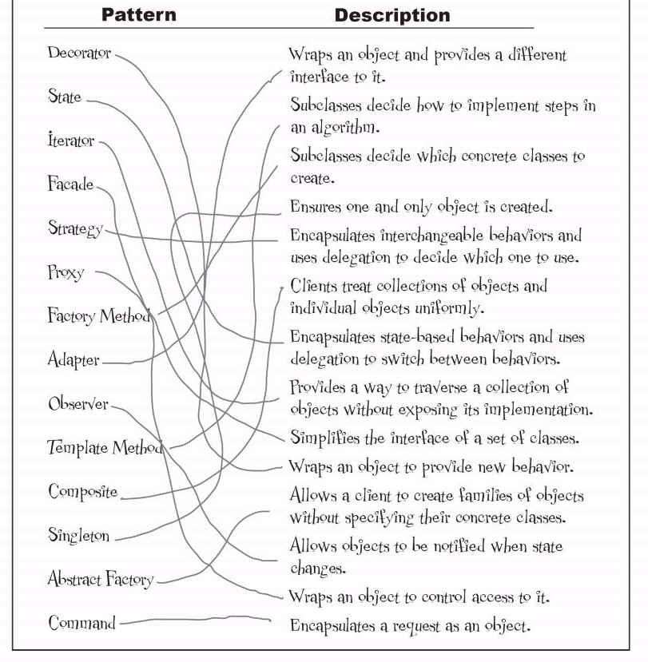

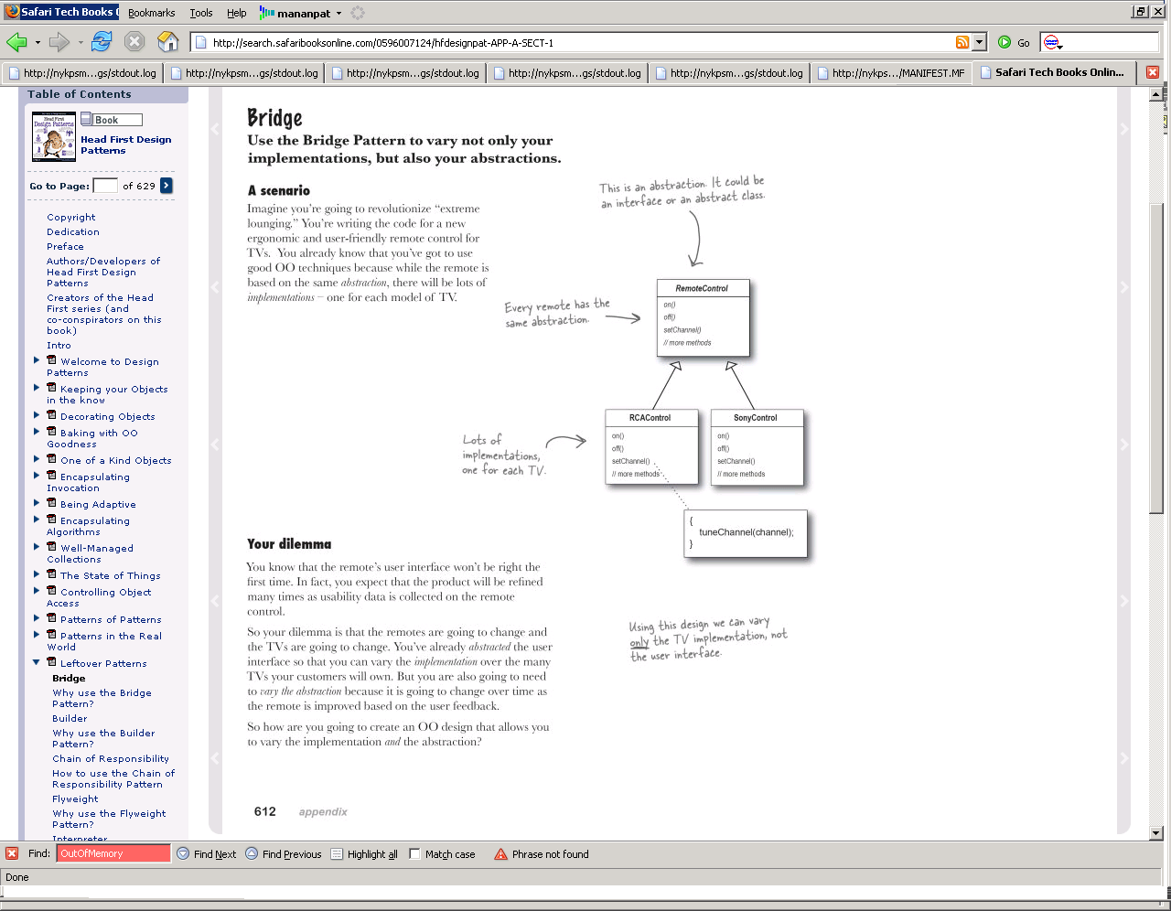

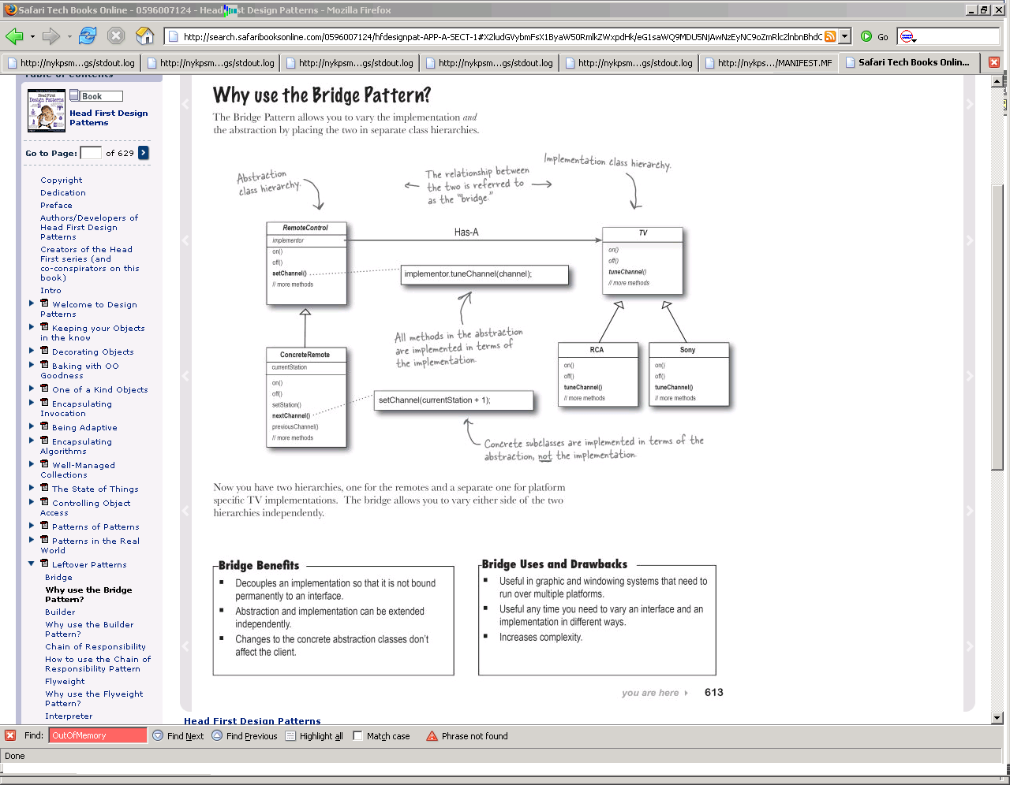

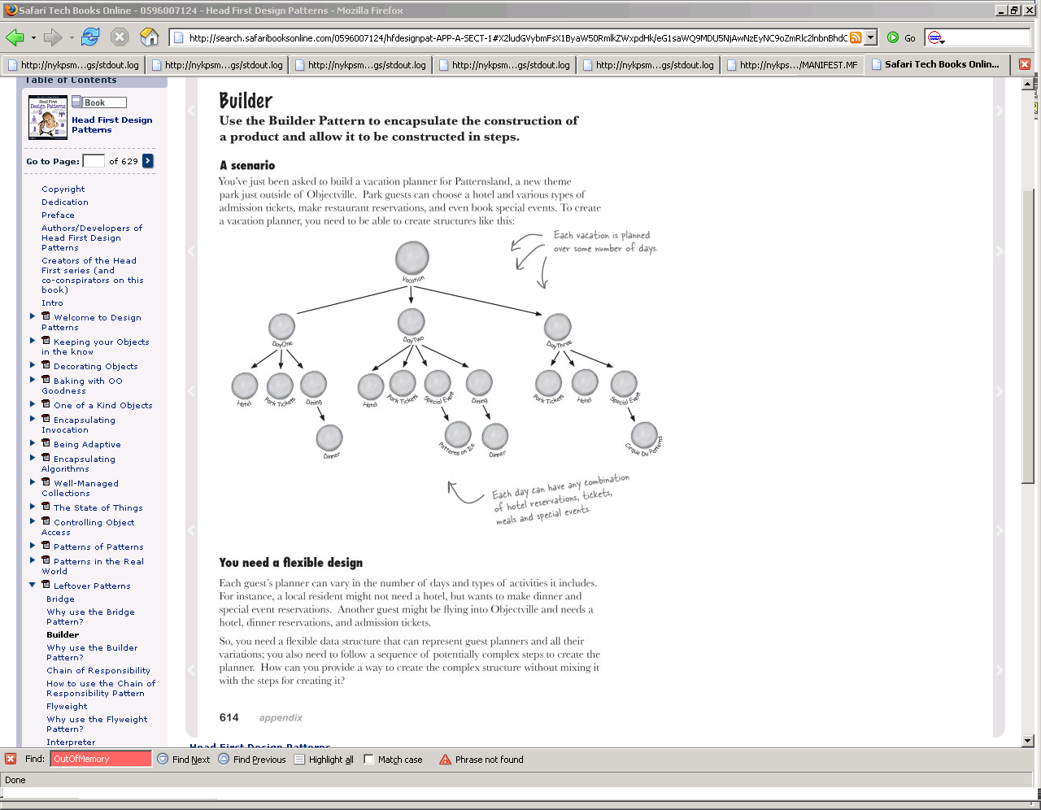

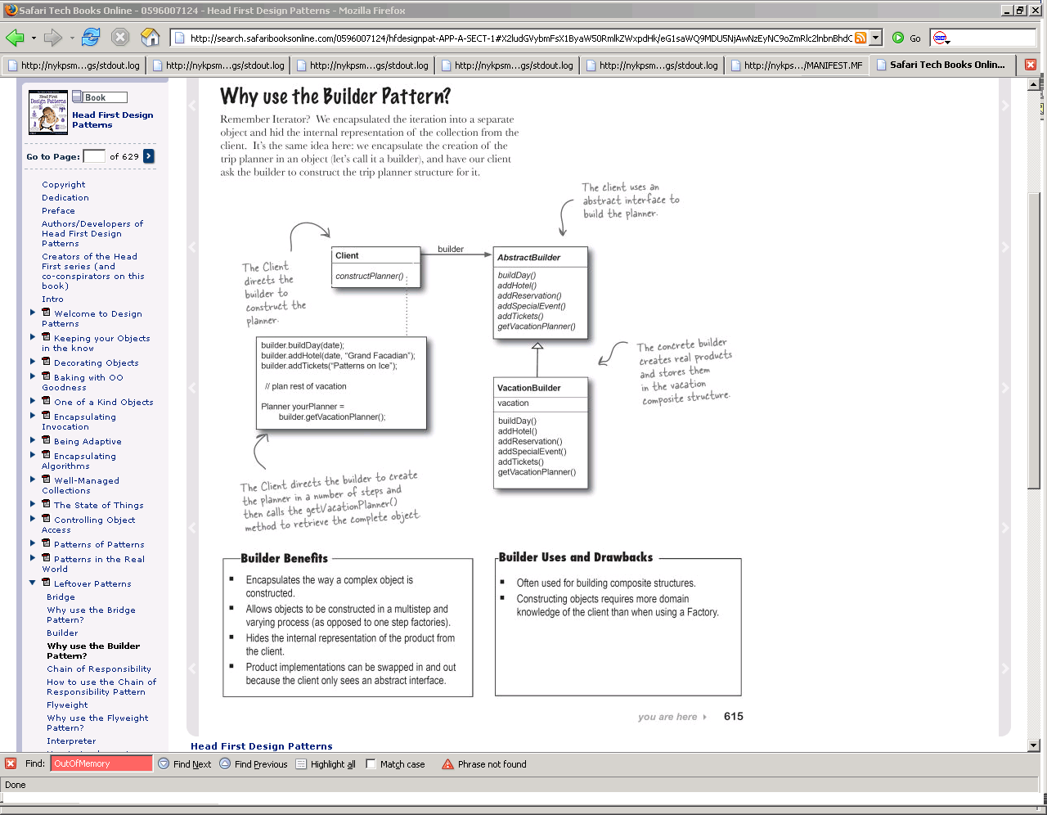

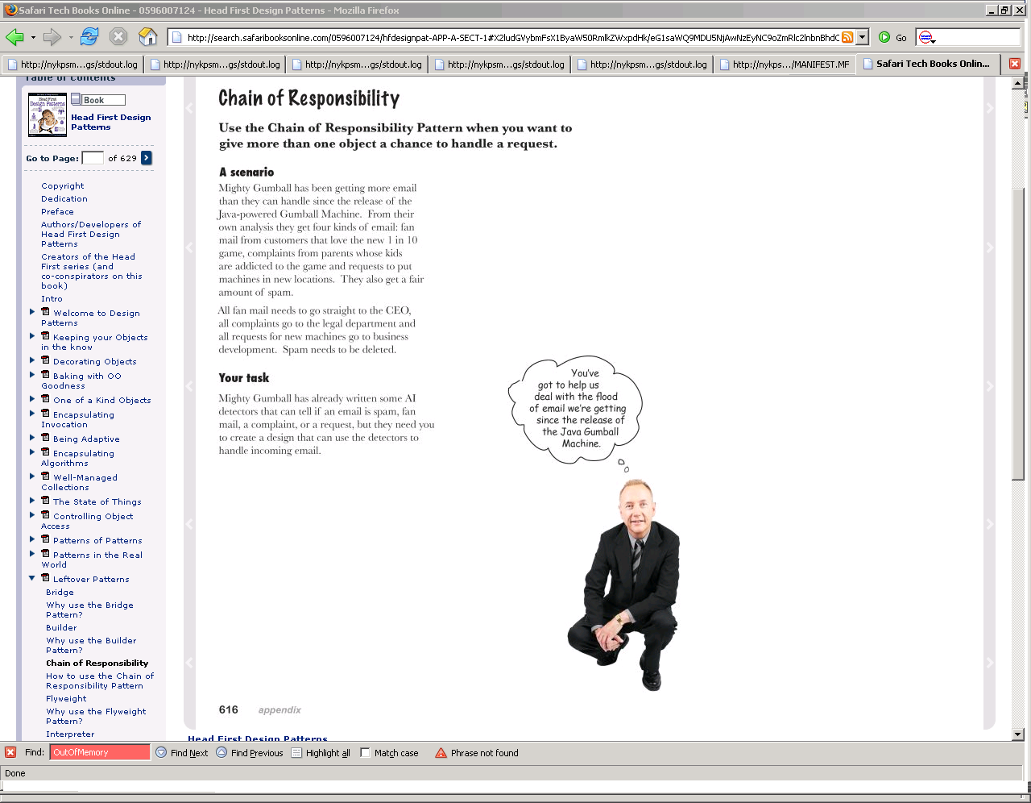

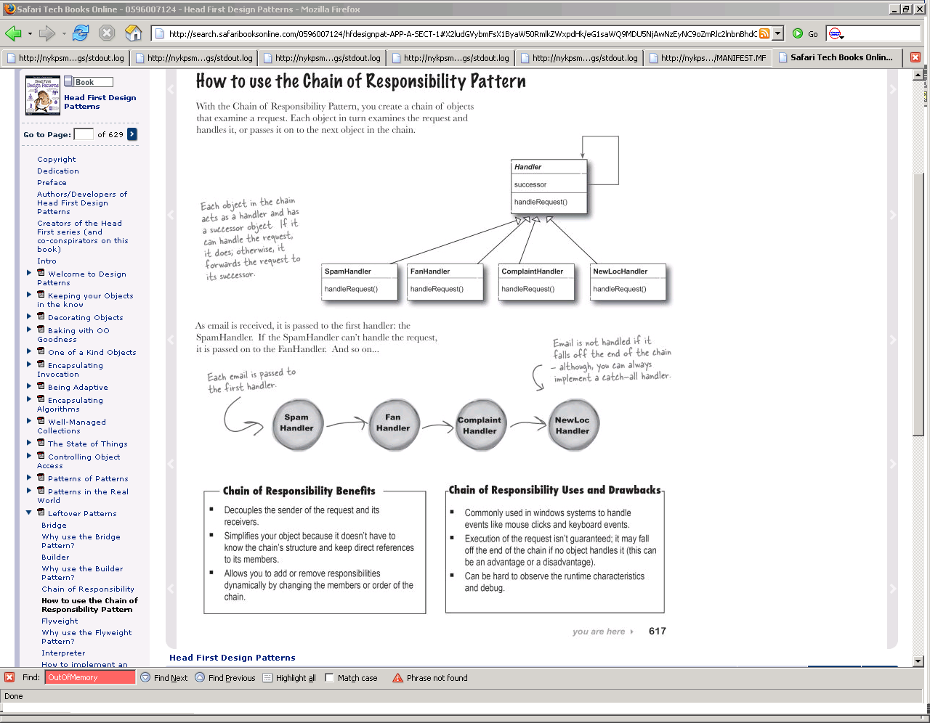

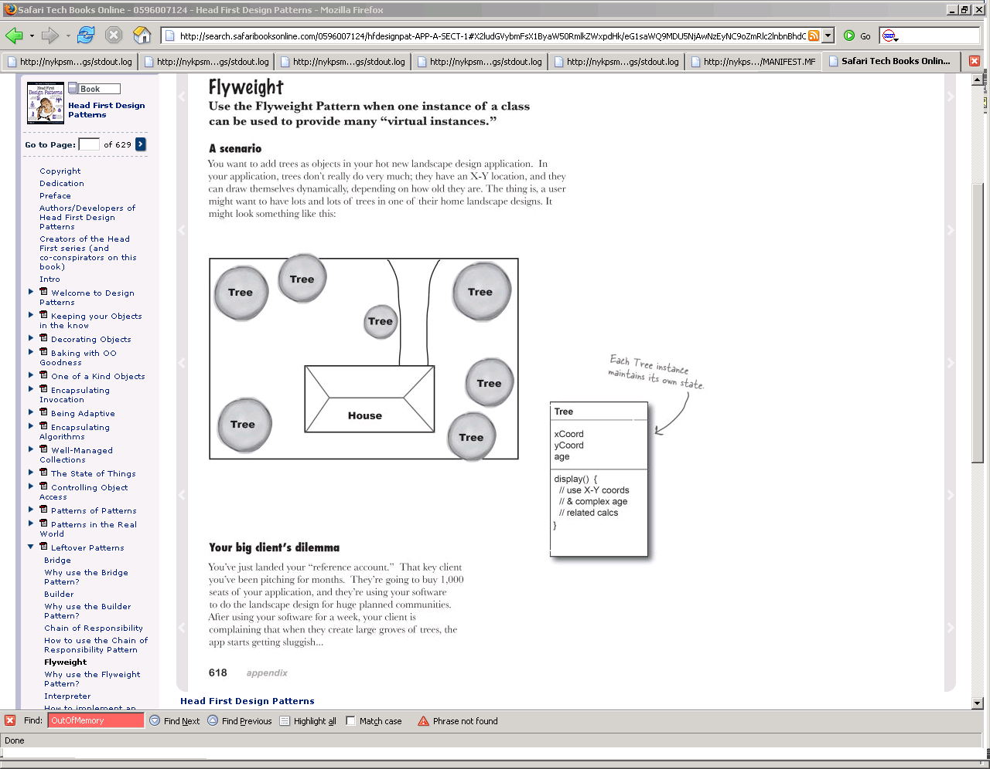

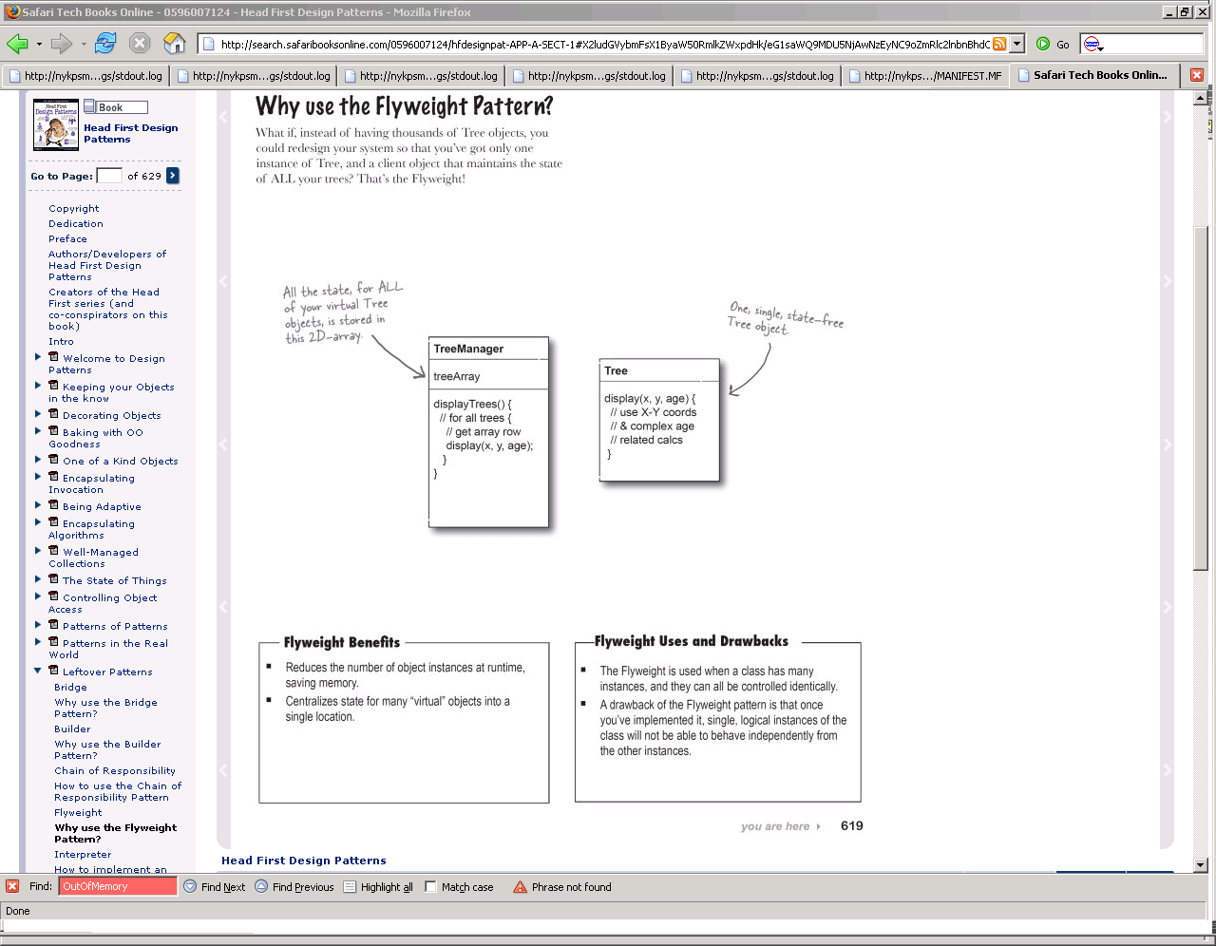

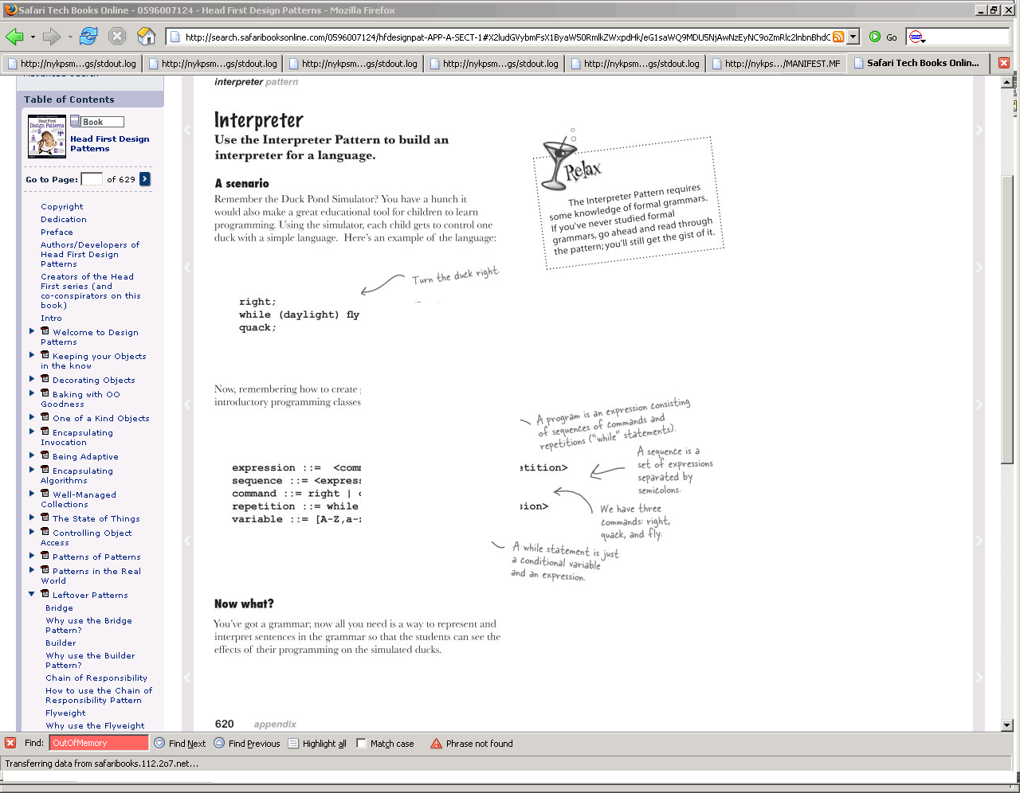

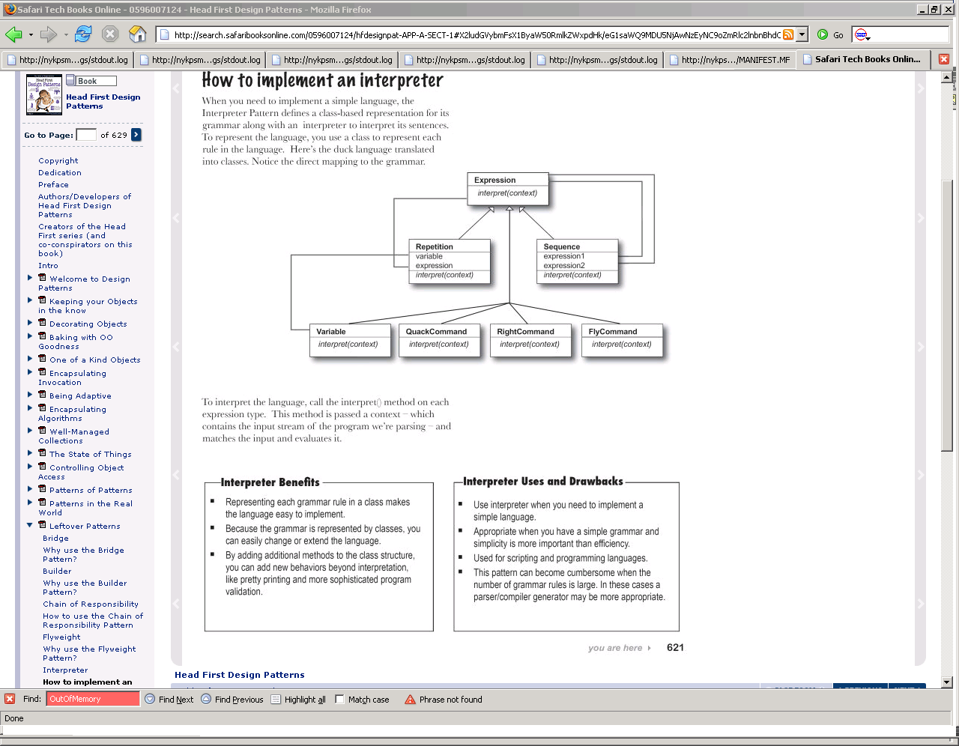

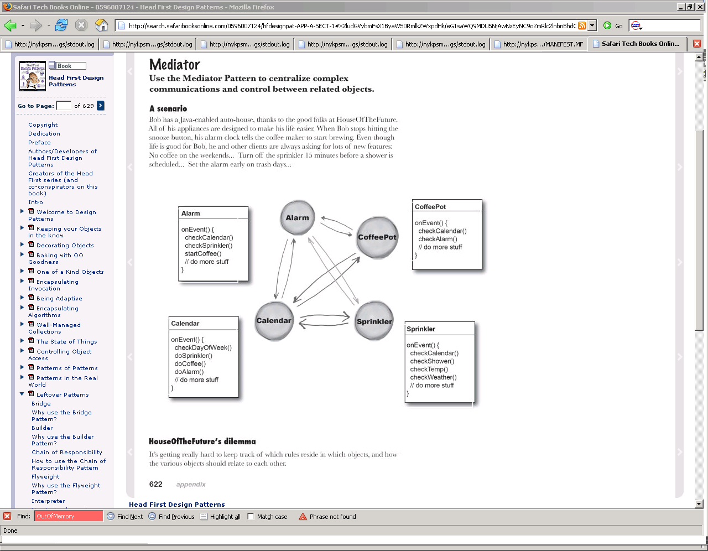

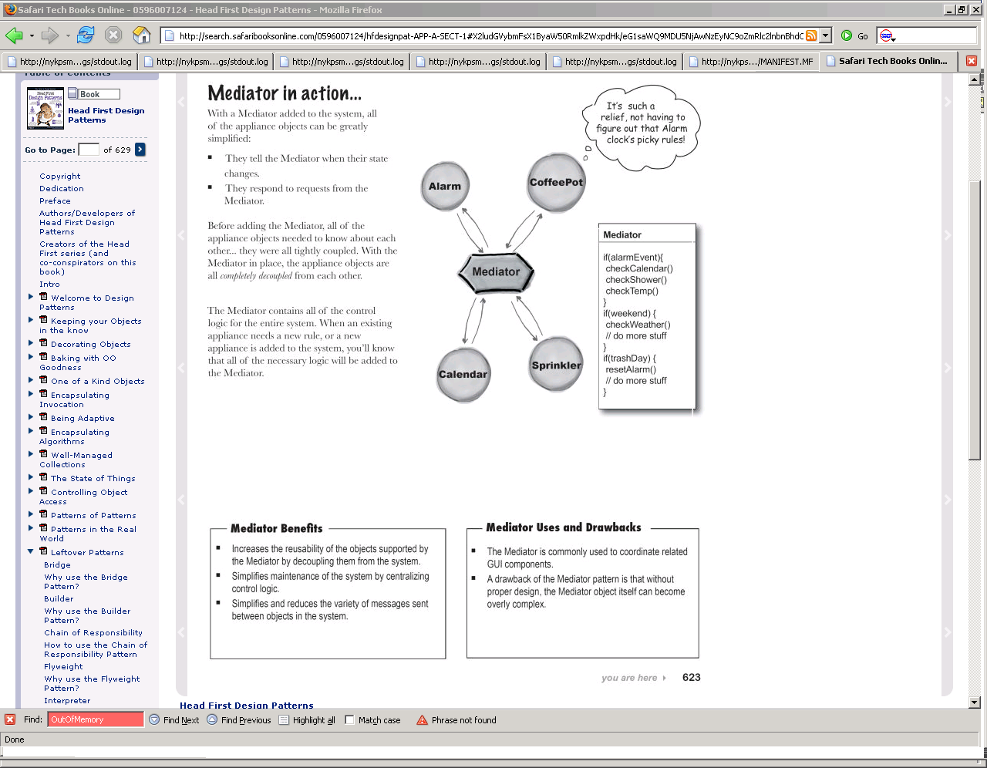

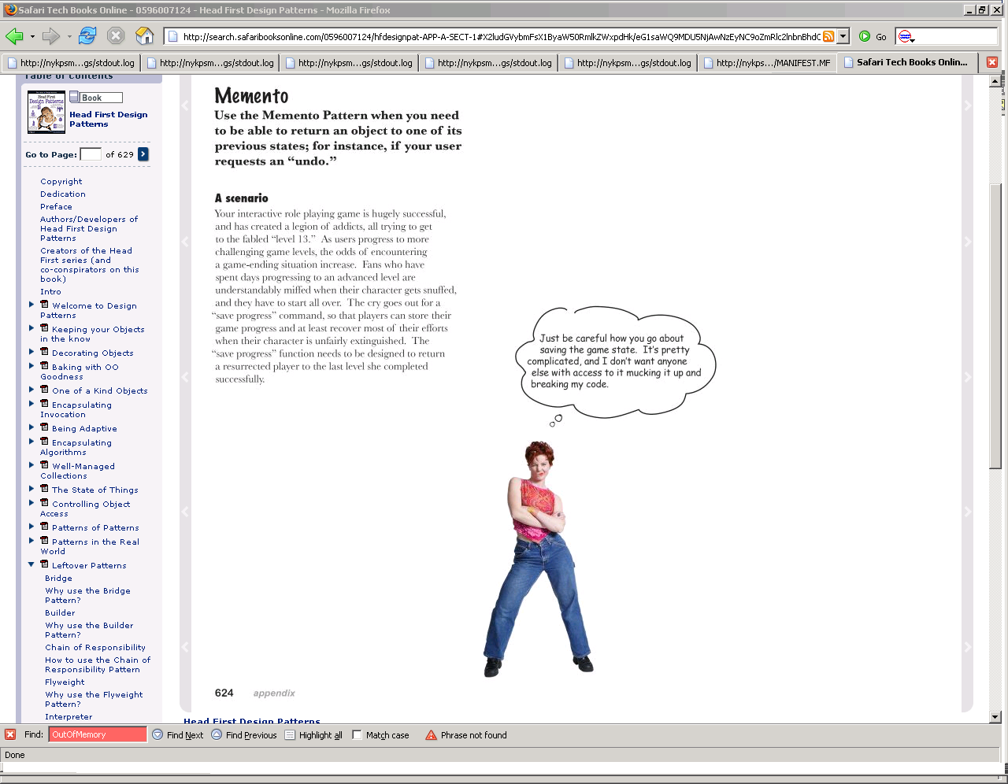

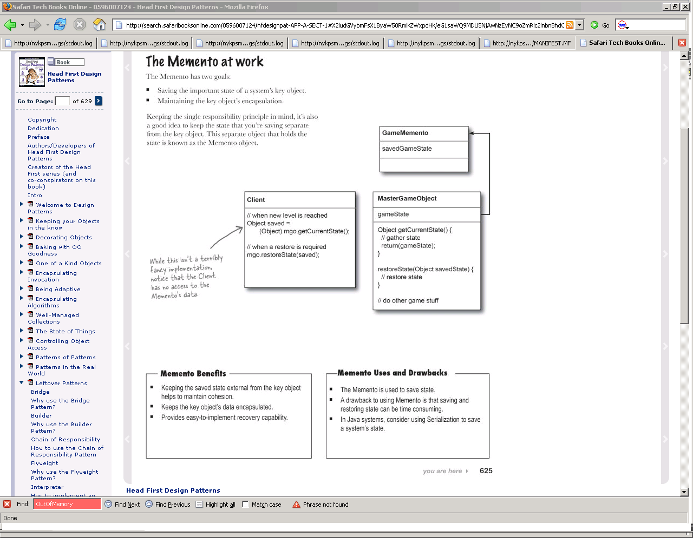

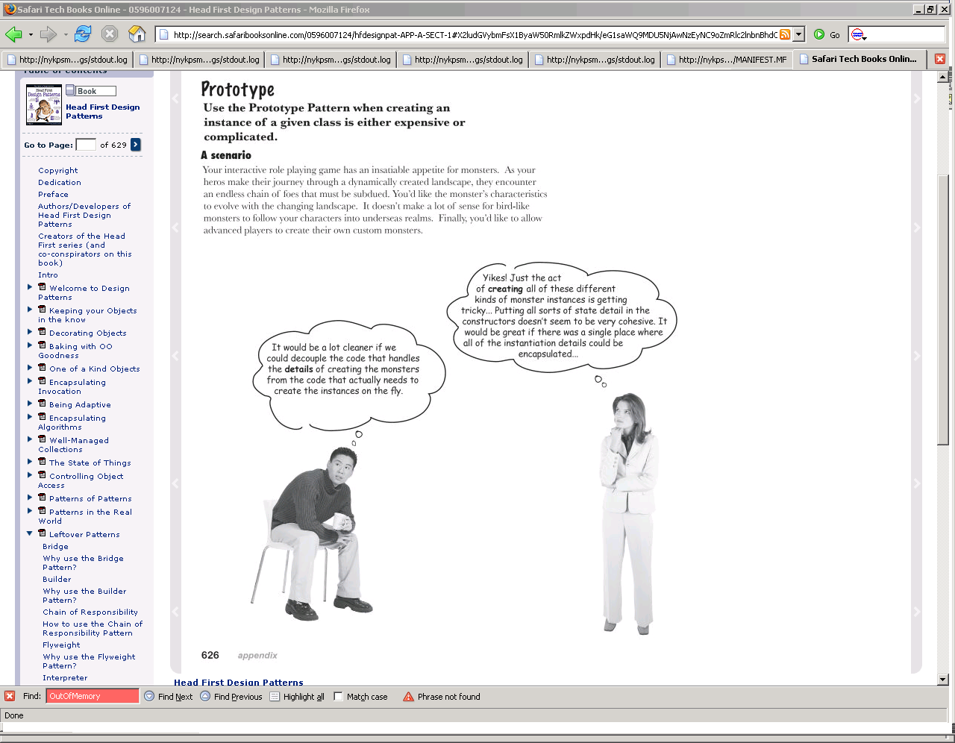

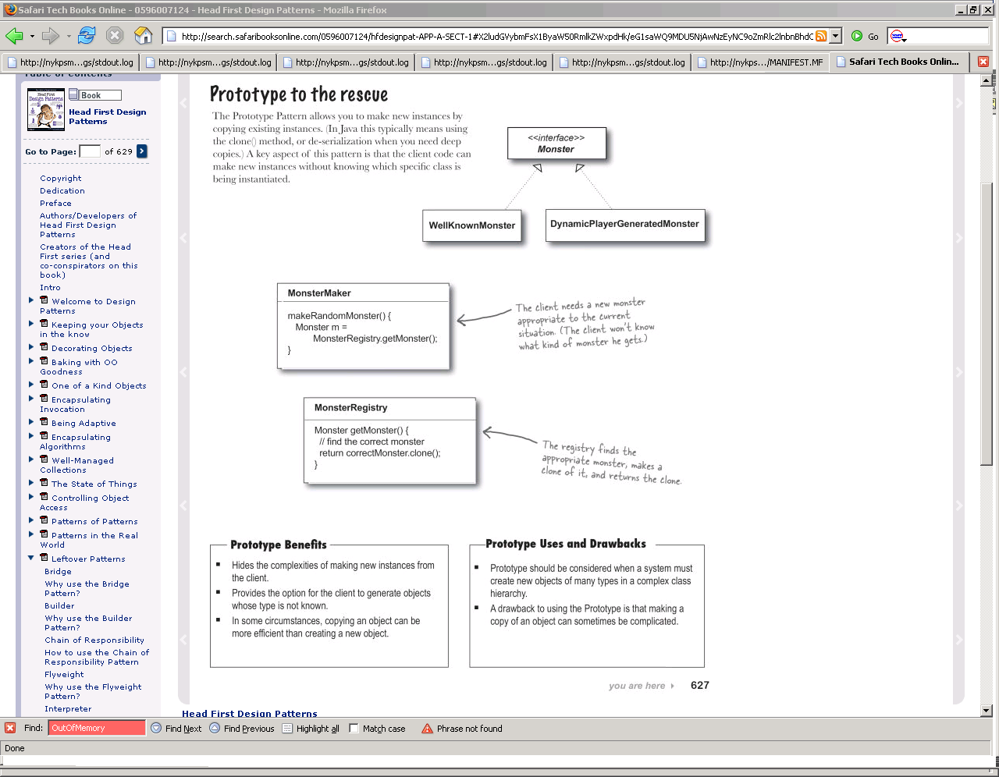

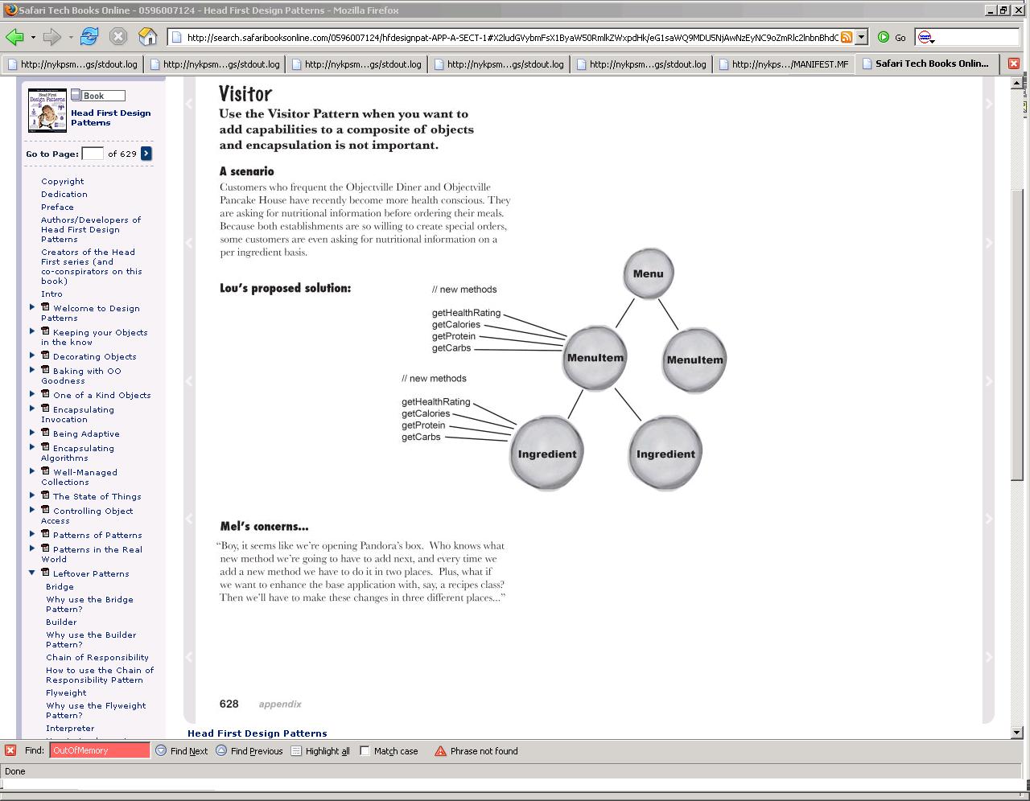

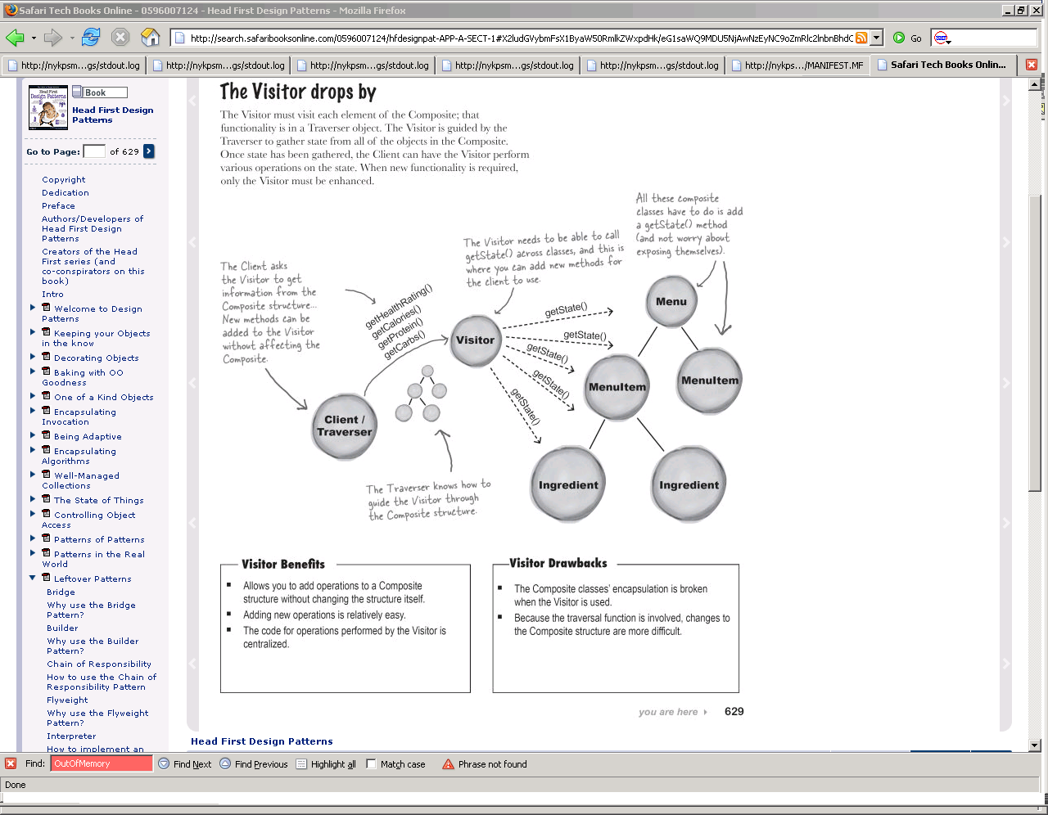

## Core J2EE:

## Presentation Tier:

**Intercepting Filer**: You want to intercept and manipulate a request and a response before and after the request is processed. **Use an Intercepting Filter as a pluggable filter to pre and post process requests and responses. A filter manager combines loosely coupled filters in a chain, delegating control to the appropriate filter. In this way, you can add, remove, and combine these filters in various ways without changing existing code.**

**Front Controller**: Centralized Access: **Use a Front Controller as the initial point of contact for handling all related requests. The Front Controller centralizes control logic that might otherwise be duplicated, and manages the key request handling activities.**

**Application Controllers: Centralized and modularize action and view management. Use an Application Controller to centralize retrieval and invocation of request-processing components, such as commands and views.**

**View Helper: separate view from processing logic: Use Views to encapsulate formatting code and Helpers to encapsulate view-processing logic. A View delegates its processing responsibilities to its helper classes, implemented as POJOs, custom tags, or tag files. Helpers serve as adapters between the view and the model, and perform processing related to formatting logic, such as generating an HTML table.**

**Composite View: Use Composite Views that are composed of multiple atomic subviews. Each subview of the overall template can be included dynamically in the whole, and the layout of the page can be managed independently of the content.**

**Service To Worker: Use Service to Worker to centralize control and request handling to retrieve a presentation model before turning control over to the view. The view generates a dynamic response based on the presentation model.**

## **Business Tier:**

**Business Delegate: Use a Business Delegate to encapsulate access to a business service. The Business Delegate hides the implementation details of the business service, such as lookup and access mechanisms.**

**Service Locator:** transparently locate business components and services in a uniform manner**. Use a Service Locator to implement and encapsulate service and component lookup. A Service Locator hides the implementation details of the lookup mechanism and encapsulates related dependencies.**

**Session Façade:** expose business components and services to remote **clients Use a Session Façade to encapsulate business-tier components and expose a coarse-grained service to remote clients. Clients access a Session Façade instead of accessing business components directly**

**Application Service: (a.k.a App controller)** centralize business logic across several business-tier components and services. **Application Service to centralize and aggregate behavior to provide a uniform service layer.**

**Business Object: Business Objects to separate business data and logic using an object model**

**Composite Entity:** entity beans to implement your conceptual domain model. (local entity bean) **Use a Composite Entity to implement persistent Business Objects using local entity beans and POJOs. Composite Entity aggregates a set of related Business Objects into coarse-grained entity bean implementations**

**Transfer object:** transfer multiple data elements over a tier.

**Value List handler:** **Use a Value List Handler to search, cache the results, and allow the client to traverse and select items from the results.**

## **Integration Tier:**

**Data Access Object**: You want to encapsulate data access and manipulation in a separate layer. **Use a** Data Access Object **to abstract and encapsulate all access to the persistent store. The** Data Access Object **manages the connection with the data source to obtain and store data.**

**Web Service Broker: Use a Web Service Broker to expose and broker one or more services using XML and web protocols.**

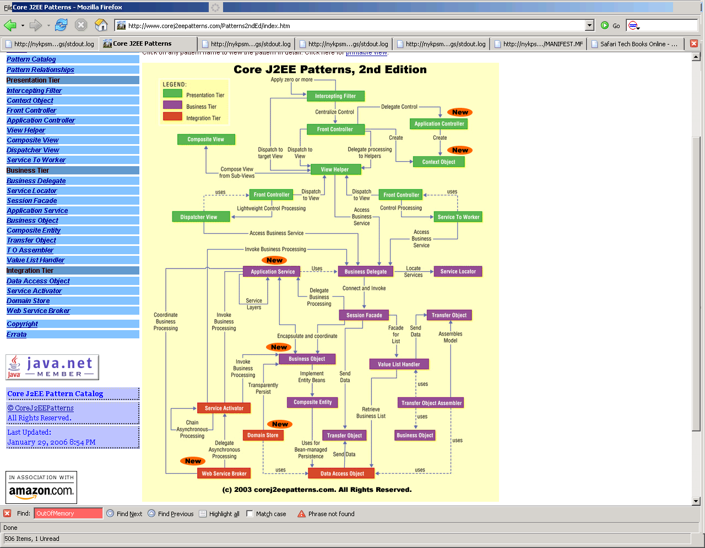

**Intercepting Filter:**

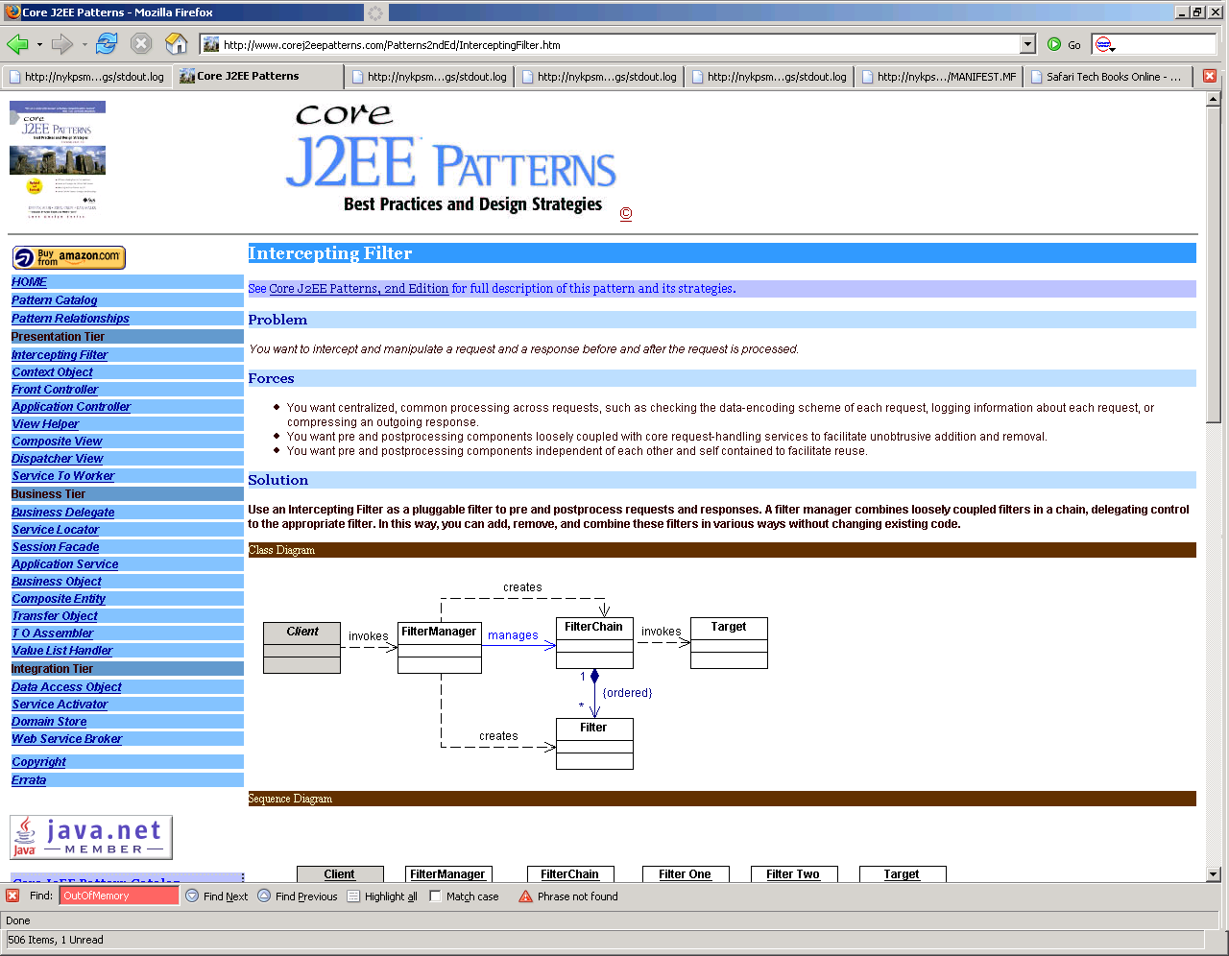

**Front Controller:**

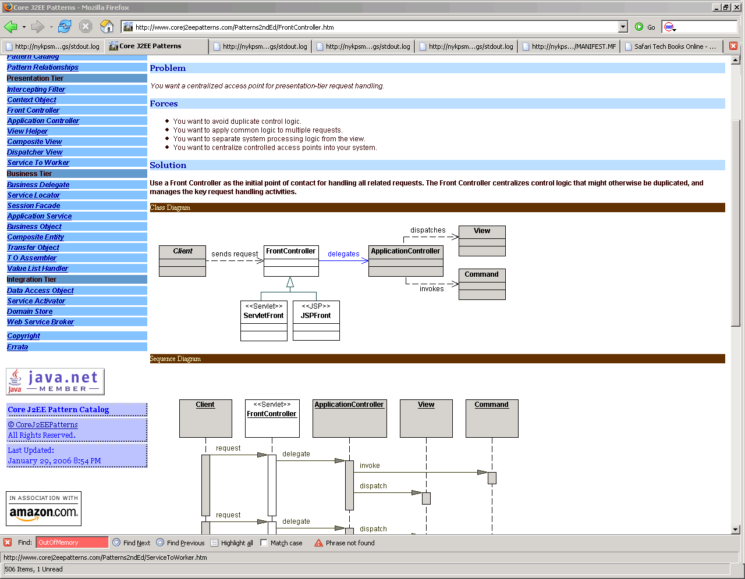

**Application Controller:**

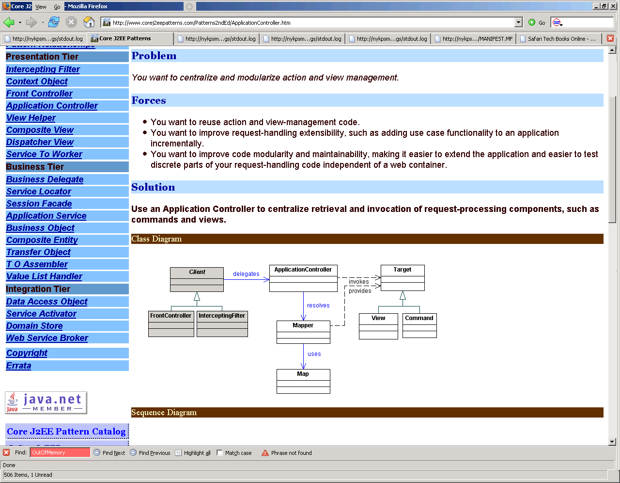

**Service To Worker:**

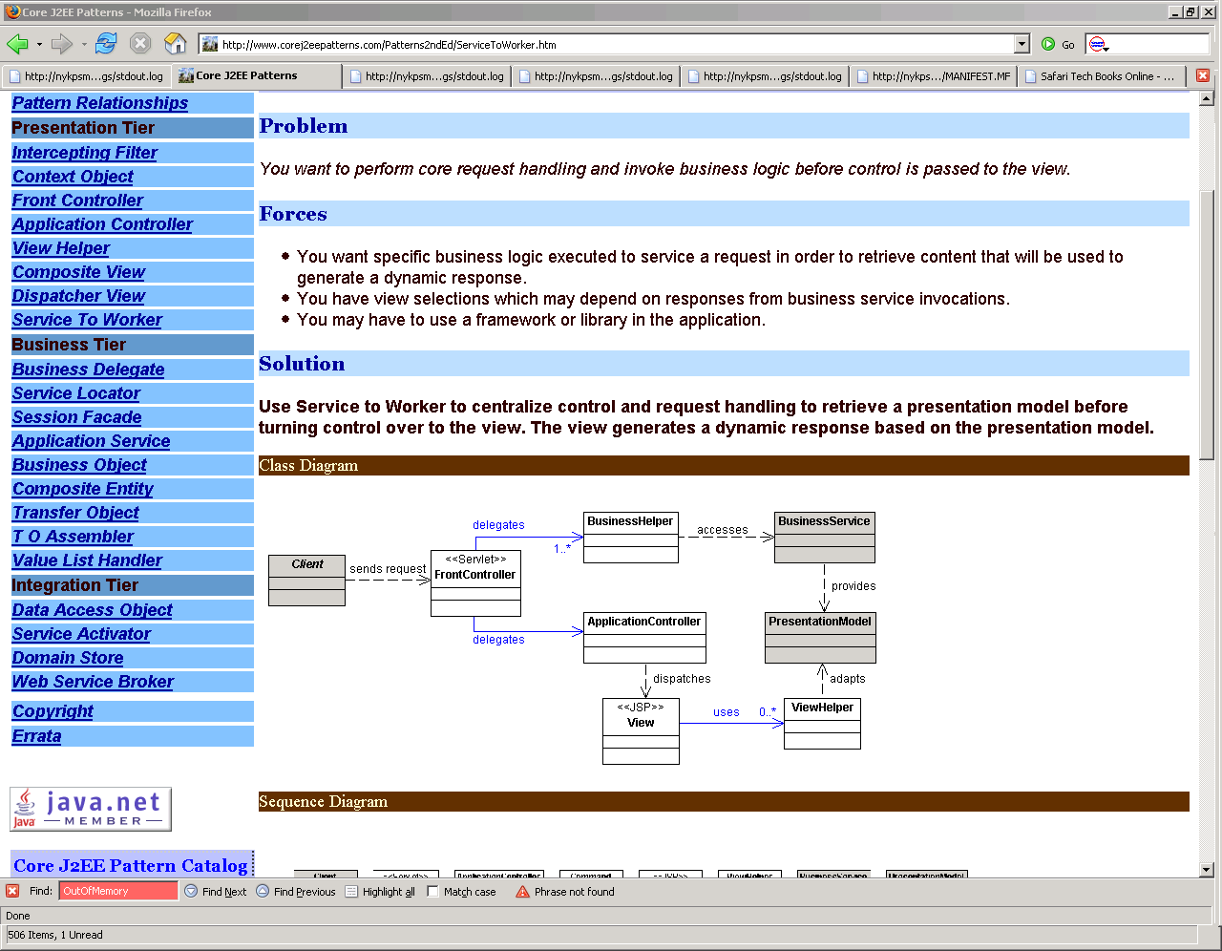

**Business Delegate:**

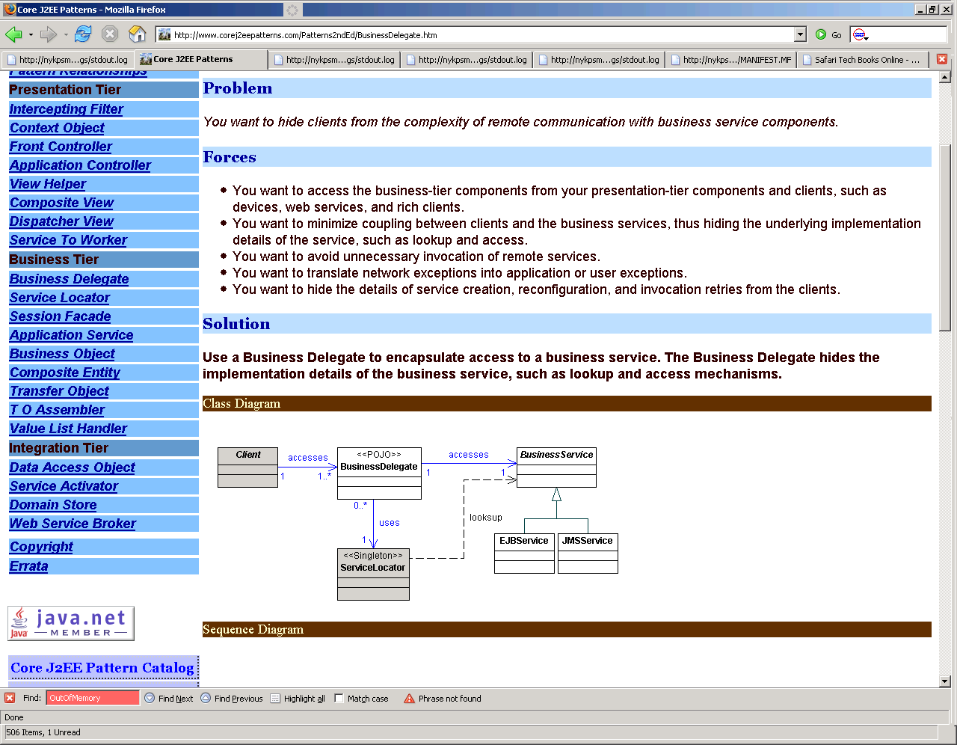

**Service Locator:**

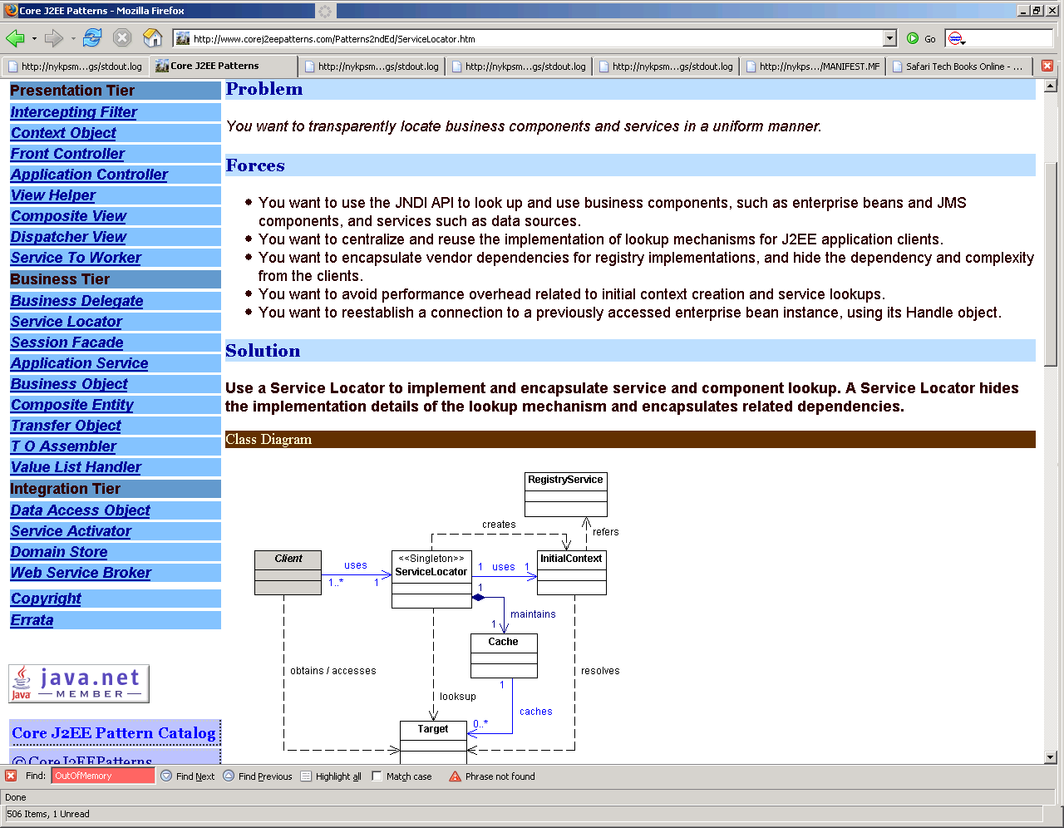

**Session Façade:**

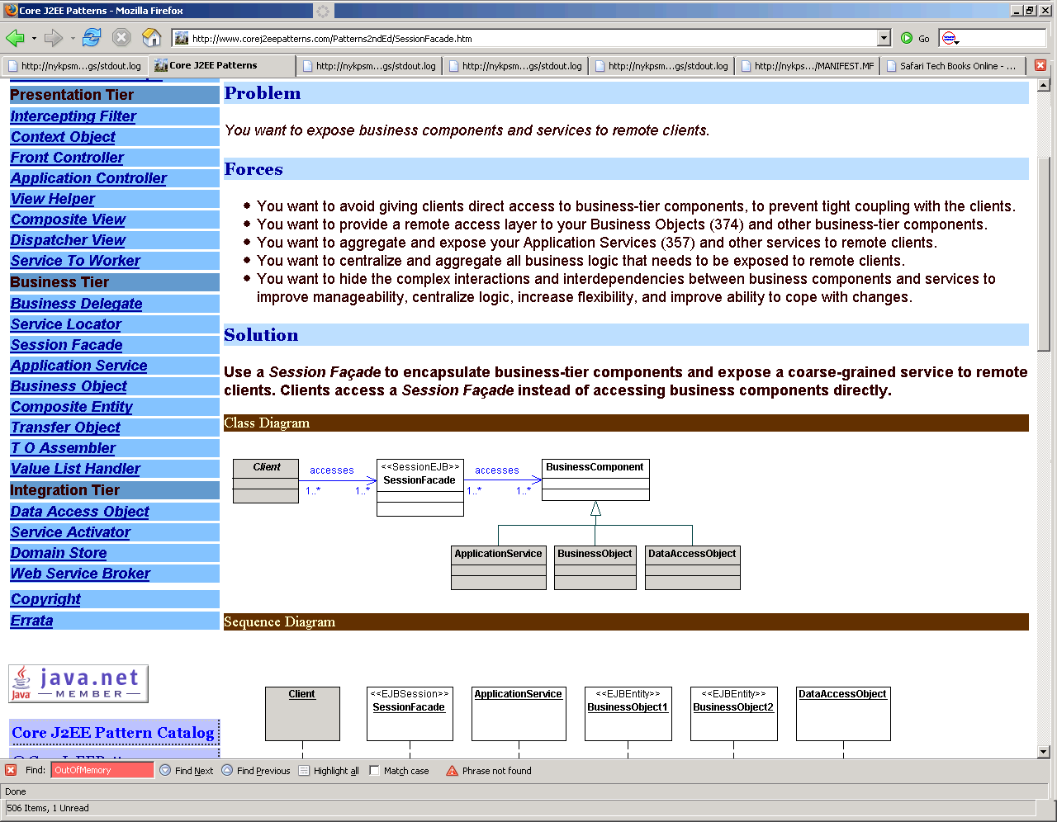

**Data Access Object:**

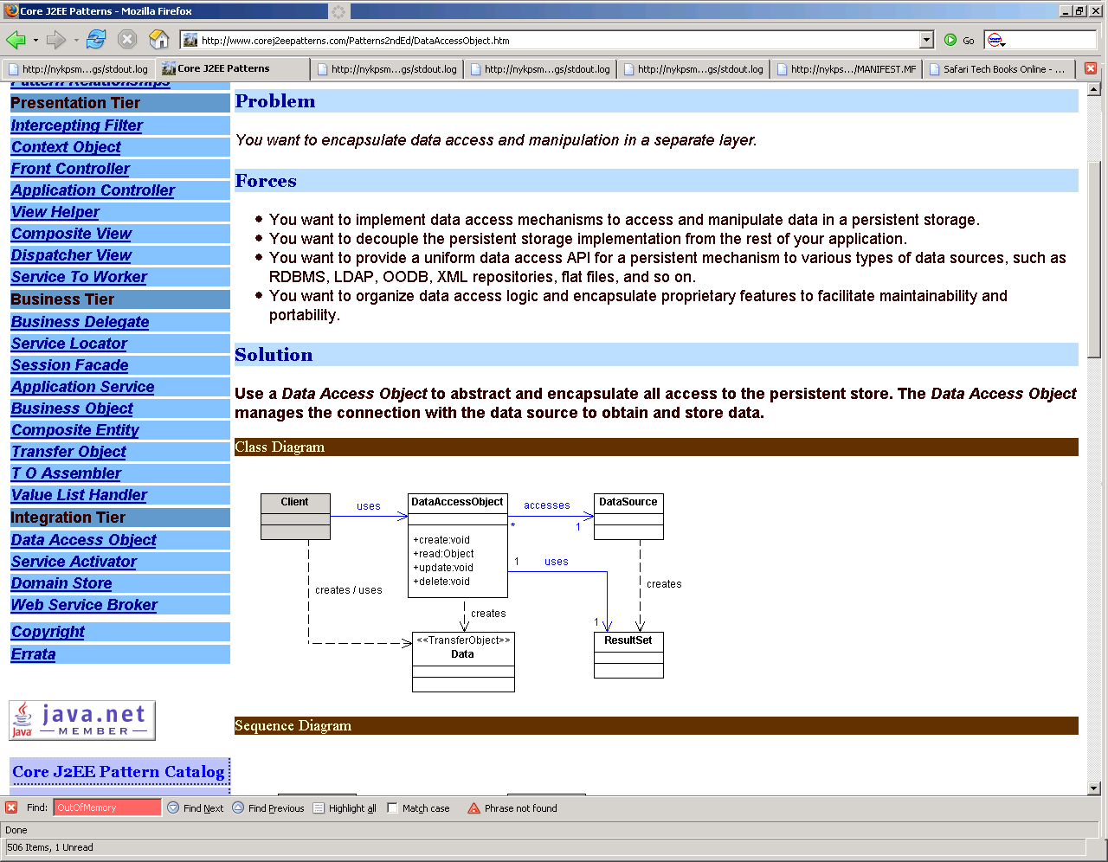

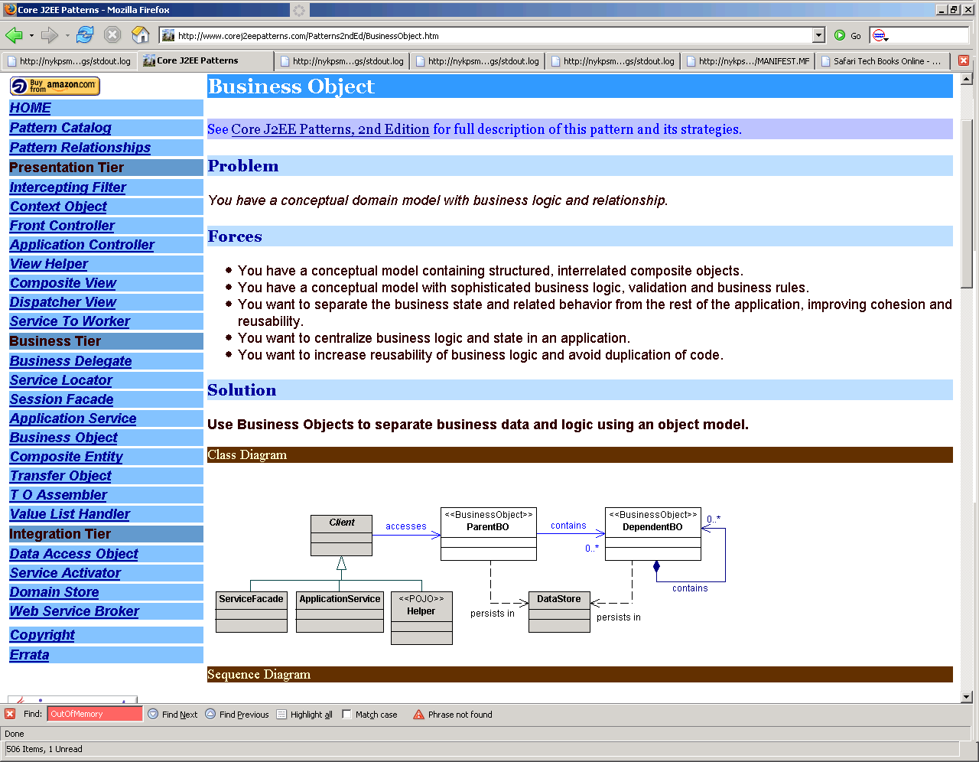

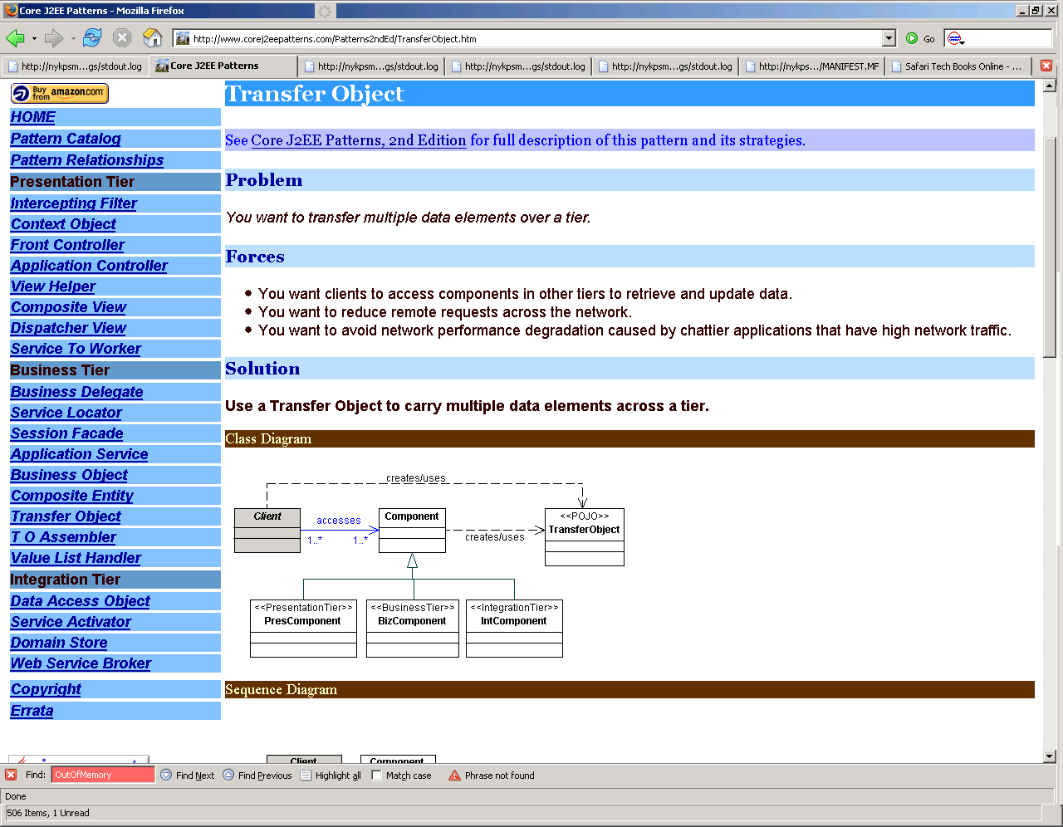**Web Service Broker:**

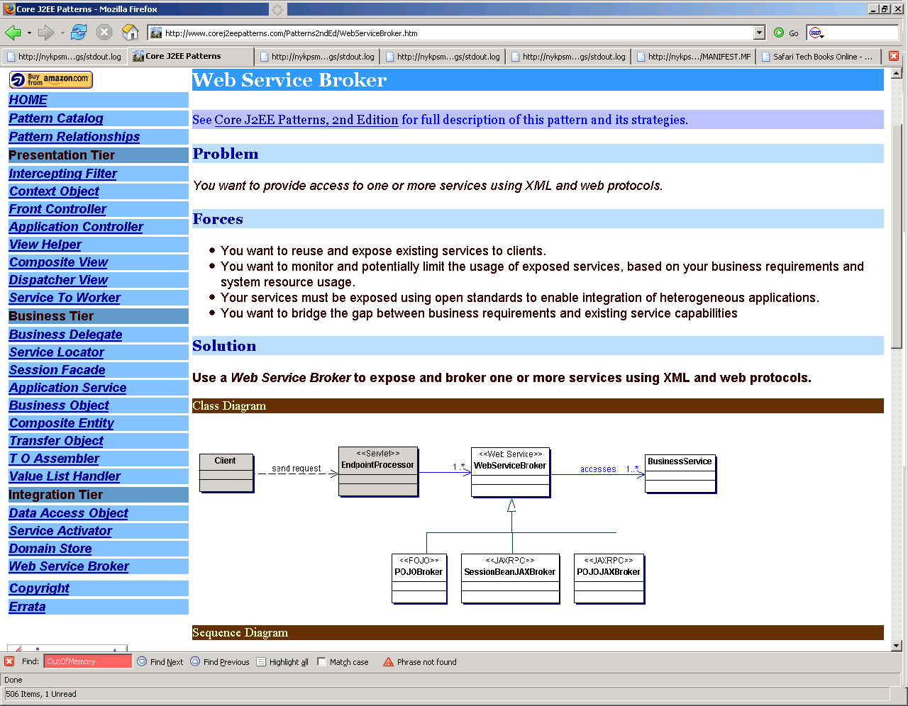

# Algorithms

1.  You have a ladder n-steps in height.  You can either take one step  
or two steps up the ladder at a time.  How can you find out all the  
different combinations up the ladder?  Then figure out an algorithm that  
will actually print out all the different ways up the ladder.  ie:  
1,1,2,1,2,2... etc...  
  
2.  Given the root node to a singly linked list, reverse the last 5  
nodes in the list.  
  
3.  Given the root node to a singly linked list, write an algorithm to  
see if it loops back on itself somewhere in the middle.  
  
4.  Write an algorithm to calculate the square root of a number.  
  
5.  Given a const null terminated string containing a sentence, can you  
print out the words of the sentence in reverse without changing any data  
and without creating a temporary string buffer?  Do not use any helper  
functions, write it all out on your own.  (ie "The dog is fast"  
becomes "fast is dog The")  
  
6.  Implement a deque.  Think about what properties a deque must have.  
 Implement it as a base class that can be extended and as a template.  
In general, start thinking about what's underneath all the other STL  
data types and how they work.  
  
7.  Given a char pointer to large buffer of memory, write your own  
version of my_malloc and my_free without using any system calls.  Make  
it as robust as possible.  How would you minimize memory fragmentation?  
  
8.  Implement quicksort().  
  
9.  Given the function: "bool numExists( int array[], int array_len,  
int num )" where "array" is a sorted array of integers.  Determine if  
"num" exists in the array.  This is basically a binary search question.  
Do a recursive version and an iterative version.  Writing binary search  
is easy but getting it the most efficient is hard.  Can you do it with  
the minimum number of operations possible?  
  
10. The standard library function of atoi() is not very robust.  How  
would you design/implement a better version of it?  
  
11. Implement a Singleton.  It's the most over used and mis-used  
design pattern.  Everyone knows the "textbook" implementation of the  
singleton but think of all the different ways you can implement it and  
what are their pros/cons?  Make a thread-safe version.

Basic Java (to be used for more junior candidates)

1. Hashcode and equals 1 pt

Follow up Q: what will happen if hashcode always returns same value for all objects?

1. When will you use, LinkedList, ArrayList, HashMap 2 pts

Advanced practical Java (to be used for Sr. candidates)

1. Multithreading: how would you implement a system that that work in multithreading environment? What classes Java offers to help with this? 5 pts

A: Callable, Runnable, Thread, synchronization package (locks, mutexes, etc)

1. How you implemented REST in your application? (spring or jersey or java-rx) 5 pts
2. Implement @RestController

Follow up Q: What are the annotations for rest in spring?

A : @requestMapping and @requestBody, and more

1. Have you followed TDD , BDD. 5 pts
   * Junit, testNg, Mockito, mockMvc, CoreMatchers.
   * How will you segregate the testing based on smoke, integration, unit?
   * Coverage tools.
     + Jacoco, surefire, etc

Theory

1. What is Lamba expression and how can it be used? 4 pts
2. Inheritance or composite? what would he/she prefer? 2 pts
3. What is micro service? 2 pts
4. Patterns:
   * What is circuit breaker 3 pts

Spring circuit breaker(hystrix): When this pattern is applied to a method in muService, Hystrix watches for failing call to that method, and it trips the circuit open and subsequent calls are redirected to the fallback method. This currently only works in a class marked with @Component or @Service.

Add @HystrixCommand with a parameter fallbackMethod to the Service class (e.g. @HystrixCommand(fallbackMethod = "return")

Implement the specified fallback method in the above annotation

Add @EnableCircuitBreaker to the Application class

* + Decorator. Do you know any Java classes that follow this pattern? 2 pts
  + Factory 2 pts

1. What are the recommended communications styles between muServices?
   * Synchronous communication based on HTTP/REST/JSON 1 pts
   * Asynchronous communication based on AMQP (Rabbit) 3 pts
2. Difference between SOAP and REST? 3 pts

A:

SOAP has its own protocol.

REST is over HTTP

REST is preferable in most cases

SOAP has transactions, etc.

1. Have used spring, what spring component you have used. 7 pts
   * Spring –netflix ( hystrix, eureka, turbine, zuul)
   * Spring-cloud ( spring profile and configurations)
   * Spring dependency injections and inversion of control.
   * Spring batch
   * data modelling and persistence using spring extra 3 pts

A: Spring data, Spring-jpa , crudRepository and @entity, in memory database like H2.

1. How do you secure your rest URLs (CRUD) 5 pts

A:

HTTPS

Secure Token

Spring Security

Java Authorization and Authentication

OAUTH

1. Distributed caching and storage (Gemfire) 3 pts

Gfsh cli

Regions

Members

functions

Gemfire pulse

1. Build tools knowledge 2 pts

Jenkins

Concourse

Maven , working with maven plugins

**Practical**

1> Write a java data structure to declare and initialize the above data? 1 pt

A B C D

E F G H

I J K L

A: char[4][4]

2> Fill in this method:

public String cat(String[][] data) {

// Return a comma separated string. eg A,B,C,D,E,F,G,H,I,J,K,L

}

3> Draw a simple block diagram that lets me use 3 different types of cache libraries by some means of external configuration.

4> Reverse the string ( how many ways, he/she can solve this)

A: Loop, recursive, call api?

**Optional Q**. (use if the person does not know other topics)

1. What is AOP? 3 pts.

**Additional Micro Service Tech:**

1. What does @ComponentScan annotation do?
   1. This tells Spring to look for classes with @Component, @Configuration, @Repository, @Service, and @Controller and wire them into app context as beans.
2. What does @Enable AutoConfiguration do?
   1. This turns on Boot’s auto-configuration behavior for adding extra beans. This decision is made using the classpath and settings found inside application.properties file.
3. What Are The Issues With Sticky Session?
   1. There are few issues that you may face with this approach. The client browser may not support cookies, and your load balancer will not be able to identify if a request belongs to a session. This may cause strange behavior for the users who use no cookie based browsers. In case one of the machine fails or goes down, the user information (served by that machine) will be lost and there will be no way to recover user session.
4. How would you implement simple workflows using asynchronous communications?
   1. Mainly correlation IDs and distributed transactions should be used for tying up various microservice calls together.

1. Java Question "With the list of ranges given, find the overlapped ranges"

2. SQL Question "Given the three tables (student, subject, and score with no common column between student and subject) list all students for each subject"

1. Explain how to do the authentication in a J2EE application, including both UI section and and server side.

1. Give an array [1,2,3,4,5,6,7,8,9], output result should be production without current member, like [2*3*4*5*6*7*8*9, 1*3*4*5*6*7*8*9, ...., 1*2*3*4*5*6*7*8].

No division allowed and must consider the large production number bigger than integer limitation. Also need to consider how to handle big size of input, like one million elements inside the input array

3. Use the regular expression to classify the string with 256 ASCII codes. like given a string This is a Bloomberg's Java8 question score 345 &with \t $100 worth.\n".

In the output you should put all the words together, and all number together, then all special character together.

4. What is autoboxing in Java and write some codes to explain it.

5. Given two lists (A->B->C->D and E->Y->H->C->D), then output the common tail "CD", the time complexity shouldn't be larger than O(n) and space complexity should be O(1)

The question and answer can be found here

http://www.geeksforgeeks.org/design-a-data-structure-that-supports-insert-delete-search-and-getrandom-in-constant-time/

## Maths Problems:

1. Generate power set of given set

int A[] = {1,2,3,4,5}; int N = 5; int Total = 1 << N; for ( int i = 0; i < Total; i++ ) { for ( int j = 0; j < N; j++) { if ( (i >> j) & 1 ) cout << A[j]; } cout << endl; }

1. Find if the given expression contains redundant parantheses. ex : if expr = a+(b*c) , print false, if expr = a+((b*c)), print true.

**3.** Given a set of intervals like 5-10, 5-10, 8-12, 9-15. Find the ith smallest number in these intervals.

for eg:-Suppose we have intervals like 5-10, 8-12. Then total numbers in these two intervals would be: {5,6,7,8,8,9,9,10,10,11,12} So, 1st smallest number: 5 4th smallest number: 8 5th smallest number: 8

**4.** Add two numbers without using + operator.

**5.** Negate a number without using just +operator. Eg: negate(5) = -5 ; negate(-5)=5.

**6.** Find number smallest number K , if exists, such that product of its digits is N. Eg: N = 6, smallest number is k=16(1*6=6) and not k=23(2*3=6). int getnumber(int n) { if(n==0|| n==1) int i=9; int num=0; int pow=1; while(i>;0) { while(n%i==0 && i>;1) { num=i*pow + num; pow=pow*10; n=n/i; } i--; } if(n!=1) return -1; else return num;

**7.** How to find the smallest number with just 0 and 7 which is divided by a given number?

**8.** Count the trailing zeros in factorial of a number N? (5! Has number of 0’s = 1)

**9.** Check if the bit representation of a number is palindrome or not? Eg . 9 => 1001 > is palindrome. Function

boolean isPalindrome(int anumber) { uint numberOfBits = sizeof(uint)*8; for(uint i=1; i<= numberOfBits/2; ++i) { if( ((aNumber & (1<<(numberOfBits-i)))? 1:0) == ((aNumber & (1<<(i-1)))? 1:0)) { continue; } else { return false; }

} return true; }

**10.** Generate random number generator (mod 7) using (mod 5). Understand the trick then you can generate any random number generator using a given generator. int rand7() { int vals[5][5] = { { 1, 2, 3, 4, 5 }, { 6, 7, 1, 2, 3 }, { 4, 5, 6, 7, 1 }, { 2, 3, 4, 5, 6 },

{ 7, 0, 0, 0, 0 } }; int result = 0; while (result == 0) { int i = rand5(); int j = rand5(); result = vals[i-1][j-1]; }

**11.** Get the least number after deleting *k* digits from the input number. For example, if the input number is 24635, the least number is 23 after deleting 3 digits.

<http://codercareer.blogspot.in/2013/11/no-48-least-number-after-deleting-digits.html>

check first decreasing number, and remove that from the number. Keep doing it until kth element.

**12.** Find how many squares are present on a chessboard.

<http://www.programmerinterview.com/index.php/puzzles/find-number-of-squares-chessboard/>

Number of squares for an NxN chessboard?

What if we want to find the number of squares for a chessboard of size NxN, where N is any number. Do you notice a pattern in the results in the table above? Well, if you take a look at the results that we showed above for the normal-sized 8×8 chessboard, you can see that the number of squares is equal to the sum of squares from 12 to 82, where 8 is equal to N. So, we can say in more general terms that the sum of squares for a chessboard of size NxN is equal to n2 + (n-1)2 + (n-2)2 + …. (1)2.

## Linked Lists:

**13.** Reverse a doubly linked list. ( Just don’t ignore the problem because it sounds simple). Code it and be careful at edge cases.

**14.** Merge two sorted linked lists (**in-place**) , don’t form third linked list.

**15.** Quick-Sort on Doubly linked list. Also try it on Singly linked list.

**16.** Reverse singly linked list without using three pointers. You can use only two pointers. eg: p-> points to head ; q-> points to head->next then, while(q) { q = p ^ q ^ (q->next) ^ (q->next=p) ^ (p=q) ; } At the end, p points to newHead.

**17.** Loop in linked list. Start of loop, if loop exists.

**18.** Find middle of singly linked list. Break Circular linked list into two different circular linked lists.

**19.** Number is represented in linked list such that each digit corresponds to a node in linked list. Add 1 to it. For eg: 1999 is represented as : **(1->9 -> 9 -> 9 ) + 1** => **(2->0->0->0)** Extension : Don’t reverse linked list.

**20.** Reverse nodes in linked list problems. Like : k-alternate node reverse **OR** reverse k nodes, then next k nodes and so on..

## Arrays Problems:

**21.** You have an array which has a set of positive and negative numbers, print all the subset sum which is equal to 0.

**22.** Divide a given array into two subarray (not necessary to be continuous) such that difference between sum of both array is minimum.

**23.** Find number of inversions in an array. Inversion means a pair where a[i] > a[j] and i <j in O(nlogn).

**24.** Triplet sum problem. Find all pairs of numbers such that a[i]+a[j]+a[k]=N.

**25.** A stream of integers is coming. Find median of numbers received till now. Hint: Two heaps required, one minheap and other one maxheap.

**26.** Find equilibrium index in array. Its the index i where sum till i from 0th index = sum from ith index to last index.

**27.** Find the Minimum length Unsorted Subarray, sorting which makes the complete array sorted. Eg: ( 0 4 12 3 15 16 18 17 19).. Seems like mean length unsorted subarray is from 14 to 17, but its not. Because if you sort that partition you get, ( 0 4 3 12 15 16 17 18 19 ) which is not sorted. Think of all cases and find minimum length such that , if we sort that contiguous subset, we get sorted array. Hint : In above example, once you find shaded part, just get min and max in that shaded part and check if anything in left of that partition is not greater than min and anything on right side of that part is not less than max, so that once you sort that partition, you will get sorted array.

**28.** Numbers in array are repeated thrice except one number which is present just once. Find the one? Hint : A number appears three times, each bit (either 0 or 1) also appears three times. If every bit of numbers appearing three times is added, the sum of every bit should be multiple of 3.

**29.** Write heap functions to build heap, add new element in heap.

**30.** Find peak element in array. A[i] is peak element, a[i-1] < a[i] > a[i+1].. For corner elements a[0] is peak, if a[0] > a[1] **or** a[length-1] > a[length-2] then a[length-1] is peak. There can be many peaks in array. Find anyone. No repetition of elements in array. Try it on O(logn).

**31.** There are 0’s and 1’s in array. Bring all 0’s on odd positions and 1’s at even positions. If 1’s or 0’s are more, leave the remaining as it is after arranging at even/odd positions. Hint: Keep two pointers. Odd and even position pointers. Both will move +2 steps at a time. Keep moving odd pointer ahead till u get a place where 0 is not present. Do the same for

even pointer. Then exchange values of these two pointers. Continue till anyone of them reaches end of array.

**32.** Given an array of integers, sort the array according to frequency of elements. For example, if the input array is {2, 3, 2, 4, 5, 12, 2, 3, 3, 3, 12}, then modify the array to {3, 3, 3, 3, 2, 2, 2, 12, 12, 4, 5}. Hint: Insert elements into maxheap. Condition for maxHeap is frequency of elements. So root will contain element that has maximum no of repetitions.

**33.** The cost of a stock on each day is given in an array, find the max profit that you can make by buying and selling in those days. For example, if the given array is {100, 180, 260, 310, 40, 535, 695}, the maximum profit can earned by buying on day 0, selling on day 3. Again buy on day 4 and sell on day 6. If the given array of prices is sorted in decreasing order, then profit cannot be earned at all.

**34.** You are given a one dimensional array that may contain both positive and negative integers, find the sum of contiguous subarray of numbers which has the largest sum. For example, if the given array is {-2, -5, 6, -2, -3, 1, 5, -6}, then the maximum subarray sum is 7. Dont use Kadane.. Try with Divide and conquer approach. Refer geeksForGeeks.org

**35.** Find maximum difference in indexes. Say, (j-i) is answer if i,j are both indexes such that i<j and A[i]>A[j]; .. This problem is different from the one below..

**36.** Maximum difference in two elements in arrays such that the larger elements appear on right-side.

**37.** Suppose array values represent height of histograms. Find largest area rectangle formed by some contiguous histograms.

**38.** Imp problem: Find number which is repeated more than n/2 times in array where n is length of array. Extension: Now find element which is repeated more than n/4 times, n/8 times and so on. Hint: http://www.cs.utexas.edu/~moore/best-ideas/mjrty/ This will help you find n/2 times repeated element. To find( n/4 or more )times repeated element, repeat same algorithm but this time ignore the one which is already found as repeated n/2 times.

**39.** Find number of elements on right side, which are greater in value then current element. Find this for all elements of array. (Hint: Use BST tree).

## Stacks and Queues Problems:

**40.** Simplest and famous one: Design stack for top(),push(),pop() and getMin() operations in O(1) time complexity. Hint: Two stacks. Beware of edges cases like when last element is popped out. Extension: How would you design for getMax() operation also.

**41.** Find the next smallest element on right side for every element a[i] in array a[].

**42.** Design queue for getMiddle() in O(1) time complexity. Hint : Think in terms of how to implement queue. How about LinkedList. Can we maintain one additional pointer to middle element always and update it whenever new element is added at rear.

**43.** Design Queue for getMin() in O(1) time complexity. Hint: Use two queue.

**44.** Inorder/postorder **iterative** using explicit stack. This problem is important as this technique is required in many problems.

**45.** Find maximum number in sliding window of k . eg : if array is { 1,5,7,2,1,3,4} and k=3, then first window is {1,5,7} so maximum is 7, print 7, then next window is {5,7,2} , maximum is 7, print 7. So final output is : { 7,7,7,3,4 } This is very famous problem usually asked in big companies during initial screening rounds.

**46.** Celebrity problem : There are n number of people in party and only one celebrity. If celebrity is the person, who knows no one but everyone knows him, find who is the celebrity? Given: a function is provided which tells whether ‘a’ knows ‘b’ or not? doesAknowB(A,B). Hint: Push all the elements into stack. Remove top two elements(say A and B), and keep A if B knows A and A does not know B. Remove both A,B is both know each other.

## Trees Problems:

**47.** Find any two elements in BST such that sum of those two nodes = K. Hint: Try O(logN). Do 2 iterative inorders, one for left-root-right and other following right-root-left. Add those two values and check cases like <k, >k,==k.

inroderRevInorderBoth(root) { done1, done2 = false; while(1) { while(done1==false) { while(curr1) { s1.push(curr1); curr1=curr1->left; } if(s1.empty()) done1 = true; else { val1 = s1.pop(); curr1 = val1->right; done1= true; } }

while(done2==false) { while(curr2) { s2.push(curr2); curr2=curr2->right; } if(s2.empty()) done2 = true; else { val2 = s2.pop(); curr2 = val2->left; done2= true; } } if(val1->data + val2->data==target) return;/*print answer val1, val2*/ if(val1->data + val2->data < target) done1=false; else done2=false; } }

**48.** Convert a binary tree to BST. Extra space allowed. ( Can you maintain same shape of the original tree and still get BST. Answer is no..( http://stackoverflow.com/questions/3531606/convert-binary-tree-bst-maintaining-original-tree-shape)

**49.** Given a BST, delete a node in BST. ( Refer to example below for hint. Node with value 6 is going to be deleted from its original position).

**50.** Given a BST, and a node in BST, make that node, as new root of the tree. But still maintain the tree as BST after making this node as root. For eg: In tree below, say given node is 6, then change the tree to make 6 as root of tree.. Hint: Take 6 as root, as its on left of original root(8) so, make 8 as right child of 6 and 3 as left child node. Now, there are two cases: - If 6 is leaf, then no worries at all - if 6 is internal node, remove 6 and replace it with ( either max in left substree or min in

right subtree)

**51.** Find the inorder successor of BST in O(logN). By using inorder, you can find it in O(n) but then you are not using its BST properties. public class inorderSuccessor {

public static TreeNode iterativeSolution(TreeNode root, TreeNode target) {

if (root == null || target == null) return null; boolean targetFound = false;

TreeNode currNode = root, candidate=null; while (currNode != null) { if (currNode.val == target.val) { targetFound = true; currNode = currNode.right; } else if (currNode.val > target.val) { /* only update candidate here as we r looking for successor.. it will always be greater.*/ candidate = currNode; currNode = currNode.left; } else {// currNode.val < target.val currNode = currNode.right; } } return targetFound ? candidate : null; // important check to return candidate. }

}

**52.** Determine if a tree is a valid BST with no duplicated values. (This means that if the binary tree has a duplicated number it should return "invalid" even if it's an actual BST)

Hint: Check if left subtree or right subtree is invalid or not. Also keep track of prev node visited in inorder traversal and check if value is repeated by comparing previous visited node with current node.

**53.** Implement a function which returns list of all nodes in a binary tree having a given number of leaves, say k . Also mention complexity. Eg: k=4, ans is {4,5} .. k=2 ans is {8,9,10,11,12,7} Hint: Think bottom-up, so at every node, getall nodes from left and right subtree and see if its k, then print the node.

**54.** Replace each node with the sum of all greater nodes in a given BST? Hint-1 : If converted to Doubly linked list, then you can take prefix sum, starting from tail to head. But this will modify the tree. Hint-2: Try reverse inorder(right, root,left). Take sum of all nodes in right first, add current node’s value to it and pass to left subtree. Total sum returned by left subtree can be passed to root. Recursion is the key.

**55.** Do **iterative** inorder, preorder **without** using stack. No extra space allowed. Hint : Morris traversal.

**56.** Find least common ancestor in tree for given nodes ‘a’ and ‘b’. But time complexity should be O(n) and note its binary tree and not BST.

**57.** Print all paths in trees ( not just root to nodes ). Hint: O(n^2) to get all pairs of nodes and to print path between them, you can find LCA(a,b) between nodes ‘a’ and ‘b’ to get path between them, which will take O(n) so, total complexity O(n^3). Can you get better?

**58.** Find median in BST. There are can be different approaches. Extension to question: Suppose ‘K’ number of queries are coming in such a way that they ask for i-th smallest element in BST. Hint: For extension, you can preprocess tree such that, it stores extra information about number of children in left/right subtrees so that, we can traverse tree based on value of ‘i’. Eg: if a node has 5 nodes in left subtree and 3 on rightside, and i=7, then at node you know, you have to go in right substree. So, for ‘K’ queries, O(logn) will be required to get i-th element.

**59.** Two nodes in BST are incorrectly placed. So, swap the two nodes such that BST is formed correctly.

**60.** Form BST from given preorder traversal output. eg: Preorder given : 8,3,1,6,4,7,10,14,13 ... Think recursion, 0th element is root, then find elements that qualify for left subtree and right subtree and go recursive to get actual trees. Output:

**61.** Find distance between two keys in Binary tree. (not BST). Hint: LeastCommonAncestor

**62.** Given a binary tree, a target node in the binary tree, and an integer value k, print all the nodes that are at distance k from the given target node. No parent pointers are available. Hint: Refer geeksForGeeks.org

Given a binary tree where each node has an additional pointer filed *'sibling'* (in addition to the *'left’* & *'right'* fields), connect all the siblings. Note, the tree may not be a complete binary tree. Hint-1: Do level order traversal and previous node is connected to current node in level order traversal. Hint-2: For every node, (if right child exists),connect its left-child to right-child, if not, connect left child to ( find node by traversing, sibling pointer of current-node, and finding appropriate next sibling for left child). For right child, find sibling by traversing, sibling of current node and finding required node. eg. In example tree of question 60, at node 8, connect 3’s sibling pointer to 10. At 3, connect 1’s sibling to 6, and for 6, traverse sibling of 3 which is 10, and get 10’s right child(14) as left is not present. Attach sibling of 6 as 14. And so on.

## Strings Problems:

**63.** Find longest repeating substring in string. Eg; abcdsabcaewcabcad ..Here ans is ‘abc’. Hint: http://en.wikipedia.org/wiki/Longest_repeated_substring_problem

**64.** Find longest palindrome substring in O(n2) without extra space. Hint: No dynamic programming required. - For odd length palindromes, From each element, moves both directions left+right and check if palindrome is formed and record length if maximum. - Also, for even length palindromes, start from between every two elements and go both directions till palindrome property is formed.

**65.** Famous problem for interviews: Given a string ‘str’and some other string ‘str2’, find smallest substring in str which will contain all characters of ‘str2’ even if they are in any order. eg: str=”bzdsdaddwcfaobwww” str2=”abc”. Highlighted part is answer.

**66.** KMP search : Find if given ‘pattern ‘ is present in given string “str”, if present return the index of start of pattern in str. For eg: str=”asdqeaicicaiciciaaw”, pattern=’icici’, then ans is 11. One of the Important questions, understand KMP search properly as its frequently asked.

**67.** Design String class of our own. Be careful to design understanding all properties of Java String class like immutable. ( Hint: See how to make class immutable and check Java String class properties)

**68.** There is a dictionary of billion words and there is one method provided "String getWord(int index);". We can give it index and it will return the String on that index. Hint: Use Binary search if end index is known. Or else try Fibonacci search to reach a point where string at that index is greater than given word.

**69.** String compression**(in-place)**. O(n) required. For given string compress using following logic: case1 : input string : aaawwwbbbcc compressed output: a3w3b3c2 case 2: input string : acccbww compressed output: a1c3b1w2 Assume that every input string has infinite amount of memory. Hint: Count number of places where no repetition is present but don’t insert 1 now, just count. - For characters where repetition is present, replace duplicate characters by digits. At last, let compressed string be called str(as its in-place). - To insert 1’s at places where no repetition is there, start copying each char from end of str to str.length+count position. This is new length of string. - While copying for characters for which number is not present in-front of them, it means, they appeared once, so insert 1 and then the character. - Eg: str=acccb After transformation, str=ac3b and new_length=4 and count=2 So, keep pointer at end of str, at ‘b’, and copy it to new_length position in str. But we observe that for ‘b’ , no number appeared before it so, its not repeated, so we insert 1 at that new position. Then, we get number, so for numbers, just copy them to new postion as it is. ( new position -1 ) is to be done every time. Now, for c, we saw a number just before ‘c’ so, it means, c was repeated so copy ‘c’ as it is.

## Dynamic Programming

Now, comes ‘a’ and we see no number associated with it, so insert ‘1’ and then ‘a’. So final answer : a1c3b1 **Dynamic Programming(Only frequently asked):**

**70.** Find length of longest series questions : - Longest common subsequence in two strings - Longest common substrings in two strings - Longest increasing subsequence in O(nlogn) Refer : http://www.algorithmist.com/index.php/Longest_Increasing_Subsequence.cpp

**71.** You are given an array A with elements 0 to n-1, numbers can be repeated in the array. Create n sets where S[i]={a[i],a[a[i]],a[a[a[i]]]…}. Set has all elements unique. Find the size of the largest set. Input: First line contains n, size of the array. n<1000 Next lines contains n numbers, each element of the array Output Prints one number: Size of the largest set. Sample Test Case: Input: {3,1,2,0} Output: 2 Explanation: Four possible sets are {3,0},{1},{2}{0,3} Refer: http://www.careercup.com/question?id=4724898538717184

**72.** Find optimal binary search tree that can be formed from given sorted array of values. Better explanation for dynamic programming given at : http://orion.lcg.ufrj.br/Dr.Dobbs/books/book2/algo032a.htm

**73.** Check if there exists, **non-contiguous** subset in array such that sum of subset is exactly total_sum/2. Where total_sum = sum of all elements in array.

**74.** Mostly asked in written test of Amazon: Given coins of certain denominations and their infinite supply, find minimum number of coins required to get required ‘K’ amount of money. Variation: There can be only one coin of each denomination, now tell if K sum amount can be formed or not.

**75.** Word break problem. Eg: Iamlive, this string can be broken,i am live, which are three valid words in dictionary. Figure out , if a string can be broken down into valid words or not? Function written should just return true/false.

**76.** A frog can jump 1 or 2 steps at a time. In how many different ways can he reach distance K. Hint: Is Fibonacci related to this problem?

**77.** There are N houses in a row. Each house can be painted in either Red, Green or Blue color. The cost of colouring each house in each of the colours is different. Find the colour of each house such that no two adjacent houses have the same colour and the total cost of colouring all the houses is minimum. Hint:

- If you are calculating cost of colouring till ith house and you know the minimum cost of colouring the (i-1)th house and color of (i-1)th house, then you can color ith house to keep cost minimum. There will always be two colors by which you can paint ith house except 0th house(0th you can color in 3 ways). So at every house, there will be two values and you need to consider both of them when calculating the cost of next one. At last house, we can paint it using any two colours again, choose the one which gives minimum cost. - Point is only at last house, you can choose only one colour, the colour that gives minimum cost. At all other houses, you have to maintain two values for two colors, you are giving them. Because, if at every house, you keep choosing only the color that gives minimum that is greedy approach and may not always give correct answer.

**78.** Edit distance problem. (http://en.wikipedia.org/wiki/Edit_distance) Solution at http://www.csse.monash.edu.au/~lloyd/tildeAlgDS/Dynamic/Edit/

**79.** Matrix chain multiplication problem. Very famous problem.

**80.** You are given a boolean expression consisting of a string of the symbols 'true', 'false', 'and', 'or', and 'xor'. Count the number of ways to parenthesize the expression such that it will evaluate to true. For example, there are 2 ways to parenthesize 'true and false xor true' such that it evaluates to true. Hint: http://people.cs.clemson.edu/~bcdean/dp_practice/dp_9.swf

## Miscellaneous problems:

**81.** Find median,if K sorted arrays of length N are merged. Hint: MinHeap. Take min element from each array and add to minHeap. Remove min element from root of heap and insert new element into heap from the array to which root belonged. Keep on doing this, till you get to median. ( Median => if K*N is odd, then median is (K*N)/2 + 1 th element, and if (K*N) is even, then ((K*N)/2 + ((K*N)/2)+1))/2 th element.) Check this condition once.

**82.** Find top 10 frequent words in a file with millions of words. Hint: Trie and minheap. Size of heap will be 10. Insert word into trie, the last node containing last character of word will have count which will incremented by 1 , everytime word is inserted. If count > (the minimum value in minheap(i.e. root’s count) then remove root and insert this word into heap. MinHeap is arranged based on number of occurances a word had till now. Food for thought: Can we used doubly linked list instead of minHeap to reduce time complexity. Extension : Instead of top 10 words, it can top 10%. In that case, the minheap size will change such that everytime it will store 10%(high-frequency words) of the words read till now.

**83.** Implement Least Recently used cache. Write code for it too.

**84.** Find maximum sum rectangle in matrix of size m*n with 1’s and 0’s. Hint: You will need Kadane algorithm to reduce time complexity from O(n^4) to O(n^3). Refer geeksforgeeks.org for solution.

**85.** Given a number find the next smallest palindrome. eg: 123 -> 131, 991 -> 1001, 121 -> 121 itself. Hint: - There are two cases, whether the number of digits in the number is odd or even. We’ll start with analyzing the odd case. - Let’s say the number is ABCDE, the smallest possible palindrome we can obtain from this number is ABCBA, which is formed by mirroring the number around its center from left to right (copying the left half onto the right in reverse order). - This number is always a palindrome, but it may not be greater than the original number. If it is then we simply return the number, if not we increase the number. But which digit to increment? - We don’t want to increment the digits on the left half because they increase the number substantially, and we’re looking for the smallest palindrome larger than the number. - The digits on the right half increase the value of the number much less, but then to keep the number palindrome we’ll have to increment the digits on the left half as well, which will again result in a large increase. So, we increment the digit just in the middle by 1, which corresponds to adding 100 in this case. - This way the number stays a palindrome, and the resulting number is always larger than the original number.

Courtesy: Ardent (http://www.ardendertat.com/2011/12/01/programming-interview-questions-19-find-next-palindrome-number/)

**86.** Backtracking problems: N-Queens problem. Place N queens in such a way that, they can’t kill each other.

**87.** One knight is placed at some position Y in chessboard, find in how many minimum moves it will move to some given position X in chessboard. By position X or Y means, it will have row and column number.

**88.** Print all permutations of number in sorted order formed by last digits. Eg: number=123, then numbers formed are: 123,132,213,231,312,321. Hint: To get next number which is greater than given number. 1. Start from rightmost digit and go left till you find ith element such that, digit_at_i < digit_at_i+1. 2. Now go find on right-side of ith element, find the element(say at position ‘j’) that is greater than ith element but smallest among all those elements which are greater and on right side of ith element. 3. Swap the digits at position ‘i’ and ‘j’. 4. Sort digits from i+1th position to end.

**89.** Given a text file and a word, find the positions that the word occurs in the file. You’ll be asked to find the positions of many words in the same file. Hint: Do some precomputation which will help to reduce complexity of getting position of word in text. So kind-of inverted index ( word -> position mapping ). Choose datastructure. It can be hashtable or trie( at whose end node will have List<Integer> indexes where the word occurred.)

**90.** Given a matrix of integers and coordinates of a rectangular region within the matrix, find the sum of numbers falling inside the rectangle. Our program will be called multiple times with different rectangular regions from the same matrix. Hint: Refer (http://www.ardendertat.com/2011/09/20/programming-interview-questions-2-matrix-region-sum/)

**91.** Implement Trie operations -> insertion, deletion and lookup operations.

**92.** Stream of 0’s and 1’s is coming, find whether the number formed together by this binary bits is multiple of 3 or not. The stream will keep sending 1 bit at a time. At every bit, tell the new number formed is multiple of 3 or not. 1) Get count of all set bits at odd positions (For 23 it’s 3). 2) Get count of all set bits at even positions (For 23 it’s 1). 3) If difference of above two counts is a multiple of 3 then number is also a multiple of 3.

**93.** From interview standpoint, always know and have understanding about problems like Reader-writers problem and Producer-consumer problem. Also know their solutions using semaphores or monitors.

**94.** Train station timings are given. That is, at a station arrival and departure times of trains is given. Find minimum number of platforms to be constructed at that train station so that trains at similar interval range can be accommodated. Eg: Train 1 Arrival:9:30am Depart: 10:30am Train 2 Arrival:9:45am Depart: 10:10am Train 3 Arrival:10:35am Depart: 11:30am Train 4 Arrival:11:55am Depart: 12:10pm Train 5 Arrival:11:50am Depart: 12:15pm Ans: 2 ( Train 1,2 and Trains 4,5 overlap, so two platforms are required) Hint: The required platforms is the number of trains whose timings overlap. If none overlaps, then we can do with one platform. - Sort all the timings including arrival and departure timings by keeping them in one single array. And maintain that a particular timing is for arrival and departure. So, if n trains are present, you sort an array with 2n timings( arrival and departure time for each train). - Once you sort these 2n values, start from 0th index and increment count as you encounter timing value( marked as ‘arrival’) and decrement count for timing ( marked as ‘departure’). - Also, maintain the maximum value obtained by count somewhere because at last this max value achieved by count is the answer.

## Design Questions

**95.** Design an elevator system. Hint: Think in terms of algorithm to be used for elevator movement. Different usecases. Focus on classes and interaction between them.

**96.** Design spell-checker for MS-word. Hint: Think about data-structure like trie or ternary search tree.

**97.** Design Chess game. Define classes and interactions.

**98.** Design web-application that will accept pincode as input and will return list of departmental stores in that pincode. Interviewer will not say anything, after this line, he will accept you to come up with databse design and what data you will store in db to figure out which stores lie in a particular pincode. Hint: Also, don’t forget its web-application, so do focus on caching, multiple servers, load balancing for additional points ☺ 

**99.** Implement a T9 dictionary. Its keypad of mobile. When you press certain numbers, you need to suggest words that are possibly formed from characters represented by those numbers.

**100.** Imagine you're designing a Web Service for a phone application that returns a list of suggested Words that may complete a given string the user types. For example, if the user writes "ap", a list of suggested words may contain ["apple", "application", ,aptitude",...]Assume English only words and no misspelling.

1. Explain how to do the authentication in a J2EE application,

> including both UI section and and server side.

> 2. give an array [1,2,3,4,5,6,7,8,9], output result should be

> production without current member, like [2*3*4*5*6*7*8*9,

> 1*3*4*5*6*7*8*9, ...., 1*2*3*4*5*6*7*8]. No division allowed and must

> consider the large production number bigger than integer limitation.

> also need to consider how to handle big size of input, like one

> million elements inside the input array

> 3. use the regular expression to classify the string with 256 ASCII

> codes. like given a string "This is a Bloomberg's Java8 question score

> 345 &with \t $100 worth.\n". In the output you should put all the

> words together, and all number together, then all special character

> together.

>

>

> Second round:

> 1. what is autoboxing in Java and write some codes to explain it.

> 2. given two lists (A->B->C->D and E->Y->H->C->D), then output the

> common tail "CD", the time complexity shouldn't be larger than O(n)

> and space complexity should be O(1)

1. Max continuous sum of sub array.

2. Longest distance between two nodes in a tree

3. number of paths in a matrix

Most of the questions were verbal on thread synchronization,

particularly synchronized vs lock and various producer-consumer

scenarios, member and variable modifiers such as final vs finally vs

finalize

There were only 3 written questions:

1. given a class with a list member how to ensure it cant be modified -

answer copy it in the getter method

2. Spin lock example, pluses and minuses

3. the question and answer can be found here

<http://www.geeksforgeeks.org/design-a-data-structure-that-supports-insert-delete-search-and-getrandom-in-constant-time/>

*Here are the questions I could remember.*

*

*

*Question 1:*

int a=4, b=0;

try{

Begin forwarded message:

> *From:* Lakshmi Menon <[lakshmi.menon87@gmail.com](mailto:lakshmi.menon87@gmail.com)

> <mailto:[lakshmi.menon87@gmail.com](mailto:lakshmi.menon87@gmail.com)>>

> *Date:* November 6, 2016 at 8:34:06 PM EST

> *To:* Tom Morgan <[tom@pencom.com](mailto:tom@pencom.com) <mailto:[tom@pencom.com](mailto:tom@pencom.com)>>

> *Subject:* *Bloomberg Qs*

>

> Hi Tom,

>

> Following are the questions I was asked at the KYC interview:

>

> 1. Design a channel subscription site.

>

> 2. Reverse a string using built-in javascript functions (Hint: start

> by converting it into an array).

>

> 3. Write a javascript function that takes an array of numbers and a

> value 'n' as input and returns an array of arrays where the size of

> each inner array is at most 'n'.

>

> Example:

>

> (i) input_array = [2, 3, 4, 5, 6, 7, 8, 9] and n = 3

>

> output_array = [ [2, 3, 4], [5, 6, 7], [8, 9] ]

>

> (ii) input_array = [ 2, 3, 4, 5, 6, 7, 8, 9] and n = 2

>

> output_array = [ [2, 3], [4, 5], [6, 7], [8, 9] ]

>

> 4. What is the output of the following (Hint: variable hoisting):

>

> var foo = 5;

>

> function bar(){

> if(!foo){

> var foo = 10;

> }

> alert(foo);

> };

>

> bar();

>

>

> 5. Write a javascript function to print out the following given input

> 'n' where 'n' is the number of levels:

>

> n = 3

>

> #

> ##

> ###

>

> n = 5

>

> #

> ##

> ###

> ####

> #####

>

>

> 6. Using jQuery write code to create a checkbox hierarchy:

>

> Parent checkbox

> Child checkbox A

> Child checkbox B

> Child checkbox C

>

> - Selecting the parent checkbox will select all child checkboxes.

> - Unselecting the parent checkbox will unselect all child checkboxes.

> - Unselecting any child checkbox will uncheck the parent checkbox.

> - Selecting all 3 child checkboxes will check the parent checkbox.

Kathryn DiBari wrote:

  > 1 You are given an array of integers(Both Positive and Negative), Find

  > the continuous sequence with the largest sum and return the sum.

  >

  > 2. . Design a system which represents a flight radar. There are planes

  > which are flying in every direction (without any predictable route) and

  > a radar that can track their location. System should have a function

  > that returns location of ten closest to the radar planes every time it

  > is called. The function is called very frequently by clients and should

  > return data immediately.

  >

  > 3.

  > There is an array where i-th element is a closing price of a given

stock

  > on day number i. Write a program to make maximum profit if you can buy

  > and sell stock only once. For example for array {10,3,5,2,8,7} maximum

  > profit will be 6 if you buy on day 3 (price 2) and sell on day 4

(price 8).

  >

  >> On Apr 18, 2016 10:23 AM, "Joseph Mack" <[joe@pencom.com](mailto:joe@pencom.com)

  >> <mailto:[joe@pencom.com](mailto:joe@pencom.com)>> wrote:

  >> Here are some real questions asked by the MARS team-that will help

you -

  >>

  >> 1. You are given an array of integers(Both Positive and Negative),

  >> Find the continuous sequence with the largest sum and return the sum.

  >>

  >> 2. . Design a system which represents a flight radar. There are planes

  >> which are flying in every direction (without any predictable route)

  >> and a radar that can track their location. System should have a

  >> function that returns location of ten closest to the radar planes

  >> every time it is called. The function is called very frequently by

  >> clients and should return data immediately.

  >>

  >> 3.

  >> There is an array where i-th element is a closing price of a given

  >> stock on day number i. Write a program to make maximum profit if you

  >> can buy and sell stock only once. For example for array {10,3,5,2,8,7}

  >> maximum profit will be 6 if you buy on day 3 (price 2) and sell on day

  >> 4 (price 8).

  >>

  >>

  >> These are specific questions that were asked from this group in the

  >> last few weeks.

  >> Thanks

  >> 1. The first was to implement a connected graph in java and have a

clone

  >> method in the class with returns a deep copy of the graph.

  >> I think I did ok on this one.

  >>

  >> 2. You are given an array of integers(Both Positive and Negative),

Find

  >> the continuous sequence with the largest sum and return the sum.

  >> Example: input[2,-8,3,-2,4,-10] -> output: 5 (from the continuous

  >> sequence 3,-2,4).

  >> I was trying to find an efficient way to do this so it took me a

little

  >> while, but I ended up doing a nested for loop to check all the

  >> combinations which gave O(n^2 ).

  >>

  >> he gave a matrix, (B means cannot go through)

  >>

  >>> 000

  >>> BGG

  >>> G00

  >>>

  >>> i need calculate the shortest path between each 0 to G, so result

will be

  >>>

  >>> 211

  >>> BGG

  >>> G11

  >>>

  >> *1. Below are questions that I have been asked during today's

  >> technical interview on HackerRankX - to add to your questions'

  >> collection, which was very useful for interview prep.*

  >>

  >> 1. Create class which stores big integers (of any length) and

  >> implement addition operation.

  >> To store the number I used array of integers, one array element stores

  >> one digit. Digits are stored in reverse order.

  >> Method add() adds digits one by one from right to left, which is easy

  >> to implement because array has digits in reverse order. The only trick

  >> part is handling overflowing (9+3 = 12, 2 should be written to current

  >> position and 1 should be carried over to next digit to the left)

  >> The interviewer wanted the fully functional code, created a few test

  >> cases and made sure that code returns correct result.

  >>

  >> 2. Print all items on k-th level of a binary tree.

  >> I implemented this with level order tree traversal which stops at

  >> level k. Then interviewer asked me to do the same using recursion (you

  >> need to pass the current level number to each recursive call and

  >> compare it with k)

  >> I wasn't asked to actually run the code, but interviewer was diligent

  >> to make sure that there are no errors in my code.

  >>

  >>

  >> *

  >> 2. Below are questions that I was asked during on-site interview.

  >> Hopefully they will be useful for other candidates:*

  >>

  >> 1. There is an array where i-th element is a closing price of a given

  >> stock on day number i. Write a program to make maximum profit if you

  >> can buy and sell stock only once. For example for array {10,3,5,2,8,7}

  >> maximum profit will be 6 if you buy on day 3 (price 2) and sell on day

  >> 4 (price 8).

  >>

  >> 2. There is a linked list in which each node has a pointer to next

  >> node and some random node. Write a code that clones such linked list

  >> in O(n) time.

  >>

  >> 3. Design a system which represents a flight radar. There are planes

  >> which are flying in every direction (without any predictable route)

  >> and a radar that can track their location. System should have a

  >> function that returns location of ten closest to the radar planes

  >> every time it is called. The function is called very frequently by

  >> clients and should return data immediately.

  >>

  >> 4. Implement multiple-readers/single-writer lock in Java

(multithreading)

  >>

  >> 5. There is a binary tree in which each node has three pointers:

  >> pointer to left child, pointer to right child and pointer to next node

  >> on the same level. Write a code to clone such tree.

  >>

  >> *

  >> Given a sorted array, find out how many times a given integer appears;

  >> clone (deep copy) a linked list ; set right neighbor for all nodes

in a

  >> binary tree.

  >>

  >>

  >> *These were some of the questions they asked me?*

  >>

  >>> 1. What was the first thing I did when I saw the problem?

  >>> 2. How did I go about reading the problem?

  >>> 3. How did I go about designing for the problem?

  >>> 4. What kind of designs you thought of?

  >>> 5. What was the motivation of using one design over another?

  >>> 6. What are some of the things you would change?

  >>> 7. If a new requirement came in for alerts, how does it affect your

  >>> design?

  >>> 8. Why did I use a certain data structure?

  >>> 9. coupling vs cohesion?

  >>> 10. Then they asked about specific lines in the code

  >>> 11. Then they asked, if I had to build this into an enterprise

system,

  >>> what are some of the layers that I would need?

  >>> 12. Then they asked, how would I design a database to hold some of

  >>> this information?

  >>> 13. Then they went into light database questions. Foreign keys,

schema

  >>> design, data coupling

  >>> 14. Do I know about unit testing?

  >>> 15. How would I go about testing my code?

  >>>

  >> *The interviewer asked about how to implement a cache and asked me

  >>

  >>> specific questions about how the cache could be changed to

accommodate

  >>> of unexpected functionality.*

  >>>

  >> *#1*

  >> What is fork(), exec()?

  >> What does open() return?

  >>

  >> C++:

  >> Copy constructor, overload assign operator?

  >> Open question: what is the difference between passing a pointer as a

  >> parameter vs passing a reference?

  >> Open question: do you prefer passing a file name or passing a ostream

  >> as a parameter?

  >> How can you erase an element from a vector that meets certain

  >> condition using a for loop and an iterator?

  >>

  >> Multi-thread:

  >> What is a spin lock? What is its side effect?

  >> How to avoid deadlock?

  >>

  >>

  >> *#2-

  >> -* grep, wc, cat*-

  >> *

  >> 1. Code to check if binary tree is BST. Order nof vertices and with

  >> constant space

  >> 2. Reverse words in a given string

  >> 3. Queue implementation using stacks

  >> 4. Big/little endian code

  >> 5. Monte Hall Problem

  >> 6. inheritance and virtual functions

  >> *

  >> #3-

  >> *difference between pass by reference and pointer

  >> data structure questions, hashmap and map in STL

  >> IPC: mutex and semaphore uses, how to design multi thread system

  >> use of grep on Linux

  >> how to fork, select on Linux

  >> use of file descriptor

  >> linklist vs array list, design a queue using either list

  >> look a sample code, check if an object can be passed by value.

  >> how to call c++ function from c

  >> how to debug a deadlock

  >> *

  >>

  >> #4-

  >> *1. Would the following program compile and what would happen if it

ran?

  >>

  >> void main()

  >> {

  >> return main();

  >> }

  >>

  >> (Answer: it will overflow the stack when running.)

  >>

  >>

  >> 2. You have a malicious program that writes a 10GB file to your hard

  >> drive, then sleeps for 1 minute and forks (i.e., splits off a copy of

  >> itself) and repeats. When you run one copy, after 10 minutes, your

hard

  >> drive is completely full. If you ran two copies, how long would it

take

  >> for your hard drive to be full?

  >>

  >> Answer: 9 minutes. You are starting with two copies so you are on

minute

  >> ahead of the game as when you just started one copy.*

  >>

  >> #5-

  >> *I just finished the interview. It looks it went Ok. Got few tech C++

  >> question

  >>

  >> 1. a variation of atoi function (convert string to an int), first I

  >> gave a C version, then rewrote it C++

  >>

  >> 2. implement hasSum function. The idea is to check if in an array

there

  >> are two numbers, summing them up produce the expected result.

  >> I first gave them a brute force version with n2 complexity (loop +

  >> inner loop over the array), they didn't like it, then through a series

  >> of hits, I improved it to sort the array first, then the inner loop

  >> doesn't have to iterate the array completely, only from the point

of the

  >> previous iteration.

  >>

  >> Talked about my experience, asked questions about tech they use.

  >>

  >> Didn't get any complex questions, like tree/graph traversal, I was

  >> expecting to get

  >> *

  >> **#6*

  >> Questions he asked. He only asked me to code the first

  >> one.

  >> The

  >> other two I answered verbally.

  >>

  >>

  >> 1. The second question you gave me about reversing an integer he

asked me.

  >>

  >> 2. You have two linked lists. One is infinite meaning when you start

  >> at the beginning and go to the next node you will always get a next

  >> node. One is circular meaning the last element points to the first

  >> element. For this list the same condition holds - you will always get

  >> a next node.

  >>

  >> Given one of these lists, how do you determine if it's the circular

  >> one or not?

  >>

  >> 3. You have a 10 leg flight itinerary, say from NY to Sydney. The

  >> tickets or legs are not in any particular order. How would you put

  >> them in the correct order? *

  >> *

  >> *#7-

  >> *

  >> 1) Remove duplicates from a singly linked linked list.

  >>

  >> Give runtime and space complexity for any solution you come up with

  >>

  >> 2) Reverse an integer.

  >> Give runtime and space complexity.

  >> *#8-

  >> *1. Given two bonds and an incoming amount, calculate a prorate so

that

  >> all of the incoming amount is distributed among the two bonds. Ex: If

  >> BondA's balanceInCents is 100$ and BondB's balanceInCents is 200$ and

  >> the incoming amount is 100$. The prorate will be 33.33% and the final

  >> balanceInCents of BondA will be 67$ and BondB will be 133$.

  >> 2. Given an Integer, reverse it.

  >> 3. If in a program, a reference to an object is passed to a methodB

from

  >> a methodA and the methodB sets the reference to null, will the methodA

  >> also have null for the reference?

  >> 4. C program in which one variable is stored on Stack and the other on

  >> heap. The question was to predict the values of the variables.*

  >>

  >> #9-

  >> *For the written test problem, the first problem is 1900 feet of 1cent

  >> coin into a 2*2*2 cubic feet box. Beside correct calculation, there is

  >> one situation needs to be covered: When a stack of coin put into the

  >> box, because the coin is a circle, so between stacks of circles, there

  >> are 4 corner spaces that actually cannot be used. So to solve the

  >> problem correctly, we have to assume it is a stack of square being put

  >> into the box, where the square covers a coin including 4 corners.

  >>

  >> *10.*

  >> Here are some news about my phone interview. I think it went much

  >> better than my interview at Amazon and I think the additional time to

  >> prepare was very beneficial. I had three questions:

  >> 1. I was asked about the different type of memory that could be used

  >> in c++. I was, at first, a little puzzled by the question but then I

  >> realized that I was referring to the stack and heap memory. He asked

  >> about the differences between them, what each was used for, and what

  >> part needed to be managed in c++. He, then, asked me about my

  >> experience with exception handling in c++ and what type of memory I

  >> would use to implement exceptions.

  >> 2. The next topic dealt with binary trees. He asked me to draft a very

  >> simple BinaryTreeNode class and then asked me to implement a method to

  >> verify that a binary tree was a binary search tree.

  >> 3. Lastly, he asked me to design a method to get rid of duplicates in

  >> a sorted array in place. For example, starting from:

  >> [2, 3, 4, 5, 12, 12, 12, 20, 20, 34, 34, 34, 90, 100, 100] would

  >> produce the following array: [2, 3, 4, 5, 12, 20, 34, 90, 100, ?,

  >> {duplicates}, ? ].

  >>

  >> *

  >>

  >> *

  >>

  >> The questions I had during my interview were not extremely difficult

  >> but I expected questions on algorithm analysis whereas I had specific

  >> C++ questions.. on maps and structures that I do not use on a daily

  >> basis :-\

  >> I had to ask my interviewer some questions about the syntax because I

  >> forgot some details... I hope it went well...

  >>

  >> ---------------------------------

  >>

  >> Here are the questions I had yesterday:

  >>

  >> 1) determine how many bytes will be used in the following structure

  >>

  >> *struct ObjectID {*

  >> * const char name[9];*

  >> * unsigned short m1; *

  >> * unsigned short m2;*

  >> *};*

  >>

  >> Here, you have to know that a char takes 1 bytes and an unsigned (same

  >> for signed) short integer takes 2 bytes.

  >>

  >> 2) Let's consider this new structure

  >>

  >> *struct ObjectID {*

  >> * std::string name;*

  >> * unsigned short m1; *

  >> *};*

  >> *

  >> *

  >> and let's consider a map that uses this structure as the key:

  >>

  >> *std::map<ObjectID, int> myMap;*

  >> *

  >> *

  >> What do you need to write to make this map work?

  >> -> you need to write a comparator because the map does not know how to

  >> compare 2 ObjectID (this would not have been an issue if the key was

  >> an integer or a string for instance)

  >>

  >> 3) Write a comparator for this map:

  >>

  >>

  >> here is the code I wrote:

  >>

  >> *// structure that contains 2 attributes*

  >> *struct ObjectID {*

  >> * // name*

  >> * std::string object_name;*

  >> * // a short integer*

  >> * unsigned short m1; // 2 bytes*

  >> * // overload smaller operator*

  >> * bool operator<( ObjectID& o2);*

  >> * bool operator<( ObjectID const & o2) const ;*

  >> *};*

  >>

  >> we overload the < operator.

  >> NB: something that I did not see but I saw after the interview is that

  >> you need to implement the operator that takes a constant parameter

  >> because it is how it is written originally for the < operator,

  >> something important to remember when you overload any operator or

method.

  >>

  >> *bool*

  >> *ObjectID::operator<( ObjectID& o2){*

  >> * // compare the name*

  >> * if(object_name < o2.object_name){*

  >> * return true;*

  >> * }*

  >> * // else if the name are identical*

  >> * else if(object_name == o2.object_name){*

  >> * // then compare m1*

  >> * if(m1 < o2.m1){*

  >> * // if m1 smaller, return true*

  >> * return true;*

  >> * }*

  >> * // else m2 is smaller, and return false*

  >> * else{*

  >> * return false;*

  >> * }*

  >> * }*

  >> * // else my object name is larger than the object name of o2*

  >> * else{*

  >> * return false;*

  >> * }*

  >> * // end of method*

  >> *}*

  >> Be careful, you need to compare all the attributes of the structure in

  >> order to make a full comparison!

  >>

  >> 4) Let's test it!

  >>

  >> i*nt main()*

  >> *{*

  >> * // instantiate an object of type std::map*

  >> * std::map<ObjectID, int> myMap;*

  >> * // instantiate a ObjectID object*

  >> * ObjectID myobj1;*

  >> * // ...and set the attributes*

  >> * myobj1.object_name = "cat";*

  >> * myobj1.m1 = 2;*

  >> * myMap.insert(std::pair<ObjectID, int>(myobj1, 12));*

  >> * // instantiate a ObjectID object*

  >> * ObjectID myobj2;*

  >> * // ...and set the attributes*

  >> * myobj2.object_name = "dog";*

  >> * myobj2.m1 = 1;*

  >> * myMap.insert(std::pair<ObjectID, int>(myobj2, 1));*

  >> *

  >> *

  >> * // print my map*

  >> * // loop over the elements of my map*

  >> * for(std::map<ObjectID, int>::const_iterator It=myMap.begin();

  >> It!=myMap.end(); ++It){*

  >> * // ...and print*

  >> * std::cout<< It->first.object_name << " " << It->second <<

std::endl;*

  >> * }*

  >> *

  >> *

  >> * return 0;*

  >> *}*

  >>

  >

Largest Rectangular Area in a Histogram | Set 1